Jesmond Park West, Newcastle Upon Tyne, NE7 7DP
T +44 (0)191 281 8486 F +44 (0)191 281 0381
E admin@jesmondparkacademy.org.uk W www.jesmondparkacademy.org.uk o
Karen Blackburn Acting Headteacher
Hugh Robinson CEO


June 2020

Dear applicant

Application pack for the post of 6th Form Tutor

Thank you for your interest in the above vacancy.

You should find enclosed:

- the job description
- the person specification
- an application form
- a safe recruitment form

If you wish to apply for the post, you should return two documents:

- Application Form

Please complete all parts of the application form as fully as possible. These should be returned to Dawn Coffell at Jesmond Park Academy, Jesmond Park West, Newcastle upon Tyne NE7 7DP or emailed to dcoffell@jesmondparkacademy.org.uk by 9am on Wednesday 8th July 2020

It is the academy’s view that completing the application form is the simplest method of ensuring that you provide all the information that we require in order to consider your application. We therefore strongly encourage you to only complete the application form and not submit a CV.

- Safe Recruitment Form

The safe recruitment form explains that a satisfactory Enhanced Certificate of Disclosure of Criminal Convictions is an essential requirement for this post. You must disclose all previous convictions, cautions or bindovers; none of these may be considered “spent”.

It is important that the academy has information about whether or not you have any convictions so that this can be discussed with you at interview. Failure to return the safe recruitment form before interview (and, in the case of the successful candidate, failure to subsequently obtain a satisfactory Certificate of Disclosure from the Disclosure & Barring Service) will unfortunately disqualify you from further consideration for this post.

Please note that disclosing criminal convictions will not necessarily prevent you being appointed. This information will be considered in light of its relevance to the post, as set out in the ‘Code of Practice on the Disclosure of Criminal Convictions in Schools’.

I look forward to receiving your application.

Yours faithfully

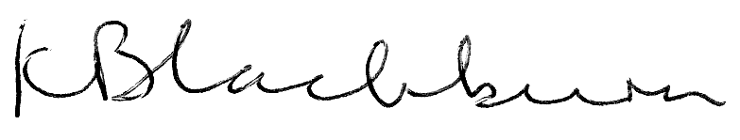
MRS K BLACKBURN
ACTING HEADTEACHER

