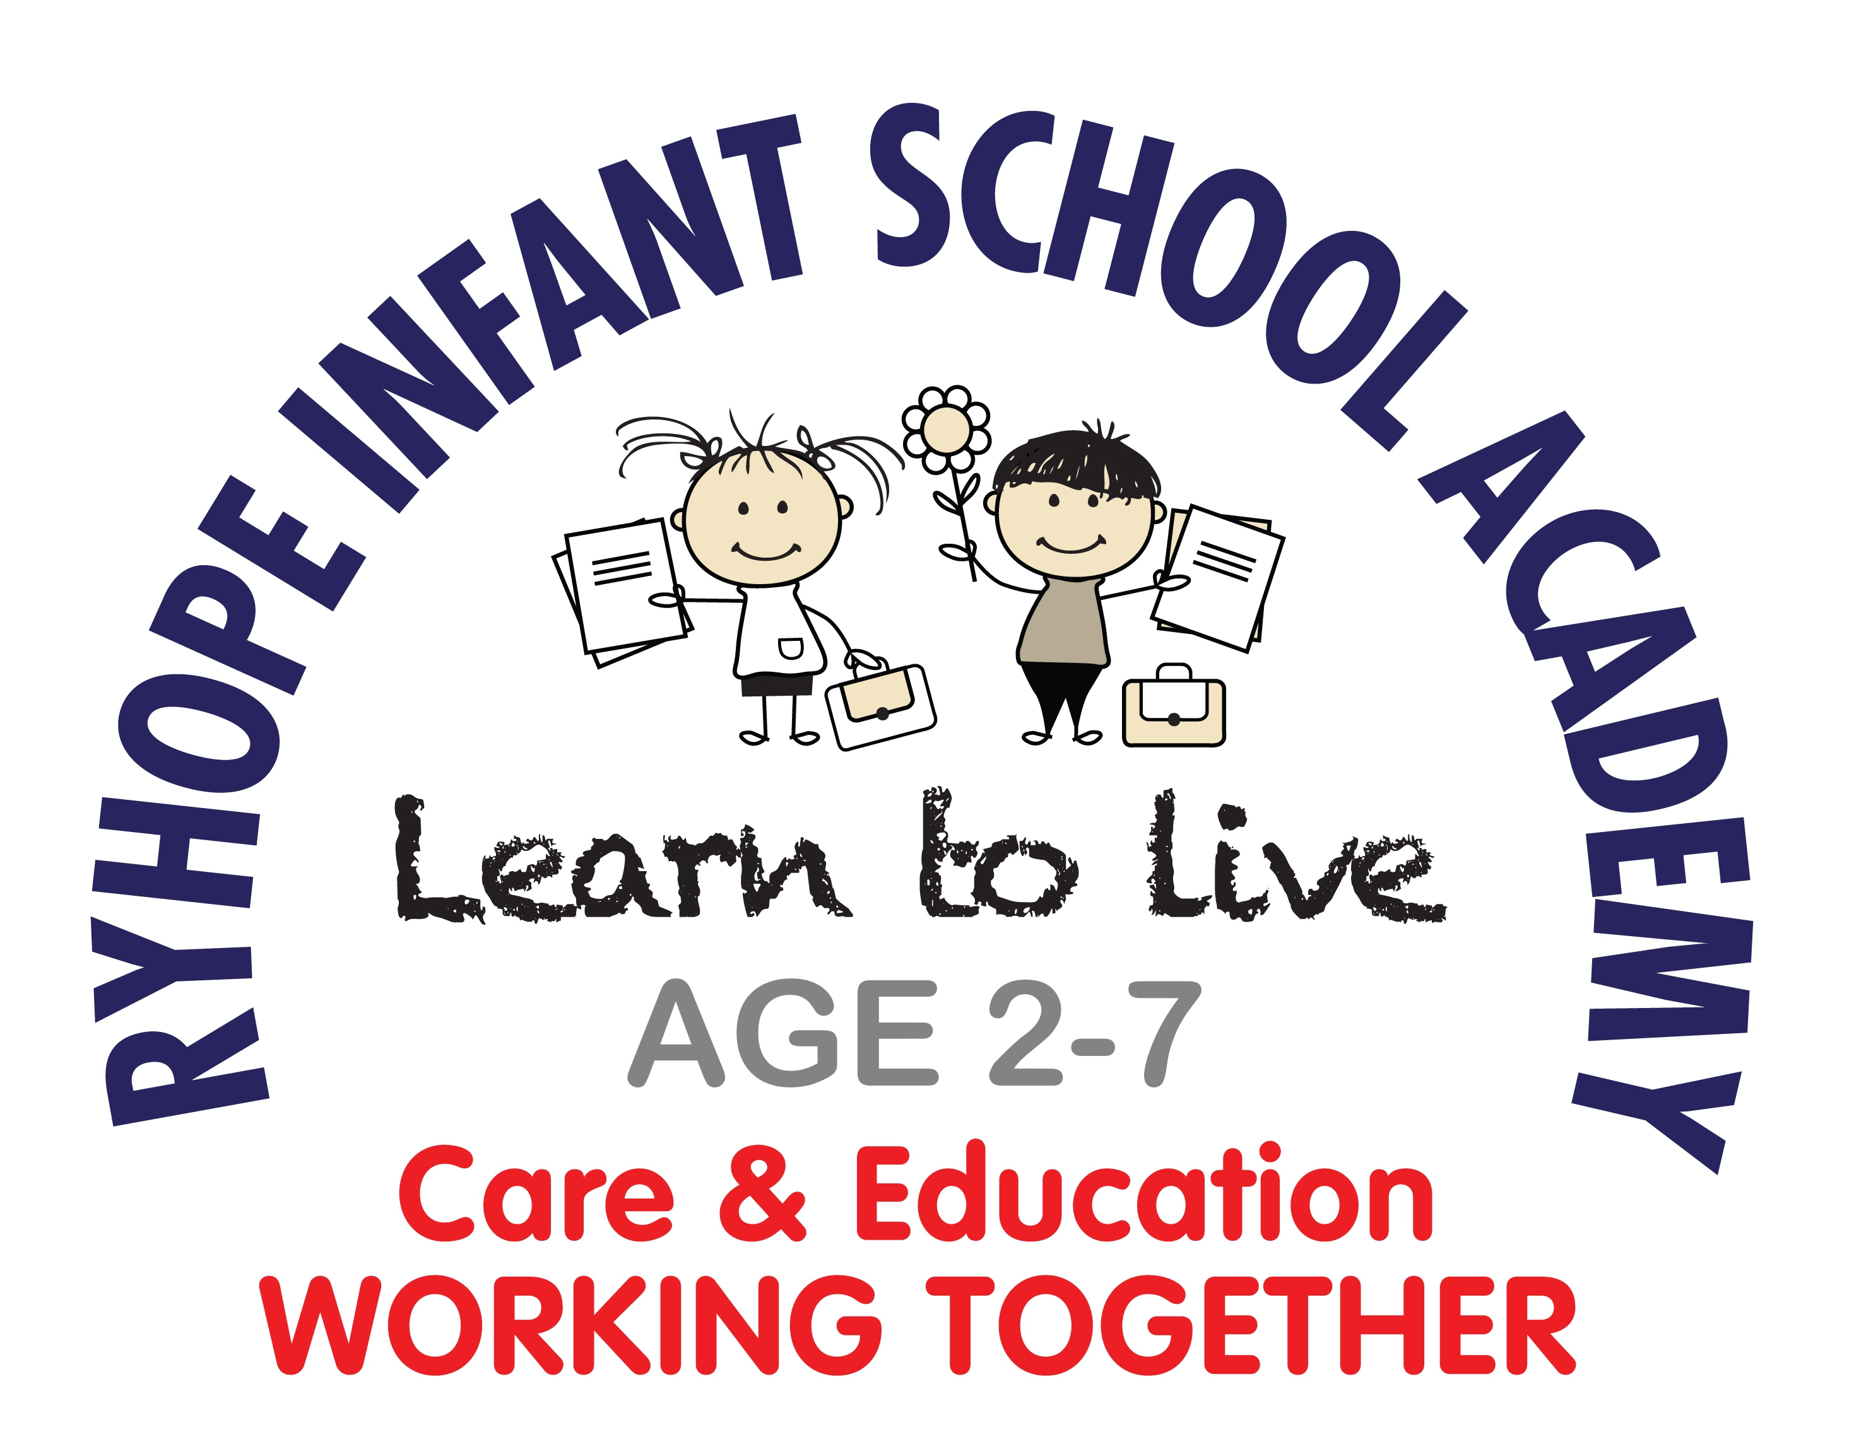 | Ryhope Infant School Academy  Shaftesbury Ave, Ryhope, Sunderland SR2 ORT  Tel: 0191 917 1910  Email: info@ryhopeinfantschool.org.uk  www.ryhopeinfantschool.org.uk  Head Teacher: Mrs T Allen
Role: Early Years Assistant - Level 2 (Minimum)
Contract Type: Fixed Term to 31st July 2026 (initially with potential of permanent if numbers continue to increase)
Working Pattern: Full Time (37 hours per week)
Term Time Only including 2 Inset Days
Advert Start Date: Monday 19th January 2026
Required from: As soon as possible
Salary: NJC 3 £24,796 per annum (Pro-rata)
Due to the increase in pupil numbers the Trust is seeking to appoint a highly motivated Early Years Assistant, to join our inclusive and creative school. Applications are invited from experienced Early Years Assistants, who are prepared to make a positive contribution to the life and ethos of our inclusive school. The successful candidate will work within our Nursery Unit with age ranges 2 to 4 years however, may be placed anywhere within the Academy, supporting children with their daily activities under the direction of the classroom teacher.

The successful candidate will:
- Have a full and relevant (DfE validated) qualification for Early Years (Level 2)
- Have experience in working within an Early Years setting
- Be passionate about working with young children and their learning.
- Have an ability to relate well to staff, parents and children.
- Demonstrate a good understanding of child development, the importance of nurturing and the impact it has on the outcomes for children
- Be an outstanding practitioner with high expectations for all children
- Be proficient in supporting the delivery of all aspects of teaching and learning including child-initiated learning.
- Be an effective communicator and be able to work collaboratively with colleagues
- Be flexible and resourceful whilst always putting the needs of the child first
- Have a commitment to their own professional development.
- Be prepared to be involved in the wider life of the school.
Ryhope Infant School Academy is a caring, supportive community where we aim to provide outstanding education in a nurturing environment.

Completed application forms should be returned to Mandy Henderson by email to: recruitment@ryhopeinfantschool.org.uk. CV applications will not be accepted.

Closing date for applications: Friday 27th February 2026 @ 12 noon
Shortlisting: Week commencing 2nd March 2026
Interviews: To be scheduled week commencing 9th March 2026

Ryhope Infant School Academy is committed to safeguarding and promoting the welfare of children and young people and expects all staff and volunteers to be fully committed to our safeguarding policies and procedures, in accordance with Sunderland Local Safeguarding Board Procedures.
In line with the guidance in Keeping Children Safe in Education, schools may carry out an online search as part of their due diligence on shortlisted candidates. Pre-employment checks and references will be sought before interview and the successful candidate will need to undertake an enhanced DBS check. This post is exempt from the Rehabilitation of Offenders Act 1974

