
Facility Services
Catering Assistants, Cleaners and Relief Cleaners

At our Condercum Road reception, you can collect and hand in application forms for the positions above. If you are successfully shortlisted, this is where you will be invited for your interview.

Condercum Road,
Benwell,
Newcastle upon Tyne,
NE4 8XN

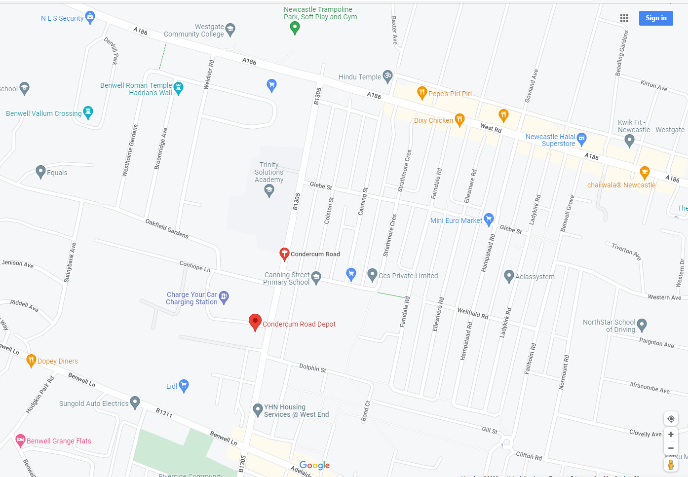
We are here



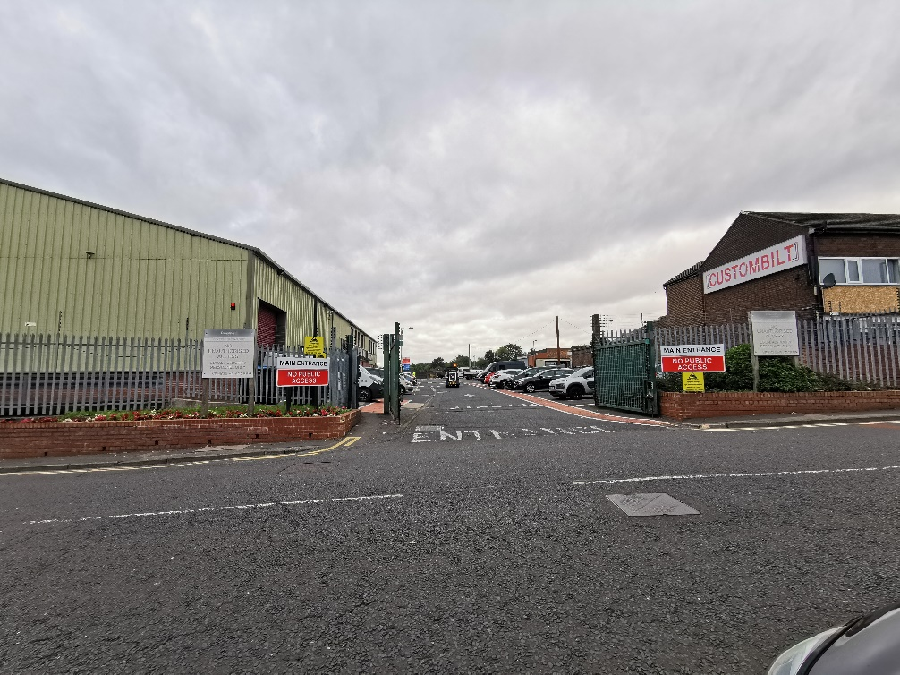

This is the entrance to the Condercum Road Depot.

Please note that there are no parking facilities within the depot.
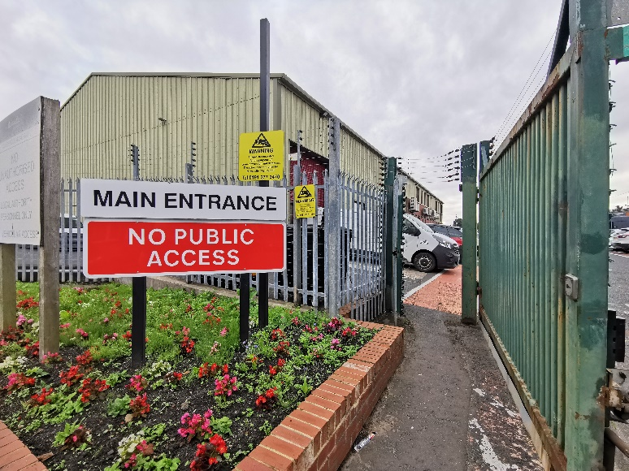
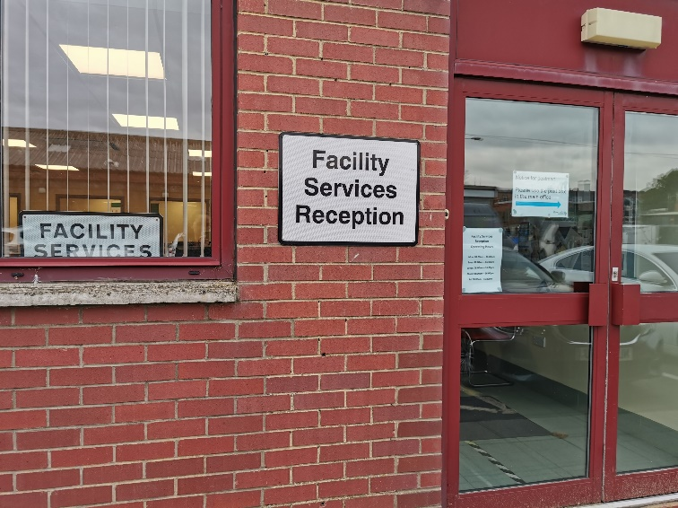
Facility Services Reception
Operating Hours

Mon: 08:00am – 16:00pm

Tues: 08:00am – 16:00pm

Weds: 08:00am – 16:00pm

Thurs: 08:00am – 16:00pm

Fri: 08:00am – 15:30pm

