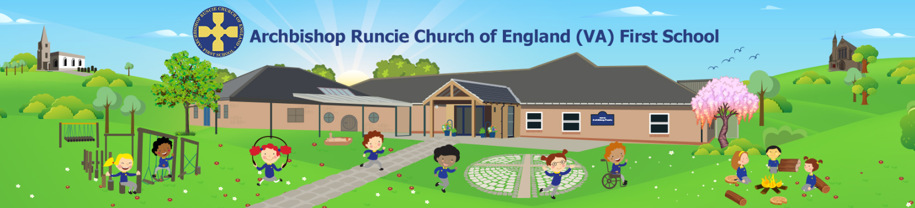
Person Specification

Post: Facilities manager

The following criteria (experience, skills and qualifications) will be used to short-list at the application stage:

Essential
- Ability to ensure the delivery of services in accordance with customers service standards, policies and procedures.
- Ability to provide a professional and efficient caretaking and maintenance service across all school premises.
- Ability to ensure that the school premises (internal and external) and furnishings are cleaned in accordance with agreed procedures, standards and methods, by undertaking cleaning and by supervising the cleaning staff.
- Ability and willingness to ensure that area of work complies with legislation relating to Health & Safety
- Capable of regular stooping, bending, lifting and carrying
- Ability to maintain security of the premises including the locking of doors, setting alarms, etc, and undertaking call out duties (overtime paid out of hours).
- Knowledge of and ability to undertake basic minor or temporary repairs and maintenance tasks or report as necessary in accordance with agreed procedures. Ability to provide advice and guidance to contractors and inspect any works undertaken.
- Ability to procure and order stocks and supplies ensuring that there are adequate levels at all times. Take delivery and arranging for the appropriate storage of materials, stores and other goods.
- Team player and to be able to use own initiative
- Good relationships with others
- Self-motivated and able to work to fixed deadlines
- Strong communication, including use of Standard English in both written and spoken forms
- Ability to maintain good communication links and working relationships with all staff and a strong understanding of the importance of such communication
- Flexible approach to work
- Willing to attend training sessions as and when required
- Ability to act in compliance with data protection principles in respecting the privacy of personal information held by the school
- A strong commitment to safeguarding

Desirable
- BICS or equivalent or give a commitment to training Health and Safety working practices
- COSHH training
- To be able to use cleaning machines
- Other qualifications or training linked to Health & Safety

The following criteria will be further explored at the interview stage:
- Good spoken English
- Evidence of certification
- A commitment to ensuring a safe environment for children, a thorough knowledge and understanding of safeguarding procedures and legislation

Additional Requirements
This post is working in regulated activity so pre-employment checks will include Disclosure and Barring Service (Children) check

