
JOB DESCRIPTION

Post Title: Childhood Enrichment 10by10 Coordinator

Grade and Salary Scale: I SCP 22-24

Directorate and Service: Finance, Resident and Business Support

Responsible To: Service Manager – Lifetime Enrichment

Post Ref: 0183

Purpose of the Post:

This role forms part of the Lifetime Enrichment team within Customer Services, Resident and Business Support team and is responsible for coordinating the Councils 10by10 Enrichment Programme.

The10by10 Coordinator, Childhood Enrichment, is responsible for coordinating the development of the programme, ensuring every child in Middlesbrough has the opportunity to access ten enriching experiences by the age of 10 years, that will support them to develop a strong sense of identity and feel a proud and valued part of Middlesbrough.

This role will work with and develop links with key partner organisations within Middlesbrough to develop an inclusive offering to all children to enable them to engage in new opportunities, discover and explore new interests and develop potential by stimulating minds, encouraging creativity and nurturing natural talents and abilities.

The post holder will research, plan, develop, evaluate and implement opportunities and activities in relation to the 10by10 Programme, contributing to the wider council plans.

Duties and Responsibilities:

- To coordinate the 10by10 programme to create opportunities and experiences for children within Middlesbrough.

- To develop the 10by10 programme to ensure that there is extensive and accessible provision across Middlesbrough.

- Engage with and develop partnerships with local organisations, businesses, education establishments and internal council service areas, to create a 10by10 programme to meet the objectives of the programme.

- To carry out research and seek out best practice, locally, nationally and wider to develop policies, procedures and initiatives to develop the 10by10 programme.

- Prepare Reports and briefings, provide updates to stakeholders, local partnerships, internal boards and management meetings.

- To support the management and monitoring of the 10by10programme and provide performance reports.

- To develop and operationalise the funding requirements for the 10by10programme to ensure opportunities can be developed.

- To develop the local provider market for the 10by10programme and establish appropriate publicity and promotion of the 10by10 programme.

- To develop and coordinate a Middlesbrough Children’s Voice to support the ongoing development of the 10by10 programme and wider council initiatives.

- To develop quality assurance mechanisms and carry out quality assurance visits to maintain standards and ensure delivery is effective, evidence based and efficient.

- To coordinate the role of the 10by10 Young Inspectors to assist in the development and quality assurance of the programme.

- To attend local meetings and events as relevant to the area of work and organise meetings and effectively contribute, manage and chair as necessary to ensure effective delivery.

- The above duties and responsibilities cannot totally encompass or define all the tasks that may be required of the post holder. The outline duties may therefore vary from time to time without materially changing the character of level of responsibility. These factors are reflected in the grade for the post.

- Middlesbrough Council is totally committed to continuous organisational and employee development. The post holder is required to participate fully in all initiatives that facilitate continuous improvement in both service quality and employee development and performance.

Corporate Responsibilities:

- We will make every reasonable effort to supply the necessary employment aids, equipment or adaptations to enable employees to perform the full duties of the job in accordance with the Equality Act 2010 where a post holder is disabled.

- You will

  - Demonstrate a commitment to the principles of equality of opportunity and fairness of treatment in relation to employment issues and service delivery.
  - Respect all confidentialities and principles and practices of the Data Protection Act.
  - Comply with Health and Safety policies and legislation.
  - Be committed to continuous personal development, including Middlesbrough learns.
  - Demonstrate a commitment to the safeguarding of children and vulnerable adults, highlighting any areas of concern with the appropriate service and adhering to the policies of the Council relating to these issues.

- The above duties and responsibilities cannot totally encompass or define all tasks which may be required. The outlined duties and responsibilities may, therefore, vary from time to time without materially changing either the character or level of responsibility: these factors are reflected in the post.

PERSON SPECIFICATION

For the purposes of recruitment and selection, you will be assessed against Our Values and the criterion marked as Essential/Desirable in the Qualifications and Knowledge & Experience section.
Our Values

Our Values are a critical element of our strategy to create a brighter future for Middlesbrough. They will be at the heart of everything we do and will be the foundation for how we operate, behave and make decisions. Having these values will help you be the best you can be and help Middlesbrough to grow and thrive.

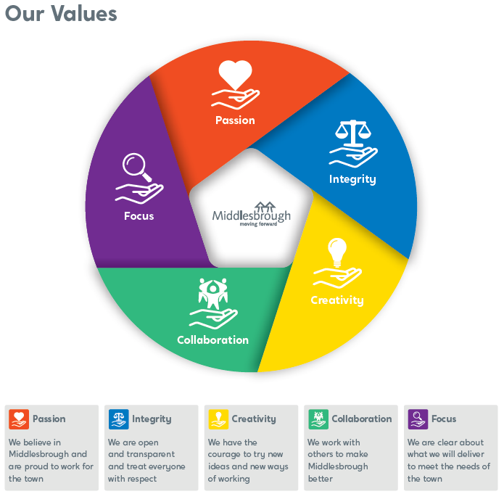

PERSON SPECIFICATION

MIDDLESBROUGH VALUES: | Essential  X | Desirable  X
- Passionate about working for Middlesbrough Council | X
QUALIFICATIONS:

- Degree or similar formal qualification or on-the-job related experience. | X
- Full UK Driving License as the role will require site visits. | X
- Car business insurance. | X
KNOWLEDGE AND EXPERIENCE:

- Knowledge and understanding of Middlesbrough and the Council’s priorities. | X
- Experience in working effectively and building relationships with other agencies and partners and the voluntary sector. | X
- Experience and knowledge of delivering and developing activities and services for children. | X
- Knowledge of local services and geography. | X
- Ability to think creatively and develop services in line with identified need. | X
- Excellent organisational skills, able to manage workload effectively to meet priorities and deadlines. | X
- Good IT literacy and skills covering all standard desktop products (email, word processing, spread sheets, databases and presentational software). | X
- Excellent team working skills. | X
- Excellent negotiating skills.

- Ability to prioritise own work and work independently with minimal supervision. | X

