


Candidate Information Pack

Hotspur Primary School
Mowbray Street, Heaton, Newcastle upon Tyne, NE6 5PA
admin@hotspur.newcastle.sch.uk – 0191 276 2762

Learning Support Assistant Level 1

September 2026



At Hotspur we aim to provide a pupil experience based on quality with equality, creativity with rigour and entitlement with diversity. Our stimulating and creative learning environment provides a safe place where children can enjoy their learning and grow into confident individuals and responsible members of society.
Message from the Headteacher

It is very important that children learn to read and write well whilst they are at primary school and gain a good grasp of number and calculations so English and Mathematics are at the centre of our work. We also believe that children should leave in Year 6 knowing what they are good at and what they enjoy – so we give them many different high-quality opportunities whilst they are here including singing, learning instruments, dancing, playing sports, investigating in science, researching in history and geography and creative design in art.
We are looking to appoint an exceptional Learning Support Assistant to join our team who is:

- passionate about making a transformational difference to the lives of young children;
- has the highest expectation of themselves and all children;
- able to use carefully structured programmes and guidelines systematically;
- highly organised and able to prioritise; and
- enjoys working collaboratively.

We have a strong record of developing staff and support those looking to take the next step in your career in a school built on collaboration, creativity, innovation and mutual support.


Kevin McVittie


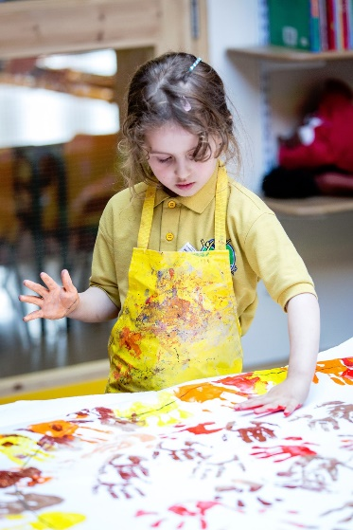

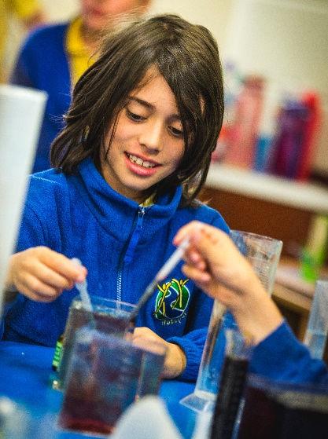
Hotspur is a vibrant two-form entry primary school in Heaton that serves a richly diverse community. We are passionate about enabling children to become rounded, confident and happy individuals. As a school we aim to provide a rich and varied curriculum that:
Learning Support Assistant Level 1
From October 2026
Fixed term until 31st August 2027
1 Vacancy
Contract;
8.15am-3.30pm Monday-Friday (33.75 hours per week, Term time only)
£22,737 (Actual Salary £17,549)

Advert

- develops a love of learning
- ensures high standards in English and Maths
- is balanced between tightly structured and creative learning
- helps children to discover what they are good at and what they enjoy doing
- nurtures inquisitive minds that are open to new ideas
- promotes equality and diversity.

We are looking to appoint an exceptional Learning Support Assistant to join our team who is:

- passionate about making a transformational difference to the lives of young children;
- has the highest expectation of themselves and all children;
- able to use carefully structured programmes and guidelines systematically;
- highly organised and able to prioritise; and
- enjoys working collaboratively.

If candidates would like to visit school, please contact the school office to make an appointment.

Closing date- 12pm Monday 5th October 2026
Shortlisting- Wednesday 7th October 2026
Interview Date- Monday 12th October 2026

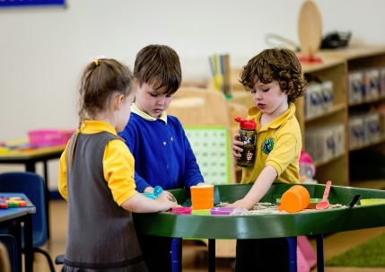


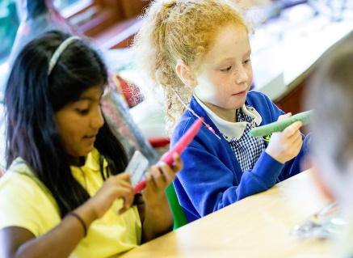
We are committed to safeguarding and promoting the welfare of children and young people. It is essential that all our staff and volunteers share this commitment. The appointment of the successful candidate will depend upon a satisfactory enhanced criminal records check from the Disclosure and Barring Service and other recruitment and vetting checks.
Job Description

Job Description

Job Description
Job Description
POST TITLE: | Learning Support Assistant Level 1
GRADE: | N2 (SCP 2)
RESPONSIBLE TO: | Headteacher or other designated teacher
JOB PURPOSE: | To assist in the education of pupils within the school
MAIN DUTIES: | The following list is typical of the level of duties which the post holder will be expected to perform. It is not necessarily exhaustive and other duties of a similar type and level may be required from time to time.
(a) General
- Supporting the teacher in the general management of the classroom.
- Undertaking activities, as directed by the teacher, with individuals or small groups of pupils.
- Providing clerical/admin support, e.g. photocopying, typing, filing, collecting money etc.
- Supervising groups of pupils alone and participating in general activities including giving sensitive support and intervention in children’s play.
(b) Classroom Organisation
- To be responsible for the organisation, classroom maintenance, setting out, clearing away and care of resources to create a purposeful and attractive learning environment.
- Assisting in the preparation, maintenance and repair of books, apparatus, and equipment, to include cataloguing and stocktaking of all resources.
- Preparing pupils’ work for display in the classroom and around the school.
(c) Pupil Support
- Working with pupils directly on curriculum related tasks under the direction of the teacher.
- Giving relevant feedback to the teacher regarding the social, emotional and physical needs of pupils thus offering the teacher support in their assessment.
- Following school policy documents and schemes of work to keep updated with
- school documentation.
(d) Welfare and Other Duties
- Assisting in the supervision of pupils particularly at break periods, during lunchtimes and the beginning and end of sessions.
- To support with Breakfast club
- To assist in the administration of medicines.
- To carry out care procedures to meet the health care needs of children e.g. nappy changing.
- Attending to sick or injured pupils and taking sick pupils home.
- To promote and implement the Council’s Equality Policy in all aspects of employment and service delivery.

(e) Child Protection
The postholder will have responsibility for promoting and safeguarding the welfare of children and young persons s/he is responsible for, or comes into contact with.

Person Specification
Part A: Application Stage
The following criteria (experience, skills and qualifications) will be used to shortlist at the application stage:

- Skills, Knowledge and Aptitudes

- Able to produce accurate and up to date record and reports
- Able to undertake observations and assessments of pupils including those with special educational needs
- Able to work within and apply all relevant school policies and schemes of work
- Able to work in partnership with other agencies

- Qualifications

- Level 2 Basic Skills (Literacy and Numeracy) or equivalent competency

- Experience

- Experience of supporting pupils in a learning environment
- Experience of classroom organisation
- Experience of using the PACE approach
- Experience of supporting children with additional needs

- Dispostion

- Enthusiastic, positive, confident
- Welcoming of change and ability to respond to it with a flexible approach
- Caring, supportive, nurturing
- Reflective on own performance
- Reliable, punctual, organised, visionary
- Sense of humour
- Liking of children
- Commitment to equal opportunities and anti-discriminatory practices

- Special Requirements
- Very good health and attendance record
- DBS enhanced disclosure

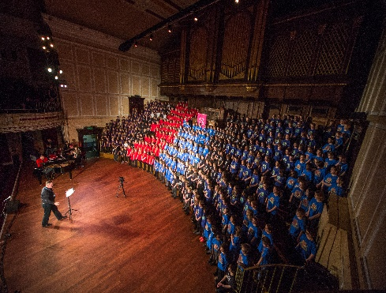
Hotspur is a primary school for children aged 3 - 11 years old. We offer a curriculum that is broad and balanced, ensuring that children do their very best in core subjects through quality first teaching informed by the latest educational research. Children are also given memorable opportunities to discover their ‘spark’ as they learn through the arts. This includes working with a national opera company, being taught by professional musicians and dance teachers, performing at The Sage Gateshead and taking part in the annual Shakespeare Schools’ Festival.
About Hotspur
Hotspur is part of the Ouseburn Learning Trust and enjoys a fantastic location in the Ouseburn Valley on the edge of Newcastle city centre. We utilise links within the local community to enrich the curriculum and carry out many whole-school projects in collaboration with local cultural partners and venues such as the Laing Art Gallery and the Great North Museum.
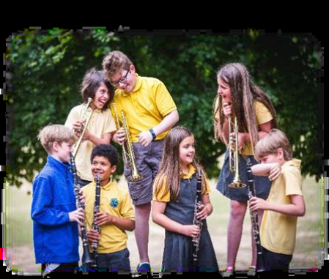
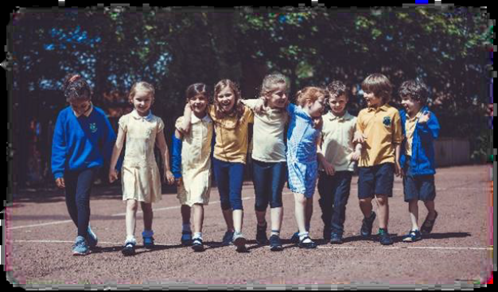
Hotspur is an ambassador school for the Thrive Approach to social and emotional wellbeing. Thrive is embedded across the curriculum and recognises that children’s mental health and wellbeing are essential pre-requisites to accessing the curriculum and developing emotional resilience. Our behavioural approach is rooted in consistency and kindness. We respond to poor behaviour by providing the support children need: consistency, positive reinforcement and restorative practice. One of the things that makes Hotspur unique is the exceptional pastoral care and support we offer to all of our children and families.
The school has fabulous grounds with huge outdoor spaces. We have a wildlife garden with a pond, a sensory garden, outdoor classroom, allotment and brand new play structure, all of which lend themselves to exciting outdoor learning opportunities. 

