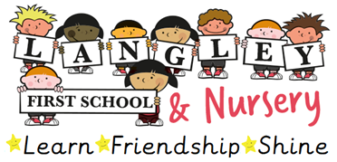 | Person Specification for Classroom Teacher
Essential |  | Desirable
Qualifications
- Qualified Teacher status  - Degree or equivalent |  | - Evidence of additional further educational qualifications  - Ambition to undertake further CPD
Experience
- Able to design and teach effective lessons and learning activities across the relevant curriculum, age and ability ranges including personalising learning to meet individual needs.  - Evidence of consistently effective classroom practice.  - Able to engage and motivate learners in the school environment.  - Experience of teaching in EYFS- including through ITT placements |  | - Experience of contributing to an engaging curriculum taught creatively.  - Experience of teaching Maths Mastery approach  - Experience of teaching in more than one key stage and/or EYFS, including the teaching of Phonics
Knowledge & Understanding
- Understand the principles of effective teaching and learning including current developments in Maths Mastery, Oracy and the teaching of Phonics  - Thorough knowledge of the National Curriculum and Early Years Foundation Stage Framework.  - Understanding of how to secure outstanding pupil progress.  - Awareness of current developments in education and the implications for teaching and learning.  - Experience of using a range of behaviour management strategies successfully in classroom settings.  - Experience of using data to inform future planning.  - Understanding of how to support all learners regardless of their starting points.  - Skilled use of ICT that will enhance learning outcomes.  - Understanding of safeguarding practices. |  | - Understanding of appropriate pedagogies that have contributed to successful outcomes.
Leadership Skills
- Experience of working effectively in a team.  - Demonstrate a clear understanding of the ethos and vision of the school to establish consistently high standards of outcomes, attitudes and behaviour.  - Demonstrate an interest towards a National Curriculum subject with a view to becoming a subject lead. |  | - Experience of leading or supporting whole school projects that improved outcomes for children.
Personal Attributes
- Excellent and engaging oral and written communication skills.
- Have positive values, attitudes and have high expectations for learners.
- Adaptability to changing circumstances and ideas
- Promote diversity and success for all.
- Commitment to on-going learning and professional development
- Aspirational for all
- Sense of humour, energy and enthusiasm
- A ‘can do attitude’- and a willingness to take a full and active part in the school community.

