

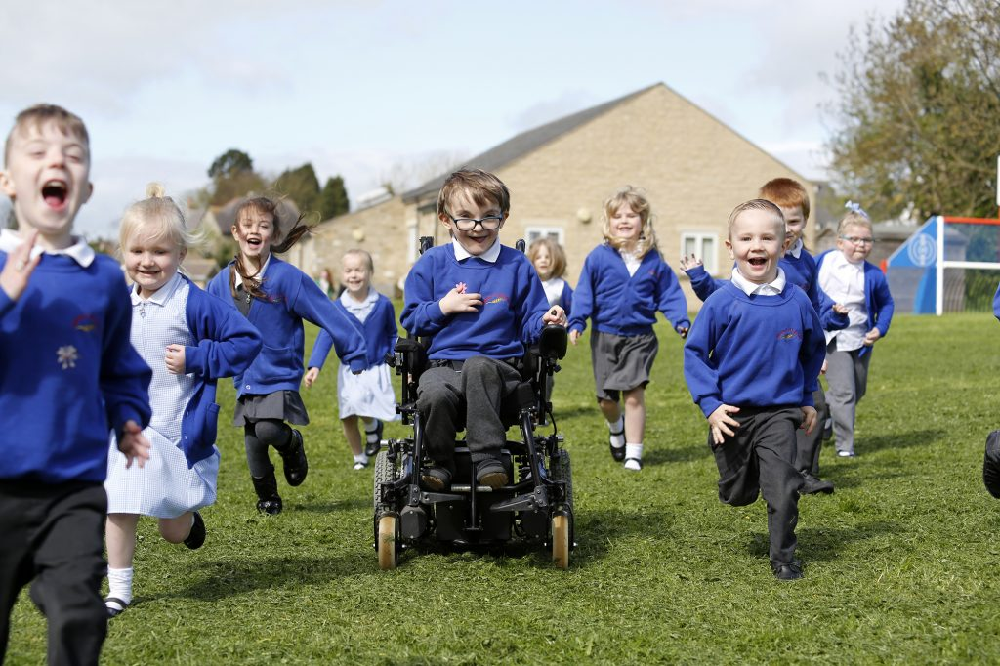

Thornaby Church of England Primary School
24.25 hours per week KS2 Teaching Assistant Band D (6-9)

Permanent role, to start as soon as possible

Candidate Information Pack
Closing date: Tuesday 22nd September 2026 (at 12noon)
Short Listing: Tuesday 22nd September 2026
Interviews: Friday 25th September 2026

CONTENTS
· Welcome from the CEO
· Advertisement
· About The Dales Academies Trust
· Brief Description of our School
· Teaching Assistant Job Description
· Teaching Assistant Person Specification
· The Selection Process




Welcome to
Dales Academies Trust

Dear Candidate
Thank you for taking your time to download our application pack and expressing your interest in the teaching assistant post at Thornaby Church of England Primary School, a school within Dales Academies Trust (Dales).
This pack has been developed to provide you with a summary of all the information you need to consider when applying for a job within Dales.
Within the pack you will find a job description, a person specification, information about the school and the Trust, as well as details of how to apply for this post should you choose to make an application.
We wish you every success with your application and we look forward to meeting you in the near future.

Damian Chubb
CEO

NJS Grade D 6-9 Teaching Assistant (ATA)
Permanent role, to start as soon as possible
24.25 hours

NOR 289 + 52 place nursery

The Head Teacher and Governors of Thornaby Church of England Primary School are seeking to appoint an enthusiastic teaching assistant.

Post Teaching Assistant (ATA)
Grade/Band NJS Grade D (6-9)
Actual salary £14,766 to £15,485
FTE salary £25,989 to £27,254
Vacancy Hours 24.25 hours per week, worked over five days: three full days of 5.75 hours and two half-days of 3.5 hours. The precise working pattern will be agreed with the successful candidate.
Contract Type Permanent, term-time only plus 5 professional development days.
Weekend Working N/A
Application Closing Date Tuesday 22nd September 2026 (at 12noon)
Interview Date Friday 25th September 2026
Venue for Interview Thornaby Church of England School
Start date: Required from the earliest opportunity, with the start date to be agreed.

Advert details
Thornaby Church of England Primary promotes the highest standards for all of our children. The Head Teacher and Governors wish to appoint a motivated and committed Teaching Assistant (ATA) to support pupils in Key Stage 2. The successful candidate will be required to support individual pupils and groups of pupils with learning and intervention in Key Stage 2. We are looking for a good team player who is able to work well as part of a supportive staff, as well as having an ability to foster excellent working relationships with children. Our school environment is a very caring, nurturing one and we value and celebrate the achievements of every child. We take pride in our church school ethos.
The successful candidate will:
- Be a team player who is committed to the aims and ethos of our school
- Have successful experience of supporting learning in a primary school
- Be enthusiastic about working with young children, and able to relate well to staff, parents and children
- Have a good understanding of phonics
- Have excellent written and oral communication skills
- Be flexible and confident in supporting children’s learning
- Be confident to lead intervention work
- Have a positive, consistent approach to behaviour management
- Be able to work under supervision and also use their own initiative

What we can offer:
- Happy and welcoming pupils, staff, governors and parents
- Pupils with good behaviour and a thirst for knowledge
- A warm, supportive environment in which to work, learn and develop
- Opportunity to work in collaboration with other schools and be part of the establishment of the Dales Academies Trust
- A chance to be part of a caring, Christian environment with exciting visions for the future

The successful candidate will become part of a team that is enthusiastically driving the schools forward and building upon their achievements and strengths. We are a warm, inclusive family school with a strong Christian ethos, a sense of community and a commitment to excellence for all children in our care. We aim to ensure that our children feel safe, happy and achieve their potential as a unique individual and as a learner. Christian values are at the heart of all that we do.

We are committed to safeguarding and promoting the welfare of children, young people and vulnerable adults. We expect all staff and volunteers to share this commitment. The school is also committed to safer recruitment procedures. This post is subject to an Enhanced Disclosure and Barring Check.

We welcome visitors to our school and would really like to meet you prior to your application. If you would like to request an application pack or arrange a visit to the school, please contact the school office and speak to Mrs Pawass or email admin@thornaby.dalesmat.org.

Dales Academies Trust is committed to safeguarding and promoting the welfare of children and young people. All staff and volunteers are expected to share this commitment. The successful candidate will have a responsibility to safeguard and promote the welfare of pupils and must act immediately on any safeguarding concerns in accordance with school and Trust procedures. Safeguarding and pre-employment checks will be undertaken before any appointment is confirmed. The post is subject to an enhanced Disclosure and Barring Service check, including a children’s barred list check where applicable. This post is exempt from the Rehabilitation of Offenders Act 1974. As part of the Trust’s due diligence and safer recruitment procedures, an online search may be undertaken for shortlisted candidates.
Application forms and further details are available from the school office on admin@thornaby.dalesmat.org and should be returned to the school by email by Tuesday 22nd September 2026 by 12 noon
Interviews will take place on: Friday 25th September 2026



Background
Thornaby Church of England Primary School

Our school is a mixed-aged class 1.5-form entry primary school with a committed staff and a strong positive Christian ethos. Our school environment is a very caring, nurturing one and we value and celebrate the achievements of every child. We are inclusive and seek for excellence for all. Our Christian vision is ‘Walking and Learning with faith in the footsteps of Jesus’. This is underpinned by our four Christian values of love, perseverance, hope and forgiveness.
School Leaders, at every level, work together to provide an exciting curriculum and wide-ranging enrichment opportunities. We believe that every child should be encouraged to achieve the highest standards possible, within a positive and supportive atmosphere where all success, great or small, is properly celebrated.
Our children love school and have the confidence to grow in responsibility and independence and leave us as flourishing citizens, equipped for a journey of lifelong learning. We hope you come and visit us and we look forward to welcoming you into our school family.
Dales Academies Trust
Dales Academies Trust is a new Multi Academy Trust (MAT), with sponsor status, for the northern church schools of the Anglican Dioceses of Leeds and York.
As with the other church MATs across both dioceses, the Trust is open to church and non-church schools with a core purpose of providing an inclusive education for children of any ability, culture, gender, sexuality, faith or no faith. The ethos will be derived from and informed by the Church of England’s commitment to education and schooling over more than 200 years.

To date Dales consists of the following schools:

- All Saints Church of England Academy (Secondary) | - Kirkby Fleetham Church of England Primary School
- Barton Church of England Primary School | - Middleton Tyas Church of England Primary School
- Croft Church of England Primary School | - Ravensworth Church of England Primary School
- Eppleby Forcett Church of England Primary School | - Richmond Church of England Primary & Nursery School
- East Cowton Church of England Primary School  - Ainderby Steeple Church of England Primary School  - Carnagill County Primary School | - South Otterington Church of England Primary School  - Thornaby Church of England Primary  - St Francis of Assisi Church of England Primary school  - Oakbridge CofE Primary School

Historically the Primary schools within Dales and their Head Teachers have worked closely together for many years.

Thornaby Church of England Primary School Details
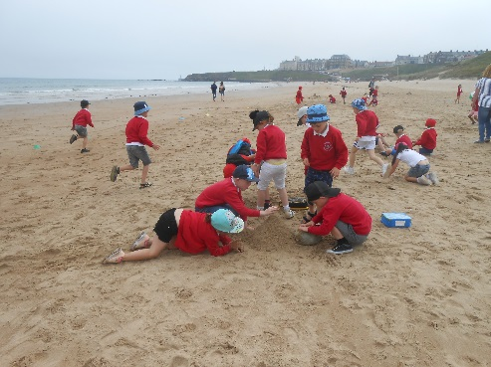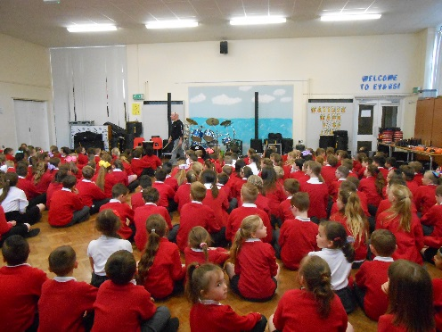



Our vision statement ‘Walking and Learning with faith in the footsteps of Jesus’ is at the heart of all we do and our staff are committed to ensuring that all children are able to be the very best that they can be. We provide an exciting, rich and varied curriculum to challenge and inspire our pupils and give them every opportunity to flourish. We value academic and personal success and have high expectations of behaviour and effort. Our children have fun together and work hard together.
Our school caters for children aged 3 – 11 years old and consists of fourteen classes and a 52 place nursery. We pride ourselves on being a supportive, caring school with a strong Church of England ethos.

Visits to school are welcome and encouraged. Please telephone the school administrator, Mrs Emma Pawass to arrange a convenient time. Completed application forms should be returned to the Head Teacher, Mr Richard Chandler, Thornaby Church of England Primary School, Baysdale Road, Thornaby, Stockton TS17 9DB by email to admin@thornaby.dalesmat.org to arrive no later than noon on Tuesday 22nd September 2026

It is expected that interviews for the post will be held on Friday 25th September 2026. Individual interview times will be confirmed with shortlisted candidates. Please alert referees that we may request references at relatively short notice.

Details of the interview arrangements will be sent out to those on the shortlist. Thank you in advance for completing your application.

Yours sincerely

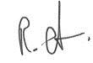

Mr Richard Chandler
Head teacher

In relation to Data Protection, Information Security and Confidentiality, all staff are required to comply with the school's policies and supporting documentation in respect of these issues.

Terms and Conditions

The employer for this post is the Dales Academies Trust.

The post is based at Thornaby C E Primary School

An Enhanced DBS is required for this post.
Closing date for applications: Tuesday 22nd September 2026
Short Listing: Tuesday 22nd September 2026
Interviews: Friday 25th September 2026

If you would value an informal discussion about the post, please contact Richard Chandler, Head teacher on 01642 763060.
If you would like to apply for this position, please complete the application form and submit it to admin@thornaby.dalesmat.org

JOB DESCRIPTION

POST: |  | KS2 Teaching Assistant
GRADE: |  | Grade D 6-9
RESPONSIBLE TO: |  | Head Teacher
STAFF MANAGED: |  | N/A
POST REF: |  |  | JOB FAMILY: | 7
JOB PURPOSE: | To provide support for pupils and individual pupils in-line with their identified needs, liaising with other staff to do this. Adapt learning and the learning environment to support the needs of individual pupils. The role may involve planning, preparing, delivering lessons or assessing and reporting on the development progress and attainment of pupils.
JOB CONTEXT: | This school is committed to safeguarding and promoting the welfare of our pupils and young people. We have a robust Child Protection Policy and all staff will receive training relevant to their role at induction and throughout employment at the School. We expect all staff and volunteers to share this commitment. This post is subject to a satisfactory enhanced Disclosure and Barring Service criminal records check for work with children.  An ability to fulfil all spoken aspects of the role with confidence through the medium of English
ACCOUNTABILITIES / MAIN RESPONSIBILITIES
Supporting Learning & Development | - Provide support and encouragement to pupils, and manage classroom organisation during the cover lesson  - Manage the behaviour of pupils through the implementation of the school behaviour policy and practices, and encourage pupils to take responsibility for their own behaviour. Make adaptions to practice in order to support pupils behavioural needs.  - Collect any completed work at the end of the lesson and return it to the appropriate person
Communication | - Establish rapport and respectful, trusting relationships and communicate effectively with pupils  - Communicate pupil work as set out by the classroom teacher  - Report back as appropriate using agreed referral procedure on the behaviour of the class
Sharing Information | - Pay due regard to professional boundaries, maintaining appropriate levels of confidentiality  - Provide feedback to teachers and other professionals as required
Safeguarding and Promoting the Welfare of Children & Young People | - To be committed to safeguarding and promote the welfare of children, young people and adults, raising concerns as appropriate  - Assist pupils with personal hygiene, first aid and welfare, including physical and medical needs, whilst encouraging independence
Administration / other | - Prepare the classroom/ resources for lessons, ensuring that resources are cleared away at the end  - Undertake administration and any other duties that might be reasonably required commensurate with the grade of the post  - Supervise pupils and provide access arrangements for pupils sitting internal and external examinations ensuring that examinations comply with Examination Board Regulations  - Participate in the school’s procedures for appraisal, training and other learning activities
Data Protection | - To comply with the Dales MAT policies and supporting documentation in relation to Information Governance this includes Data Protection, Information Security and Confidentiality
Health and Safety | - Be aware of and implement your health and safety responsibilities as an employee and where appropriate any additional specialist or managerial health and safety responsibilities as defined in the Health and Safety policy and procedure  - To work with colleagues and others to maintain health, safety and welfare within the working environment
Equalities | - Promote inclusion and acceptance of all pupils  - Within own area of responsibility work in accordance with the aims of the equality Statement, treating individuals with respect for their diversity, culture and values
Flexibility | Whilst this job outline provides a summary of the post, this may need to be adapted or adjusted to meet changing circumstances. Such changes would be commensurate with the grading of the post and would be subject to consultation. All staff are required to comply with Dales MAT Policies and Procedures
Date of Issue:

24.25 hours KS2 Teaching Assistant

PERSON SPECIFICATION

Essential upon appointment | Desirable on appointment
Knowledge  - Good numeracy / literacy skills | - Good understanding of child/young people’s development and learning processes  - Understanding of classroom roles and responsibilities  - Working knowledge of relevant policies and legislation e.g. child protection and health & safety  - Knowledge of behaviour management techniques
Experience  - Experience of working with pupils of a relevant age in a education environment  - Managing student behaviour | - Invigilating internal and external examinations  - Supporting individual pupils, personalising/ adapting learning to meet needs.
Occupational Skills  - Good written and verbal communication skills: able to communicate effectively with all children, young people, families and carers  - Demonstrable ICT skills | - Demonstrable ICT skills and ability to use them as part of the learning process, or, the ability to develop ICT skills in a reasonable time frame
Qualifications  - Level 2 qualification or equivalent. | - Childcare or supporting learning qualification at Level 2 or above (or equivalent)  - Appropriate first aid training (Dependent on the schools needs - insert as appropriate)
Personal Qualities
- Ability to work successfully in a team
- Willing to learn and develop new skills
- Confidentiality
Other Requirements
- Enhanced DBS Clearance
- To be committed to the school’s policies and ethos
- To be committed to Continuing Professional Development
- Motivation to work with children and young people
- Ability to form and maintain appropriate relationships and personal boundaries with children and young people.
- Emotional resilience in working with challenging behaviours and attitudes
- Ability to use authority and maintaining discipline
- The ability to converse at ease with customers and provide advice in accurate spoken English is essential for the post.

