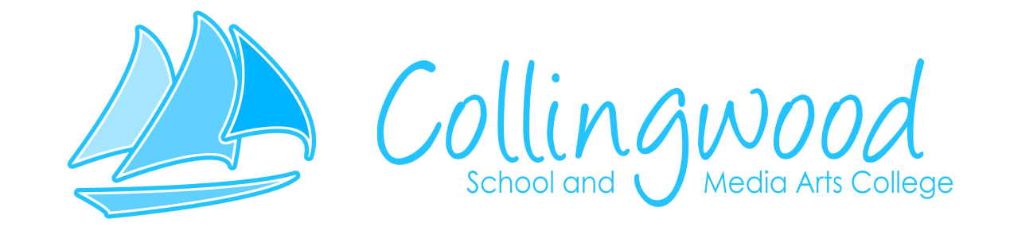

Teacher of Art & Design

Main/Upper pay scale + SEN 1 payment

0.6 (Monday – Wednesday)

Maternity Cover from ASAP

Collingwood School & Media Arts College is a community special school that caters for pupils aged 2 to 19 with a wide range of special educational needs. The school offers a specialised learning environment to support the additional requirements of our students.

We have a vacancy to cover maternity for an enthusiastic, self-motivated teacher with a specialism in Art & Design. Successful candidate(s) will be committed to raising standards and providing support to the teaching and learning agenda.

You must be:

Flexible, motivated, supportive and enthusiastic

Have the skills and commitment to improve outcomes for all pupils in our school

Able to work effectively within a team

Able to relate to a wide range of abilities

Previous SEND experience, although not essential, would be an advantage.

We are very proud of our achievements at Collingwood and the reputation we have gained for the high standard of education we provide. We are committed to continuing to improve the work we do and would welcome applications from people who will share this vision with us.

We are committed to safeguarding and promoting the welfare of children and young people and expect all staff to share this commitment. An enhanced DBS disclosure is required for this post.

Closing date Friday 2nd October at 2pm
School Address: Stobhillgate, Morpeth, Northumberland, NE61 2HA
Telephone: 01670 516374
Email: admin@collingwood.northumberland.sch.uk

