Acre Rigg Road
Peterlee
Co. Durham
SR8 2DU
Tel (0191) 586 4437
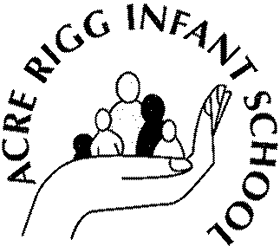Email: acrerigginfants@durhamlearning.net
www.acrerigg-i nf.durham.sch. u k

Head Teacher:
Mrs Kate Longstaff

Dear Applicant

Post of Headteacher

Thank you for your interest in the post of Headteacher at Acre Rigg Infant School.

Governors anticipate that a shortlist of candidates will be drawn up on Friday 16 October 2026 to enable interviews for the post to take place on Thursday 22 October 2026.

It is anticipated that the successful candidate will take up duty on 1 January 2027.

Visits to the school are encouraged. Please contact the school office to make an appointment.

Visits will be available on:

- Wednesday 30 September 2026 from 4:00pm to 5:00pm
- Monday 5 October 2026 from 4:00pm to 5:00pm
- Thursday 9 October 2026 from 4:00pm to 5:00pm

Further information about the school is available on our website.

Completed application forms should be returned to EDGS.Administration@durham.gov.uk. by no later than Monday 12 October 2026 at 12:00pm.

I wish you well should you decide to proceed with your application.

Yours faithfully

