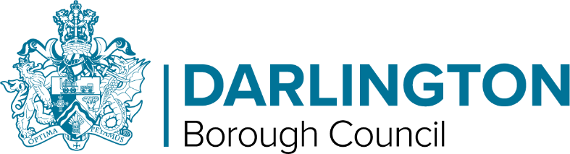
Role Profile

Registered Manager | Pay Band: 11

Job Purpose: | To manage, develop, deliver and be responsible for services to young people in one of the Service’s Children’s Homes, act as a Corporate Parent for Children Looked After and be an assertive champion for Children in Need in accordance with the Quality Standards for Children’s Homes.
What are you expected to do?

- To ensure the smooth running of the Children’s Home in line with the Guide to the Children’s Homes Regulations including the Quality Standards and monitored by Ofsted
- To be responsible for day to day management ensuring a 24hour, 7 days a week provision.
- To participate and be a member of the various panels and contribute effectively.
- To produce and regularly review a Statement of Purpose for the home in line with Children’s Homes Regulations Schedule 1.
- To be responsible for making decisions in regard to referrals and admissions to the home, taking into account assessed needs of young people and associated risk management.
- To provide leadership, guidance and management to in implementing organisational strategies
- To be responsible for the development, implementation and monitoring of individual young people’s plans, ensure a response and aim to achieve the identified outcomes for young people.
- Ensure and oversee contributions to the compilation of a robust residential placement plan, and relevant behaviour support plans.
- To ensure that the team works with young people in keeping with legislative, procedural and good practice requirements. Lead and support auditors in their work including Ofsted inspectors and Regulation 44 visitors and provide them with the necessary information.
- To be the safeguarding lead in the home as well as the single point of contact (SPOC) to safeguard and promote individual young people’s welfare and rights.

What you need to do it?

- Level 5 Diploma in Leadership and management for Residential Childcare or equivalent
- Physical intervention training
- Administration of medication training level 3 or equivalent, including necessary refresher training

What you need to be successful?

- Demonstrable understanding and application of The Guide to the Children’s Homes Regulations and relevant legislation including the quality standards, within a children’s home setting.
- 5 years’ recent experience of working with children and young people in residential care and working with looked after children/Children in need
- Approx. 2 years management experience in residential care or related setting including performance development.
- Knowledge, understanding and application of Child Protection and Local Safeguarding Children Board procedures.
- Experience of working with challenging behaviour.
- Experience in leading an Ofsted key inspection.

