Appendix A
Progression through the
Social Work Retention Career Grade
Children and Families Social Care

This document was agreed with the Trades Unions as part of the Social Worker Retention Rates Local Agreement on 28th April 2023 under a collective bargaining process.

This document and the retention rates set out within it are effective from 1st April 2023 to 31st March 2028.

This agreement will be reviewed on or around 31st March 2028 at which time there will there be a further period of consultation with the Trades Unions.

Following review, the Council reserves the right to cease payment of the higher retention rates set out in Appendix A with a minimum of 6 months’ notice.

The Council reserves the right to review the agreement before the date specified in paragraph 5.1 in the following circumstances;

- Changes to the Local Government ‘Green Book’ salary scale are implemented either regionally or nationally,
- Changes to the Council’s Pay and Grading Structure are implemented,
- There is any fundamental change to employee terms and conditions.

Employees/Workers will have no right to pay protection on cessation of payment of the higher retention rates.

INTRODUCTION

This guidance relates to Registered Social Workers in Children’s Social Care. The guide details the criteria and processes to be followed in order to progress between Social Worker and experienced Social Worker levels. If you are a NQSW, please also refer to the separate ASYE handbook and associated documents.

All Social Workers need to be registered with Social Work England to practice. To maintain high standards in social work practice, Social Workers need to re-register every 12 months, confirm that you continue to meet the professional standards and upload reflective accounts of your continuous professional development in order meet the criteria of re-registration.

PROFESSIONAL STANDARDS

The professional standards are the threshold standards necessary for safe and effective practice. They are specialist to the social work profession and apply to all registered Social Workers in all roles and settings.

Social Work England have prescribed six standards which need to be demonstrated and upheld in social work practice. These are:

- Promote the rights, strengths and wellbeing of people, families and communities.
- Establish and maintain the trust and confidence of people.
- Be accountable for the quality of my practice and the decisions I make.
- Maintain my continuing professional development
- Act safely, respectfully and with professional integrity.
- Promote ethical practice and report concerns.

CONTINUING PROFESSIONAL DEVELOPMENT (CPD) (Standard 4)

Social Work England defines continuing professional development (CPD) as “reflection and learning activity that Social Workers undertake throughout their career to maintain and improve their practice. By undertaking and recording CPD, Social Workers demonstrate that they uphold professional standards and continue to remain fit to practice.”

A number of CPD validation audits will be carried out by Social Work England. Recording online CPD at least once a quarter as a minimum would be considered good practice.

Professional Capabilities Framework

This guidance also reflects the national Professional Capabilities Framework (PCF) for Social Workers, which sets out the profession’s expectations of what a Social Worker should be able to do at each stage in their career and professional development.

The PCF comprises nine capabilities which are interdependent and interact in professional practice, so there are overlaps between the capabilities, and many issues will be relevant to more than one capability.

The Professional Capabilities Framework is as follows:

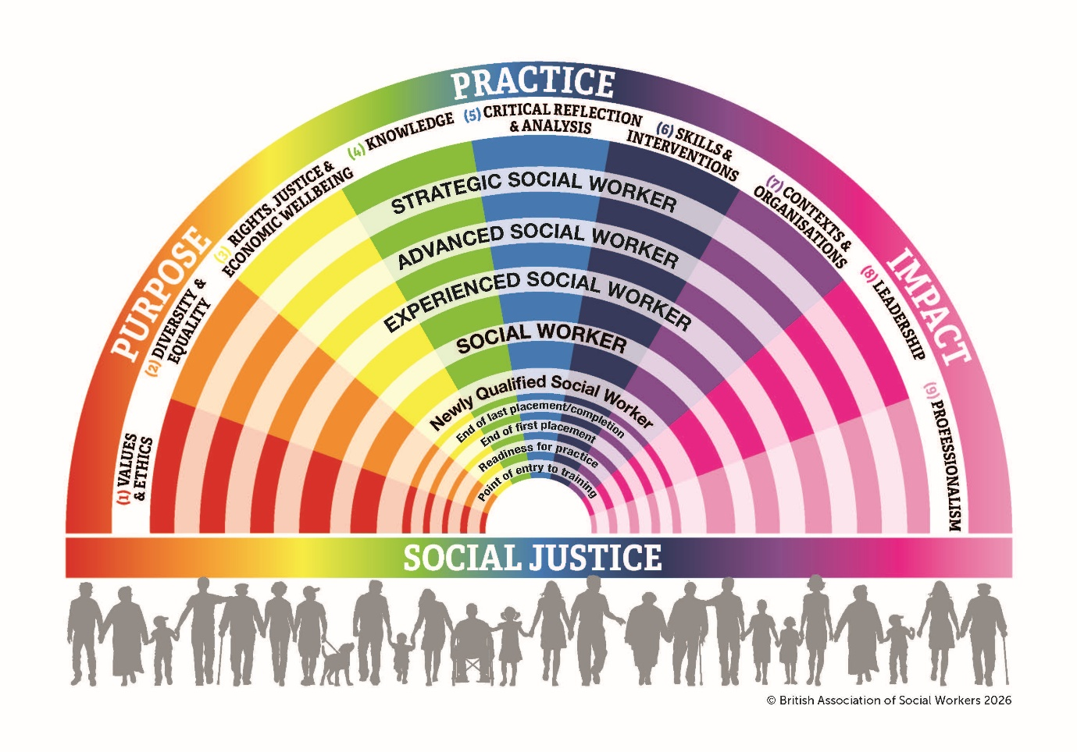

- Values and Ethics: Apply social work ethical principles and values to guide professional practice
- Diversity and Equality: Recognise diversity and apply anti-discriminatory and anti-oppressive principles in practice
- Rights, Justice and Economic Wellbeing: Advance human rights, and promote social justice and economic wellbeing
- Knowledge: Apply knowledge of social sciences, law and social work practice theory
- Critical Reflection and Analysis: Apply critical reflection ad analysis to inform and provide a rationale for professional decision making
- Skills and Interventions: Use judgement and authority to intervene with individuals, families and communities to promote independence, provide support and prevent harm, neglect and abuse
- Contexts and Organisations: Engage with, inform, and adapt to changing contexts that shape practice. Operate effectively within own organisational frameworks and contribute to the development of services and organisations. Operate effectively within multi-agency and inter-professional partnerships and settings
- Professional Leadership: Take responsibility for the professional learning and development of others through supervision, mentoring, assessing, research, teaching, leadership and management
- Professionalism: Identify and behave as a professional Social Worker, committed to professional development

Progression between levels is characterised by development in terms of:

- Level of confidence, underpinned by practice experience, reflection and deepening understanding
- The increasing ability to work independently and to collaborate on equal terms with members of other professions
- The quality of the judgements made, and the level of ability to explain and justify them
- Efficiency of the work undertaken and the outcomes achieved, including opportunities for preventive work
- The ability to take initiative, form constructive alliances and to act as a change agent
- The ability to engage effectively with situations of increasing complexity and challenge, for example those with:
  - Multi-agency input
  - Complex family / organisational dynamics
  - Serious hostility and conflicts of interest
  - Multiple problems / disadvantages
  - Multiple / significant risk factors
  - Need to take into account the public interest
- The appropriate use of authority and challenge
- The ability and commitment to educate and provide professional supervision to others
- Demonstration of leadership, management and research

The Post Qualifying Standards for children and families practitioners: Knowledge and Skills Statement (KSS) sets out a national framework for what a child and family Social Worker should be able to do. The KSS and the PCF is an integral part of the of assessment criteria in the ASYE portfolio.

All of the above standards should also be referred to an Annual Appraisal in relation to performance and professional development plans. BASW have produced a useful document which maps the PCF/PQ Standards/Social Work England Professional Standards and can be downloaded here: https://www.basw.co.uk/resources/mapping-pcf-kss-and-regulatory-standards-england

The career grade for Social Workers was revised as part of the South Tyneside job evaluation process to provide effective career pathways for Social Workers. There are bars positioned at SCPs 28, 30 and 32.

Social Work Career Grade Progression Framework

Level | Social Worker – Job Evaluated, Substantive Rate | Social Worker Retention Rate – equivalent Band/SCP | Expectations and Eligibility
Level 1  NQSW / ASYE | Band 6  SCP 26 – 28 (Bar at 28)  SCP 26 - £38,510  SCP 27 - £39,481  SCP 28 - £40,444 | Band 6/7  SCP 28 – 30 (Bar at 30)  SCP 28 - £40,444  SCP 29 - £41,177  SCP 30 - £42,123 | Any newly qualified Social Worker will commence at Level 1 entry level. It would depend upon their experience and the qualifications they bring (assessed at interview) at what SCP they would commence on. A newly qualified Social Worker (NQSW) is expected to undertake induction activities and complete the ASYE portfolio over a period of 12 months. This is assessed by the Practice Manager and submitted to a Moderation Panel where it is quality assured by a Service Manager and the Principal Social Worker. Following successful completion, the Social Worker will progress through the Bar point.
Level 2  Social Worker | Band 7  SCP 29 – 30 (Bar at 30)  SCP 29 - £41,177  SCP 30 - £42,123 | Band 7  SCP 31 – 32 (Bar at 32)  SCP 31 - £43,149  SCP 32 - £44,253 | Social Workers will now be consolidating their practice, exercising higher quality judgements, in situations of increasing complexity, risk, uncertainty and challenge. Through growing understanding, they expect and anticipate, but do not pre-judge the issues that may develop.  They will have greater confidence and independence (whilst accessing support where needed) and use their initiative to broaden their repertoire of responses; they have expertise in one or more areas of practice, be familiar with local resource networks and be recognised by peers as a source of reliable knowledge and advice.  Social Workers wishing to progress through the Bar to a Level 3 Social Worker must have completed 2 years of practice post ASYE and be supported by their Practice Manager. They will complete the Progression Portfolio, which will include an audit, and a critical reflection on their development. Both Practice Manager and Service Manager will provide written support that the Social Worker is working at this level and this will be included in the Social Worker’s submission to Progression Panel. This panel will include a Service Manager and the Principal Social Worker. The Panel will form a view and make an endorsement. The Social Worker will be eligible to pass through the Bar point.
Level 3 Social Worker | Band 7  SCP 31 - 34 (Bar at 32)  SCP 31 - £43,149  SCP 32 - £44,253  SCP 33 - £45,529  SCP 34 - £46,579  Completion of Practice Educators Award:  Stage 1 – SCP 33  Stage 2 – SCP 34 | Band 7/8  SCP 33 - 36 (Bar at 34)  SCP 33 - £45,529  SCP 34 - £46,579  SCP 35 - £47,665  SCP 36 - £48,738  Completion of Practice Educators Award:  Stage 1 – SCP 35  Stage 2 – SCP 36 | Experienced Social Workers are more autonomous in their role. They demonstrate expert and effective practice in complex situations, assessing and managing higher levels of risk, striking a balance between support and control, liaising with a wide range of professionals, including more senior levels. They manage complex caseloads and offer expert opinion within the organisation and to others.  They chair a range of meetings, offer expert support to case conferences, and produce high quality assessments and reports for a range of functions. They model good practice, setting expectations for others. They start to take responsibility and are accountable for the practice of others, mentoring newly qualified workers, and supervision of the work of junior staff.  Once having progressed through the bar, Social Workers have the opportunity to access further SCP by demonstrating additional competence and capability through their practice and through completion of the following additional academic attainment.
Specialist Role | Band 7  SCP 34 - £46,579 | Band 8  SCP 36 - £48,738 | A number of Specialist Roles are available which experienced Social Workers are able to apply for when these are advertised. The identified subjects for these roles are where a Social Worker can lead the way in areas of innovation and our approach. Each role will provide the practitioner with the opportunity to specialise and their case load will reflect that work, though not necessarily exclusively, to ensure they continue to develop holistically in other areas of practice.  They will be provided with the support and training to fulfil the role and will share their expertise with other practitioners.
Senior Practitioner | Band 8  SCP 37 - £49,817 | Band 8  SCP 39 - £51,928 | Senior Practitioners are responsible for developing and disseminating specialist practice, process and performance knowledge and skills within the team, providing specialist advice and guidance. They have a leading role to play in mentoring, motivating and inspiring our practitioners to deliver best practice.  It is expected that Senior Practitioners are able to demonstrate that they have undertaken further relevant PQ and CPD programmes such as Practice Educator, Supervision skills.  Progression to a Senior Practitioner role is dependent on a vacant post being available and access to the vacancy is by application and recruitment selection only.
AMHP | Additional 2 x SCP | Additional 2 x SCP | Those practitioners who are also Approved Mental Health Practitioners are eligible to obtain 2 additional increments if they obtain warranty, for example an experienced worker on SCP 35 would go to SCP 37, a PE2 on SCP 36 would go to SCP 38 and a Senior Practitioner on SCP 39 would go to SCP 41.
Asst Team Manager | Band 8  SCP 37 - £49,817 | Band 8  SCP 39 - £51,928
Team Manager | Band 9  SCP 42 - £54,143 | Band SM1  SCP 44 - £57,439
Independent Reviewing Officer | Band 9  SCP 42 - £55,224 | Band SM1  SCP 44 - £57,439
Practice Manager | Band SM1  SCP 46 - £59,779 | Band SM1  SCP 48 - £62,122
Continuous Professional Development Progression Framework for registered Social Workers
The zones represent the overall stages of CPD a Social Worker could undertake. The PCF levels, and PQ standards, show how the progression levels fit with the national standards related to job roles.
Routes into Social Work  Undergraduate:  BA/BSc  Postgraduate:  MA/MSc  Fast Track:  Step up to Social Work  Apprenticeships  BA/BSc | Newly Qualified Social Worker  Assessed and Supported Year in Employment (ASYE)  Practice & Portfolio Development  CPD:  Core Skills STSCAP Mandatory |  | Qualified Social Worker  Consolidation of Practice  CPD:  Relational Practice  Ongoing training | Progressed Social Worker  Expert and effective practice  CPD:  Ongoing training |  | Practice  Educator  PE1 – Post Qualifying module – student placement  PE2 – in house portfolio - student placement  CPD: Practice Educator Assessor & Mentor | Senior Practitioner  ASYE mentoring  Group Supervision  Supervision skills development  CPD:  Ongoing Training | Assistant Team Manager  Supervision skills development  Level 3 Leadership and Management  CPD:  Ongoing training | Practice Manager  Practice Supervisors Development Programme  Level 5 L&M  Leading to Excellence forum  CPD:  Audit  Training |  |  | IRO  Specialist training  CPD:  Audit  Ongoing training | Operations Manager  Principal Social Worker  Strategic /Service Manager  Practice Leaders training  CPD:  Training  Sector Led  Improvement  Audit
Pre-qualifying Zone | Zone 1 |  | Zone 2 | Zone 3 – potential roles |  |  |  |  | Zone 4 – potential roles |  |  |  | Zone 5
Professional Capabilities Framework
End of Placement | ASYE Level |  | Social Worker |  | Experienced Social Worker/Advanced Social Worker |  |  |  |  |  | Strategic Social Worker
 |  | Post Qualifying Standards/Knowledge and Skills Statements
 |  | Children and Families Practitioner |  |  |  |  |  |  |  | Practice Supervisor |  |  |  | Practice Supervisor / Practice Leader

