
JOB DESCRIPTION
Post Title: Social Worker – Middlesbrough Children’s Services
Grade and Salary Scale: I – L SCP 24 - 33

Directorate and Service: Children’s Services, Children’s Care

Responsible To: Team Manager

Purpose of the Post
To provide a high-quality social work service to children, young people and their families, promoting their safety, wellbeing and outcomes. To assess need, risk and protective factors, develop and implement effective plans, and work collaboratively with children, families, carers and partner agencies to achieve positive and sustainable change.
Duties and Responsibilities
- To provide a comprehensive social work service to children, young people, families and carers in accordance with legislation, statutory guidance, local policies and professional standards.
- To undertake assessments of children and families, identifying strengths, needs, risks and protective factors, and to formulate and implement proportionate plans that promote the welfare, safety and development of children and young people.
- To establish and maintain effective relationships with children, young people, families and carers, ensuring that their views, wishes and feelings are heard and inform assessment, planning and decision-making.
- To manage a caseload of varying complexity, ensuring that statutory responsibilities, interventions, visits, reviews and timescales are met.
- To coordinate and participate in multi-agency working, contributing to meetings, reviews, child protection conferences, strategy discussions, court proceedings and other forums as required to safeguard and promote the welfare of children and young people.
- To provide support, guidance and intervention to children, young people and families, promoting resilience, independence and positive outcomes while reducing identified risks.
- To prepare and maintain accurate, timely and high-quality records, reports and assessments, ensuring compliance with statutory requirements, professional standards and organisational procedures.
- To contribute to care and support planning, ensuring that plans are regularly reviewed, outcome-focused and responsive to the changing needs of children, young people and families.
- To identify and respond appropriately to safeguarding concerns, taking action to protect children and young people in line with relevant legislation, policy and procedures.
- To maintain professional standards and accountability, working in accordance with Social Work England's Professional Standards, the BASW Code of Ethics, and the employer's policies and procedures.
- To work collaboratively with colleagues and managers, contributing to service development, quality assurance activities and the continuous improvement of practice and outcomes.
- To participate in supervision, training and continuing professional development, maintaining and developing knowledge, skills and professional competence.
- To inform the Team Manager of any issues, risks or barriers affecting the delivery of effective services, safeguarding arrangements or outcomes for children, young people and families.
- To undertake any other duties commensurate with the grade of the post that support the delivery of effective children's social care services.
Service Areas
Social Workers may be required to work within any of the Children's Services teams and service areas, depending on service need, experience and organisational requirements. These may include:
- Assessment Team – Undertaking statutory assessments, child and family assessments, and progressing cases requiring intervention and support.
- Safeguarding and Care Planning Team – Working with children subject to Child Protection Plans, Children in Need Plans and Public Law Outline processes, undertaking long-term planning and intervention.
- Children with Disabilities Team – Providing specialist support and assessment to children and young people with disabilities and their families, ensuring their needs are appropriately identified and met.
- ASPIRE (Exploitation Service) – Working with children and young people who are at risk of, or experiencing, exploitation, including child criminal exploitation, child sexual exploitation, missing episodes and contextual safeguarding concerns.
- Fostering Service – Supporting foster carers, undertaking fostering assessments, supervision and reviews, and promoting stability and positive outcomes for children in foster care.
- MACH (Multi-Agency Children's Hub) – The front door to Children's Services, receiving and screening contacts, undertaking threshold decisions, information gathering and triage in partnership with multi-agency colleagues.
- Children in Our Care – Supporting children and young people who are looked after by the Local Authority, ensuring effective care planning, permanency planning and positive life outcomes.
- Families Together (Edge of Care Service) – Providing intensive support and intervention to children, young people and their families to safely prevent family breakdown, reduce risks and avoid the need for children to enter care.
Service Preference
Applicants are encouraged to identify within their application the Children's Services team or service area in which they have a particular interest, relevant experience or preference to work.
Middlesbrough Children's Services offers a range of opportunities across different practice areas, enabling Social Workers to develop their skills and gain experience supporting children, young people and families with a variety of needs.
Where an applicant is successful, the service area for appointment will be determined through discussion with the candidate, taking into account their skills, experience, professional interests and career aspirations, alongside the needs of the service. This collaborative approach aims to ensure the best possible fit for both the individual and the team, supporting effective practice and positive outcomes for children and families.
Successful candidates may also have opportunities to gain experience across different service areas during their employment, in line with service requirements and professional development opportunities.
Career Development and Progression
Middlesbrough Children's Services is committed to supporting Social Workers to develop, progress and thrive throughout their careers. We offer a clear and transparent career progression framework that recognises increasing professional expertise, leadership, specialist knowledge and positive impact on outcomes for children and families. Progression is based on demonstrated skills, capabilities and professional development rather than length of service alone. Social Workers have opportunities to progress from Newly Qualified Social Worker through to Social Worker, Advanced Social Worker and Experienced/Senior Social Worker, whilst remaining in frontline practice and developing expertise across a range of service areas. Beyond practitioner roles, there are opportunities to progress into Team Manager and Senior Management positions for those wishing to pursue leadership and management pathways. Comprehensive supervision, training, mentoring, practice education and continuing professional development opportunities are provided to support career-long learning and progression.
Training & Learning
Middlesbrough Children's Services is committed to investing in its Social Work workforce through an extensive programme of learning, development and professional support. We recognise that high-quality training is fundamental to delivering outstanding services to children, young people and families and to supporting Social Workers to achieve their career aspirations.
Social Workers will benefit from a comprehensive training offer, including a structured Newly Qualified Social Worker programme, specialist practice training, safeguarding development, restorative and relationship-based practice, court skills, assessment and planning, direct work with children, exploitation, disability, permanence planning, leadership development and multi-agency working. Opportunities are also available to undertake nationally recognised qualifications and professional development programmes, including Practice Educator training, Achieving Best Evidence (ABE) training and other specialist accredited learning programmes.
Learning and development are supported through regular reflective supervision, management oversight, mentoring, peer learning, practice forums, workshops and access to continuous professional development opportunities. Social Workers are encouraged to develop specialist expertise, broaden their experience across different service areas and actively contribute to practice improvement and innovation. The service is committed to creating a culture of continuous learning, ensuring practitioners are supported to develop the knowledge, skills and confidence needed to achieve positive outcomes for children and families throughout their careers.

Corporate Responsibilities:

- We will make every reasonable effort to supply the necessary employment aids, equipment or adaptations to enable employees to perform the full duties of the job in accordance with the Equality Act 2010 where a post holder is disabled.

- You will

  - Demonstrate a commitment to the principles of equality of opportunity and fairness of treatment in relation to employment issues and service delivery.
  - Respect all confidentialities and principles and practices of the Data Protection Act.
  - Comply with Health and Safety policies and legislation.
  - Be committed to continuous personal development, including Middlesbrough learns.
  - Demonstrate a commitment to the safeguarding of children and vulnerable adults, highlighting any areas of concern with the appropriate service and adhering to the policies of the Council relating to these issues.

- The above duties and responsibilities cannot totally encompass or define all tasks which may be required. The outlined duties and responsibilities may, therefore, vary from time to time without materially changing either the character or level of responsibility: these factors are reflected in the post.

PERSON SPECIFICATION

For the purposes of recruitment and selection, you will be assessed against Our Values and the criterion marked as Essential/Desirable in the Qualifications and Knowledge & Experience section.

Our Values

Our Values are a critical element of our strategy to create a brighter future for Middlesbrough. They will be at the heart of everything we do and will be the foundation for how we operate, behave and make decisions. Having these values will help you be the best you can be and help Middlesbrough to grow and thrive.
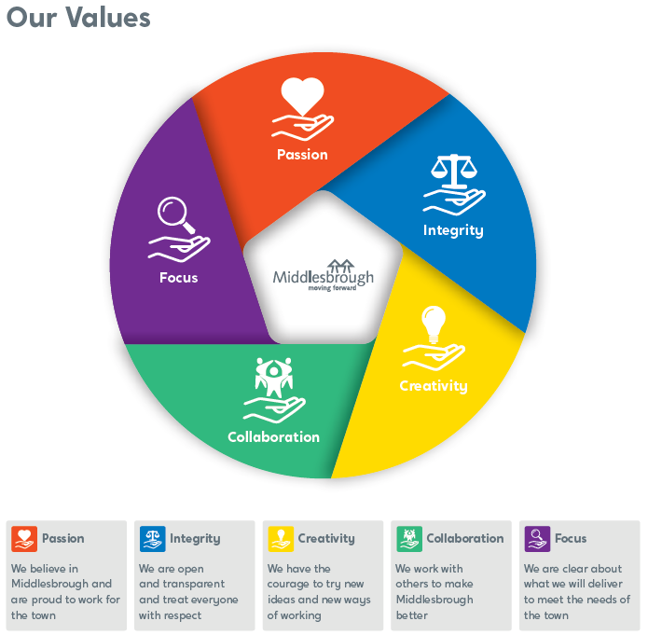

PERSON SPECIFICATION

MIDDLESBROUGH VALUES: | Essential  X | Desirable  X
Being passionate about working for Middlesbrough Council with a commitment to meeting our values.
QUALIFICATIONS:

- A recognised Social Work qualification, e.g. CQSW, CSS, Dip SW. | X
- Social Worker England registration (SW England). | X
- Must have Full UK Driving License and use of car with business insurance. | X
KNOWLEDGE & EXPERIENCE:

- Evidence of practical experience with service users. | X
- Knowledge and experience of working with looked after children and care leavers. |  | X
- Ability to acquire and implement relevant knowledge. | X
- Effective inter-personal skills (written and verbal). | X
- Sound organisational skills. | X
- Ability to develop plans and implement care packages. | X
- Ability to work purposefully in partnership with service users and their families/carers. | X
- Ability to undertake assessment of Service users and carers. | X
- Able to acquire and implement relevant knowledge. | X
- Able to work as a member of a team. | X
- Able to liaise effectively with external agencies. | X
- Able to respond to regular supervision and support. | X
- Understand lines of accountability. | X
- Understanding of Departmental policies and procedures, including the Equal Opportunities policy. | X
- Knowledge of looked after children and care leavers. |  | X
- Knowledge of the legislation relevant to looked after children and care leavers. |  | X
- Evidence of practical experience with looked after children and or care leavers. |  | X
- The potential to develop new skills. |  | X

