Durham County Council

Apprenticeship Information Pack

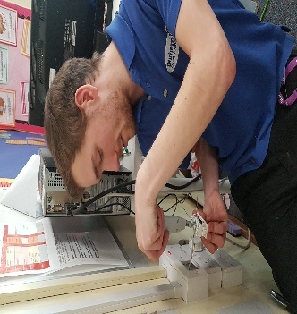
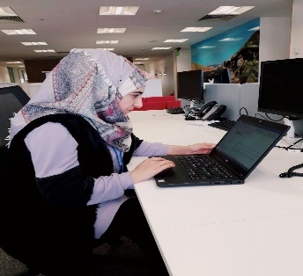

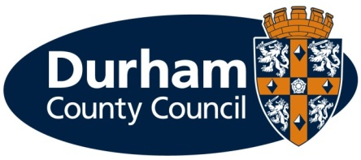
What is an apprenticeship?

Apprenticeships are an excellent option for all ages. An apprenticeship is a genuine job where you will receive formal training to gain a recognised qualification alongside gaining technical knowledge, practical experience and wider skills you need for employment and a future career.

What types of apprenticeships are available?

We currently have several Business Administration vacancies based in the Payment Income and Support and Assessment and Awards teams, which provide key front line council functions to residents and businesses throughout the county.

Later in this information pack we provide you with an overview about what each team does. If you are successful for an interview, we will ask you if you have a preference over which team you are based in. More general information about the Council and the work we do is available on the Councils website www.durham.gov.uk

Durham County Council provides the majority of local council services in the county. The council offers a huge range of job opportunities and a wide range of apprenticeships are also available including catering, accounting, construction and business administration to name a few. We have the career to meet your aspirations. Further information on the council’s services can be found on our website at www.durham.gov.uk

We are pleased to be offering the following apprenticeships for an April 2020 start:

Service Area | Apprenticeship | Length of Apprenticeship | Location | Training | Training Provider
Collections | 1 x Apprentice (Business Administration) | 2 years | Green Lane Council Offices Spennymoor | Business Administration Level 3 | Durham County Council Adult Learning and Skills Service
Debtors (Adult Social Care) | 1 x Apprentice (Business Administration) | 2 years | Green Lane Council Offices Spennymoor | Business Administration Level 3 | Durham County Council Adult Learning and Skills Service
Financial Services | 1 x Apprentice (Business Administration) | 2 years | Green Lane Council Offices Spennymoor | Business Administration Level 3 | Durham County Council Adult Learning and Skills Service

What are the different levels of apprenticeship on offer?

Durham County Council offers apprentices at different levels, which depends on your existing qualifications and experience. The 3 apprenticeships that are currently available require that you study towards an Advanced level (Level 3) – equivalent to two A level passes.

How much will I earn?

This will depend on the type of apprenticeship you are doing.

If you are working towards a Level 2, 3 or 4 qualification during the term of your apprenticeship (excluding craft apprenticeships) you will be paid:

- £4.15 per hour for the first year of your apprenticeship
- If you are aged 19 years or over and have completed the first year of your apprenticeship you will then be paid:
  - 19 to 20 year old £6.45 per hour
  - 21 to 24 year old £8.20 per hour
  - 25+ years £8.72 per hour
(Rates effective from 1 April 2020)

You will be paid on the last working day of each month, with the money paid directly into your bank account.

Your apprenticeship training will be fully funded by the council.

What should I expect from an apprenticeship at the council?

- A workplace induction to help you understand your role and the council
- A structured work programme working alongside experienced employees
- Ability to study towards a recognised qualification
- Regular review meetings with your manager
- A workplace mentor
- Opportunities to undertake work based and off the job training
- Access to a range of training opportunities
- Support to help you apply for jobs
- To be part of an Apprenticeship Network where you will receive updates of what is happening across the council including any training or job opportunities available, build a network of support, be able to discuss support/information required and put forward ideas for improvements.
- Working in an environment that promotes an inclusive and diverse workforce.

What are the additional benefits of working for the council?

- Holiday entitlement
- Pension
- A range of flexible working options, some depending on job role
- Maternity, paternity, dependency and adoption leave
- Sickness pay

How do I apply?

If you are not already registered you will need to register with North East Recruitment Portal and apply online at https://www.northeastjobs.org.uk/default.aspx?page=orghome&orgid=73 Click on the apprenticeship job category to see the opportunities available.

If you require any reasonable adjustments at the application or selection stage, please contact Peter Brockman, Senior Resources and Development Officer (Organisational Workforce Development Team) on Tel: 03000 268 547 or via email (peter.brockman@durham.gov.uk)

Key dates

Applications | Online applications close on 15 March 2020
Shortlisting | Takes place w/c 16 March 2020
Interviews | Take place w/c 23 March 2020

If you are shortlisted you will receive notification of the date and time of your interview via an e-mail from North East Recruitment Portal.

Additional Support

As a disability confident employer, we welcome applications from people with disabilities and as an inclusive employer we recognise the importance and benefits of having an inclusive and diverse workforce. To ensure we can offer the best possible support for applicants, we will pro-actively make reasonable adjustments within the recruitment and selection process for disabled people.

The range of reasonable adjustments that can be accommodated throughout the selection process include (but is not exhaustive):

- Alternative formats for job applications
- More detailed/pictorial instructions for interview
- Support from an appropriate person at the interview
- Additional time to complete applications (and or tests) where appropriate.
- Adjustments to interview venue/accommodation
- Adjustments to method of testing
- Adjustments to interview questions e.g. receiving questions in advance

Please contact Peter Brockman, Senior Resources and Development Officer, Organisational Workforce Development Team on Tel: 03000 268 547 or via email (peter.brockman@durham.gov.uk) to discuss any reasonable adjustments in more detail. This will ensure you get the appropriate support during the recruitment and selection process.

In addition to reasonable adjustments, the council also provide a ‘guaranteed interview scheme’ which allows people with disabilities to be shortlisted where they demonstrate they can meet the essential criteria of the role.

What happens if I am unsuccessful?

If you have been unsuccessful with your application to a role at Durham County Council, we would like to support you as much as possible with reviewing your options. Therefore;

- If you are unemployed and between 18-24 live in County Durham and would like support with education or training, please e-mail: durhamworks@durham.gov.uk or telephone: 0300 026 2930 for further information, support, advice and guidance.

- If you are 19 years of age and older you can also access support, information, advice and guidance or access accredited qualifications on a formal or flexible basis through our Adult Learning and Skills Service (ALSS). From more information or to speak to one of our engagement team, please contact us by emailing alss@durham.gov.uk or telephone: 03000 266 115.

There are no restrictions, in terms of accessing these services, and we would treat each enquiry on an individual basis.

We look forward to hearing from you.

Overview of the service area:
Payment Income and Support and Assessments and Awards

Payment Income and Support and Assessments and Awards are both part of the wider Finance & transactional Services team within Durham County Council.

The teams have over 300 employees, covering a wide range of front line council functions, and we are mainly based at the offices at Green Lane, Spennymoor.

We provide services to all residents and businesses throughout the county and many of the clients supported are vulnerable. There are currently approximately 60,000 housing benefit/council tax reduction claimants, 244,000 council tax households, 15,000 business rates payers and 7,000 adult social care charge paying clients supported by the service.

We currently have Business Administration apprentice vacancies located in the following teams within our service;

Collections – working in a busy customer facing team responsible for the collection and recovery of council tax and business rates. Council tax and business rates are used to pay for essential services across the county and this team ensures that prompt action is taken to recover any outstanding taxes, whilst taking into account an individual’s circumstances.

Debtors – dealing with adult social care debt, this team has two very distinct areas that it deals with. Adjusting invoices in respect of adult social care and associated queries, and also in recovery adult social care debt where service users have failed to make full payment of their invoices.

Financial Services – this team is responsible for managing and administering the financial assessment process for Children and Adult Services. The team strive to provide a customer focussed service by engaging with service users, families, carers and representatives through partnership working with key stakeholders.

