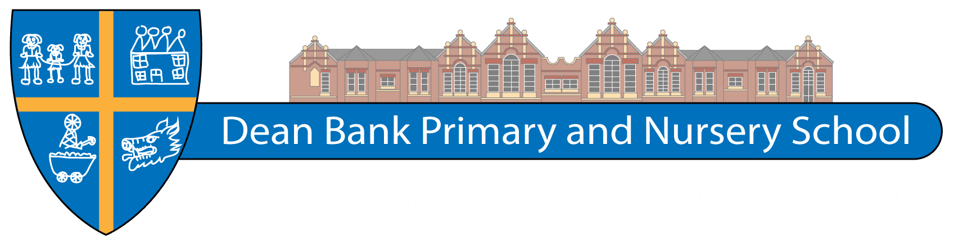
Believe, Achieve, Soar with Pride
Dean Bank, Ferryhill,
Co. Durham DL17 8PP
Telephone: 01740 651 512

E-mail: deanbank@durhamlearning.net
Website: www.deanbank.durham.sch.uk

Head Teacher: Mrs P Northcott
Acting Deputy Head Teacher Mr W Haynes
Chair of Governors: Mr D Regan

EYFS TEACHER

Salary: Main Scale
Hours: 1265 hours
Contractual Status: Temporary position for one year to cover Maternity Leave

Required from September 1st 2021

As part of our continuous drive to provide the very best opportunities we can for our children, we are seeking to appoint an enthusiastic, committed and highly motivated Teacher to join our friendly and hardworking team, who can support children’s learning in EYFS
- embrace and uphold the vision and caring, nurturing ethos of our school;
- be able to deliver high quality learning experiences for all pupils;
- have high expectations of learning and behaviour and inspire and motivate our children;
- be supportive, nurturing and understanding;
- seek to make learning exciting and a positive experience;
- be able to communicate sensitively with parents/carers;
- have a desire to be involved in all aspects of school life.

In return we will offer:-

  - a happy and forward moving school with a positive ethos;
  - pupils who are eager to learn and are a credit to the school;
  - the support of committed, enthusiastic and dedicated colleagues;
  - a supportive and challenging environment;

Application packs are available and should be e-mailed back to school at the above address.

Dean Bank Primary School is committed to safeguarding and promoting the welfare of children and young people and expects all staff and volunteers to share this commitment. Safer recruitment practice and pre-employment checks will be undertaken before any appointment is confirmed. This post is subject to an enhanced Disclosure and Barring Service (DBS) check.

Closing date: Thursday 20th May 2021.
Shortlisting: Friday 21st May 2021
Interview date: Thursday 27th May 2021.

