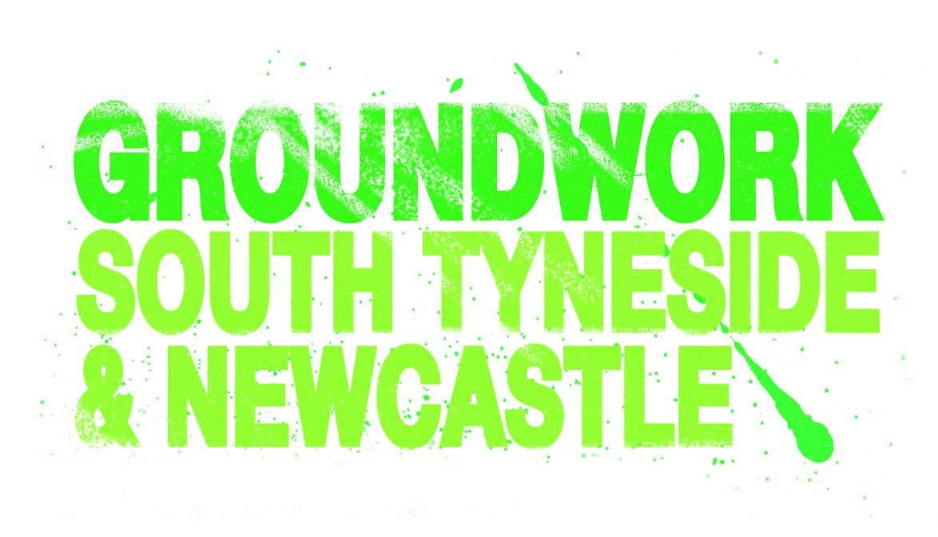

PERSON SPECIFICATION
PROJECT OFFICER LEARNING & STANDARDS (SEN)

 | ESSENTIAL | DESIRABLE
Education / Qualifications | - PTTLS / QTTLS / DTLLS or equivalent.  - SEN Specialism.  - Minimum of Level 2 literacy and numeracy. | - Level 3 Management or equivalent.  - IAG Level2/3  - Prevent Level 2  - Safeguarding Level 2  - Internal Verifier qualification  - Mini bus driver qualification  - Functional Skills Specialism
Knowledge/  Experience | - Recent delivery of funded education/skills/learning provision.  - Understanding and practical experience of the OFSTED and MATRIX frameworks.  - Knowledge of government education policy, funding and how to implement performance and standard measures to meet all areas.  - Knowledge of current issues in Further and Higher Education.  - Proven track record of tackling poor performers and making appropriate interventions.  - Experience/proven track record of successfully managing, leading and improving a team.  - Engagement and networking with local providers to engage learners onto programme.  - Evidence of continued professional development.  - Managing projects/programmes. | - Teaching experience of post 16 education including SEN.  - A full understanding, in-depth knowledge and experience of the Ofsted and Matrix inspection processes.  - Delivery of functional skills.  - Safeguarding of children and adults at risk.  - Prevent strategies.  - Experience of H&S systems including risk management.  - Experience of European funded contracts and reporting mechanisms.  - Use of a range of software linked to recording and reporting.  - Improving soft skills outcomes.
Competencies/ Skills | - Strong leadership and management skills.  - Excellent communicator both verbal and written.  - Excellent oral and written presentation skills.  - Excellent analytical, report writing and IT skills.  - Excellent organisational skills, time management and prioritisation  - Innovative and proactive to the development of relevant provision.  - Ability to work with teams and individuals to improve performance and standards.  - Tenacity, flexibility and the ability to work calmly under pressure.  - Suitable to work with young people and vulnerable adults.  - Ability to manage complexity and diversity  - Personal and professional integrity  - Confidence to work alone and show initiative. | - Effective networking skills.  - Ability to work in collaboration with partner organisations, the community and other stakeholders  - The ability to think and work commercially whilst meeting the charitable aims of the organisation.
Values and Attitudes | - Flexible according to the needs of the business.  - Sense of humour.  - Equal opportunities for all staff, volunteers and clients or participants.  - Smart and professional appearance.  - Confident.  - Enthusiastic and positive.
Additional Requirements | - Committed to the ethos of Groundwork and its practices.  - Commitment to Health and Safety, Safeguarding and Prevent processes.
PREPARED BY: | CW 13/08/18

