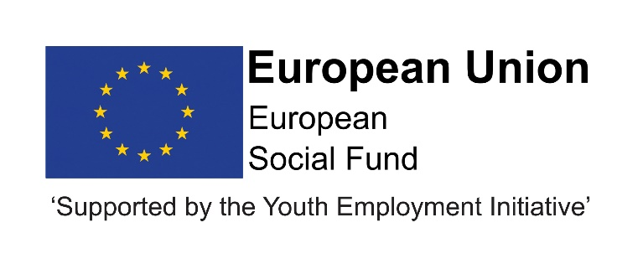
Job Description
Post title | Contract Officer
JE Reference No | N9074
Grade | Grade 9
Service | Children and Young People’s Services
Service Area | Education and Skills; Progression and Skills
Reporting to | The post holder will be responsible to the External Delivery Coordinator within the Adult Learning and Skills Service. The Contract Officer will establish positive working relationships with a wide range of partners and stakeholders.
Location | Your normal place of work will be Civic Centre, Crook, but you may be required to work at any Council workplace within County Durham.
DBS | This post is not subject to a disclosure.
Flexitime | This post is eligible for flexitime.
Politically restricted | This post is not designated as a politically restricted post in accordance with the requirements of Section 1(5) of the Local Government and Housing Act 1989 and by regulations made from time to time by the Secretary of State.
Relevant to this post | Subject to approval, 0.8 FTE of this post is part-funded through ESF and the Youth Employment Initiative (YEI) as part of the 2014-2020 European Structural and Investment Funds Growth Programme in England. The YEI/ESF funding will end in July 2021.

Description of role

The Youth Employment Initiative (YEI) is an EU funded programme to help unemployed 16-24 year olds improve their skills and move into employment, training or education. The post holder will be an experienced contract officer who will play a key role in the efficient and effective delivery of YEI and other externally funded programmes which the Adult Learning and Skills Service delivers.

Duties and responsibilities

Listed below are the responsibilities this role will be primarily responsible for:

- Working with a wide range of YEI Delivery Partners in County Durham to ensure the delivery of provision meets the needs of young people and adults in the County,

- Managing the performance of YEI Delivery Partners and subcontractors, ensuring targets are met to include:

- Developing excellent working relationships with YEI Delivery Partners, sub-contractors, internal colleagues and funding bodies,

- Engaging with appropriate groupings of YEI Delivery Partners/sub-contractors,

- Managing the contracting of service level agreements with YEI Delivery Partners,

- Managing contracting with sub-contractors,

- Ensuring appropriate and accurate data collection, recording and monitoring,

- Ensuring resources are maximised and financial claims are compiled and submitted within deadlines,

- Preparing and presenting reports on progress,

- Supporting YEI Delivery Partners/sub-contractors to develop their capacity and expertise to ensure the successful delivery of provision,

- Identifying and sharing best practice,

- Supporting the identification and delivery of new opportunities to support the objectives of the YEI programme.

The above is not exhaustive and the post holder will be expected to undertake any duties which may reasonably fall within the level of responsibility and the competence of the post as directed by the Head of Service.

Organisational responsibilities

- Values and behaviours
To demonstrate and be a role model for the council’s values and behaviours to promote and encourage positive behaviours, enhancing the quality and integrity of the services we provide.

- Smarter working, transformation and design principles
To seek new and innovative ideas to work smarter, irrespective of job role, and to be creative, innovative and empowered. Understand the operational impact of transformational change and service design principles to support new ways of working and to meet customer needs.

- Communication
To communicate effectively with our customers, managers, peers and partners and to work collaboratively to provide the best possible public service. Communication between teams, services and partner organisations is imperative in providing the best possible service to our public.

- Health, Safety and Wellbeing
To take responsibility for health, safety and wellbeing in accordance with the council’s Health and Safety policy and procedures.

- Equality and diversity
To promote a society that gives everyone an equal chance to learn, work and live, free from discrimination and prejudice and ensure our commitment is put into practice. All employees are responsible for eliminating unfair and unlawful discrimination in everything that they do.

- Confidentiality
To work in a way that does not divulge personal and/or confidential information and follow the council’s policies and procedures in relation to data protection and security of information.

- Climate Change
To contribute to our corporate responsibility in relation to climate change by considering and limiting the carbon impact of activities during the course of your work, wherever possible.

- Performance management
To promote a culture whereby performance management is ingrained and the highest of standards and performance are achieved by all. Contribute to the council’s Performance and Development Review processes to ensure continuous learning and improvement and to increase organisational performance.

- Quality assurance (for applicable posts)
To set, monitor and evaluate standards at individual, team and service level so that the highest standards of service are delivered and maintained. Use data, where appropriate, to enhance the quality of service provision and support decision making processes.

- Management and leadership (for applicable posts)
To provide vision and leadership to inspire and empower all employees so they can reach their full potential and contribute to the council’s values and behaviours. Managers and leaders must engage in personal development to ensure they are equipped to lead transformational change; always searching for better ways to do things differently to meet organisational changes and service priorities.

- Financial management (for applicable posts)
To manage a designated budget, ensuring that the service achieves value for money in all circumstances through the monitoring of expenditure and the early identification of any financial irregularity.

The above is not exhaustive and the post holder will be expected to undertake any duties which may reasonably fall within the level of responsibility and the competence of the post as directed by your manager.

Person specification
 | Essential | Desirable
Qualifications | - Level 4 qualification and/or able to demonstrate relevant experience. | - Degree or equivalent qualification.
Experience | - Range of experience in implementing successful projects to timescales and achieving targets,  - Proven track record of working with partners to effect change,  - Experience of managing externally funded programmes,  - Experience of contract management.
Skills & Knowledge | - Excellent communication skills,  - Contract management skills,  - Operation of externally funded programmes,  - Concise and accurate verbal and written reporting skills,  - Pays attention to detail,  - Able to work effectively in a team, but also capable of individual initiative,  - Excellent ICT skills including the use of Microsoft Office. | - Understanding of European grant programmes,  - Knowledge of programme management software.
Personal Qualities | - Has drive, enthusiasm and a flexible approach to work,  - Able to plan work and manage time effectively,  - Able to motivate self and others,  - Able to work effectively in a team,  - Able to carry out work with the minimum of supervision,  - Able to relate well and quickly to other team members and senior people from other organisations,  - Must be performance oriented i.e. motivated by a desire to achieve performance targets and deliver a quality service,  - Flexible approach to working across the LA geography. Acess to a car with current valid driving licence required or access to a means of mobility transport,  - Able to work under pressure, to prioritise and to meet deadlines,  - Open to change and committed to innovative development,  - Holds high aspirations for young people/young adults.

