St Mary’s RC Primary School

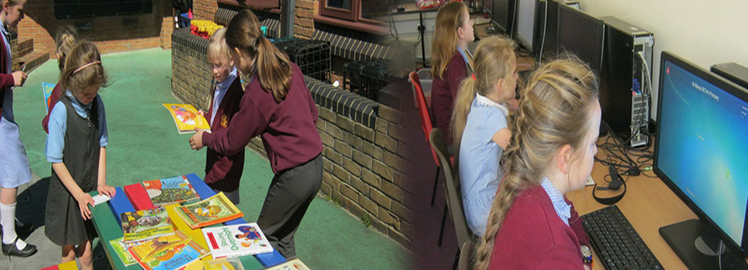

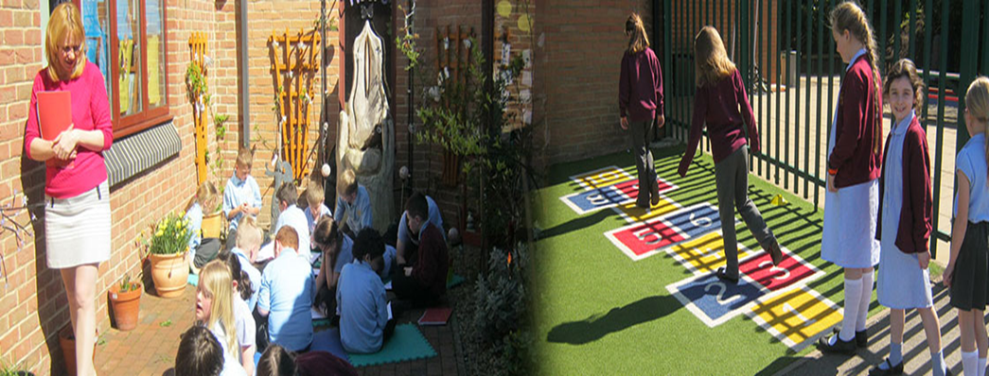

Class Teacher
Job Description

ORA BENE LABORA BENE

JOB DESCRIPTION

Job Title: | Class teacher (Reception)
Terms and Conditions: | Full-time  Maternity Leave cover until 31st December 2017 or until the postholder returns, whichever is earliest.
Location: | St Mary’s RC Primary School  Pemberton Road, Blackhill, Consett, County Durham, DH8 8JD
Salary: | Main pay scale range 1 – 6 £22,467 - £32,834 pro rata in line with the current Whole School Pay Policy and Teachers’ Pay and Conditions Document
Responsible To: | Headteacher & Deputy Headteacher
Supervisory Responsibility: | The post holder may be responsible for the deployment and supervision of the work of teaching assistants relevant to their responsibilities

Job Purpose:
- Be responsible for the learning and achievement of all pupils in the class ensuring equality of opportunity for all.
- Be responsible and accountable for achieving the highest possible standards in work and conduct.
- Treat pupils with dignity, building relationships rooted in mutual respect, and at all times observing proper boundaries appropriate to a teacher’s professional position.
- Work proactively and effectively in collaboration and partnership with learners, parents/carers, governors, other staff and external agencies in the best interests of pupils.
- Act within, the statutory frameworks, which set out their professional duties and responsibilities and in line with the duties outlined in the current School Teachers Pay and Conditions document and Teacher Standards (2012).
- Take responsibility for promoting and safeguarding the welfare of children and young people within the school.

Main Responsibilities:
All teachers are required to carry out the duties of a schoolteacher as set out in the current School Teachers Pay and Conditions document. Teachers should also have due regard to the Teacher Standards (2012). Teachers’ performance will be assessed against the teacher standards as part of the appraisal process as relevant to their role in the school.

Teaching:
- Deliver the curriculum as relevant to the age and ability group/subject/s that you teach.
- Be responsible for the preparation and development of teaching materials, teaching programmes and pastoral arrangements as appropriate.
- Be accountable for the attainment, progress and outcomes of pupils’ you teach.
- Be aware of pupils’ capabilities, their prior knowledge and plan teaching and differentiate appropriately to build on these, demonstrating knowledge and understanding of how pupils learn.
- Have a clear understanding of the needs of all pupils, including those with special educational needs; gifted and talented; EAL; disabilities; and be able to use and evaluate distinctive teaching approaches to engage and support them.
- Demonstrate an understanding of and take responsibility for promoting high standards of literacy including the correct use of spoken English (whatever your specialist subject).
- If teaching early reading, demonstrate a clear understanding of appropriate teaching strategies e.g. systematic synthetic phonics.
- Use an appropriate range of observation, assessment, monitoring and recording strategies as a basis for setting challenging learning objectives for pupils of all backgrounds, abilities and dispositions, monitoring learners’ progress and levels of attainment.
- Make accurate and productive use of assessment to secure pupils’ progress.
- Give pupils regular feedback, both orally and through accurate marking, and encourage pupils to respond to the feedback, reflect on progress, their emerging needs and to take responsible and conscientious attitude to their own work and study.
- Use relevant data to monitor progress, set targets, and plan subsequent lessons.
- Set homework and plan other out-of-class activities to consolidate and extend the knowledge and understanding pupils have acquired as appropriate.
- Participate in arrangements for examinations and assessments within the remit of the School Teachers’ Pay and Conditions Document.

Behaviour and Safety:
- Establish a safe, purposeful and stimulating environment for pupils rooted in mutual respect and establish a framework for discipline with a range of strategies, using praise, sanctions and rewards consistently as set out in the school’s Behaviour Management Policy.
- Manage classes effectively, using approaches, which are appropriate to pupils’ needs in order to inspire, motivate and challenge pupils.
- Maintain good relationships with pupils, exercise appropriate authority, and act decisively when necessary.
- Be a positive role model and demonstrate consistently the positive attitudes, values and behaviour, which are expected of pupils.
- Have high expectations of behaviour, promoting self-control and independence of all learners.
- Carry out playground and other duties as directed and within the remit of the current School Teachers’ Pay and Conditions document.
- Be responsible for promoting and safeguarding the welfare of children and young people within the school, raising any concerns following school protocol/procedures.

Team working and collaboration:
- Participate in any relevant meetings/professional development opportunities at the school, which relate to the learners, curriculum or organisation of the school including pastoral arrangements and assemblies.
- Work as a team member and identify opportunities for working with colleagues and sharing the development of effective practice with them.
- Contribute to the professional development of other teachers and support staff where appropriate, including the induction and assessment of new teachers, teachers serving induction periods etc.
- Ensure that colleagues working with you are appropriately involved in supporting learning and understand the roles they are expected to fulfil.
- Take part as required in the review, development and management of the activities relating to the curriculum, organisation and pastoral functions of the school.
- Cover for absent colleagues within the remit of the current School Teachers’ Pay and Conditions document.

Fulfil wider professional responsibilities:
- Work collaboratively with others to develop effective professional relationships.
- Deploy support staff effectively as appropriate.
- Communicate effectively with parents/carers with regard to pupils’ achievements and wellbeing using school systems/processes as appropriate.
- Communicate and co-operate with relevant external bodies.
- Make a positive contribution to the wider life and ethos of the school.

Administration
- Register the attendance of and supervise learners, before, during or after school sessions as appropriate.
- Participate in and carry out any administrative and organisational tasks within the remit of the current School Teachers’ Pay and Conditions document.

Professional development:
- Regularly review the effectiveness of your teaching and assessment procedures and its impact on pupils’ progress attainment and well-being, refining your approaches where necessary responding to advice and feedback from colleagues.
- Be responsible for improving your teaching through participating fully in training and development opportunities identified by the school or as developed as an outcome of your appraisal.
- Proactively participate with arrangements made in accordance with the Appraisal Regulations 2012.

Other:
- To have professional regard for the ethos, policies and practices of the school in which you teach, and maintain high standards in your own attendance and punctuality.
- Perform any reasonable duties as requested by the Headteacher.

