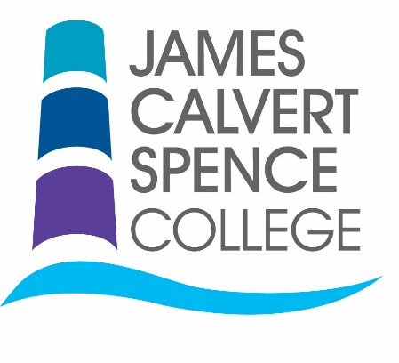

June 2017

Dear Applicant,

Thank you for your interest in this key position for our federation.

James Calvert Spence College is an improving school, with GCSE and A-Level results showing an upward trend of improvement. We serve our young people from Early Years through to Sixth Form with our federation of two schools – JCSC, which is a 9-18 through school and Acklington Church of England First School. I took up post in January 2016 and am proud to lead the federation – it’s a fantastic place to work, with friendly, happy students and committed staff.

Due to the relocation of the current postholder, an exciting opportunity has arisen for a talented and determined Director of English. You will be responsible for the curriculum, standards of teaching & learning and outcomes in the English department for years 7-13.

You would inherit a settled, committed and enthusiastic team of 4 full time English teachers who deliver KS3, GCSE and A-levels in Language and Literature to our students.

Each of our seven Directors are members of the SLT and are key players in ensuring that our vision and values permeate everything that happens across our sites. We invest in our leaders, and you will be provided with support and CPD, both internally and externally to ensure you reach your full potential, and are ready to move to the next stage of your career in due course.

I am looking for someone who is an excellent teacher, who has a depth of knowledge and understanding of the English curriculum, who understands the changes to assessment and testing, and who can work as part of a team to make a real difference to the lives of our students.

I hope that, after reading the information on offer and visiting our website at www.jcsc.co.uk, you feel compelled to apply for the post. To do so, please complete the application form and return it with a letter of application that demonstrates your suitability for this role, paying close attention to criteria in the person specification.

Application packs can be downloaded from our website and completed applications should be emailed to chutchinson01@jcsc.co.uk.

If you would like more details, or to have an informal conversation about this opportunity, please don’t hesitate to contact me at nrodgers01@jcsc.co.uk.
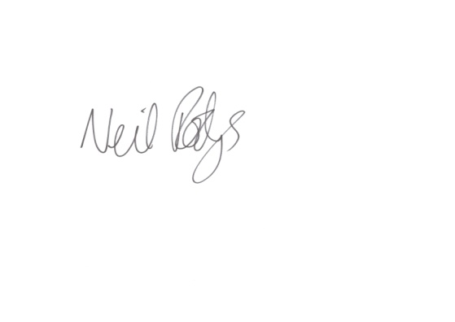

Yours faithfully,

Neil Rodgers

Executive Headteacher

