On-call Firefighter

Application Information Pack

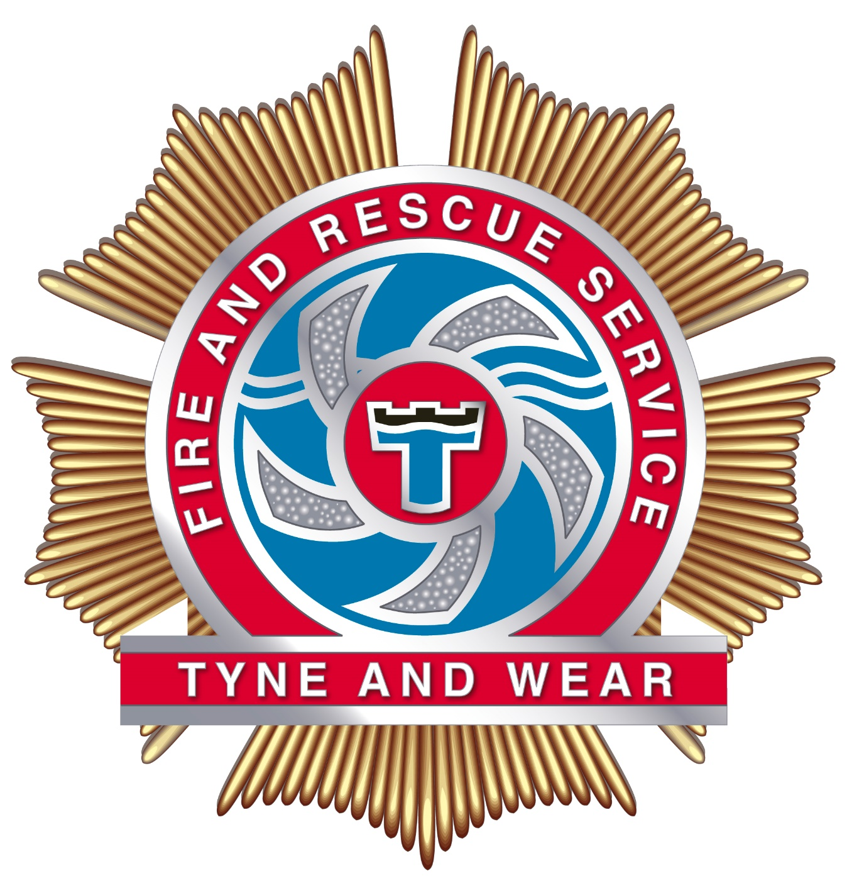

Contents

Introduction Page 3

Our area Page 4

About us Page 5

Could you be an On-call Firefighter? Page 6

Job description Page 7-10

Rates of pay Page 11

Pre-application information Page 12 – 14

Do you really want to be an On-call Firefighter? Page 15

On-call Firefighter recruitment process Page 16 – 22

Introduction
Tyne and Wear Fire and Rescue Service (TWFRS) is pleased to invite applications for On-call Firefighters to join us in this challenging and highly rewarding career. TWFRS successfully leads the operational delivery of services such as public protection, fire and other emergency prevention, operational response and resilience.
Creating the safest community through our shared mission ‘to save life, reduce risk, provide humanitarian service and protect the environment’ is the primary focus for our service.
Our communities value the services we offer and need to feel confident in the highly skilled teams we have, reducing risk as well as dealing with emergency situations. We are continually evolving and improving how we operate, whilst maintaining the highest standards.
If you feel that you have what it takes, we invite you to join our recruitment process.

This document has been created to provide you with details of each stage of the recruitment process for the role of On-call Firefighter. It is important that you are aware of how you will be assessed and what to expect at each stage. All details that you need to apply are provided in this document.

If you have any queries prior to the recruitment process please email:-recruitement@twfire.gov.uk

Members of the Human Resources Team will be available at the Open Day at Chopwell Community Fire Station on Saturday 25 May 2019, between 10am and 2pm to answer any questions you may have about completing your application or to discuss the role. There will also be on-call firefighters on site who you could speak to.

Our area

Tyne and Wear borders Northumberland to the north and Durham to the south and is a densely populated metropolitan area. Our stations, staff and appliances are strategically placed across Tyne and Wear to ensure efficient and effective response to fires and other emergencies. We have 17 community fire stations operating a variety of duty/shift systems. The deployment of operational resources is reviewed constantly using community risk and incident data to inform decisions.

The map below shows where our stations are located throughout the service area.

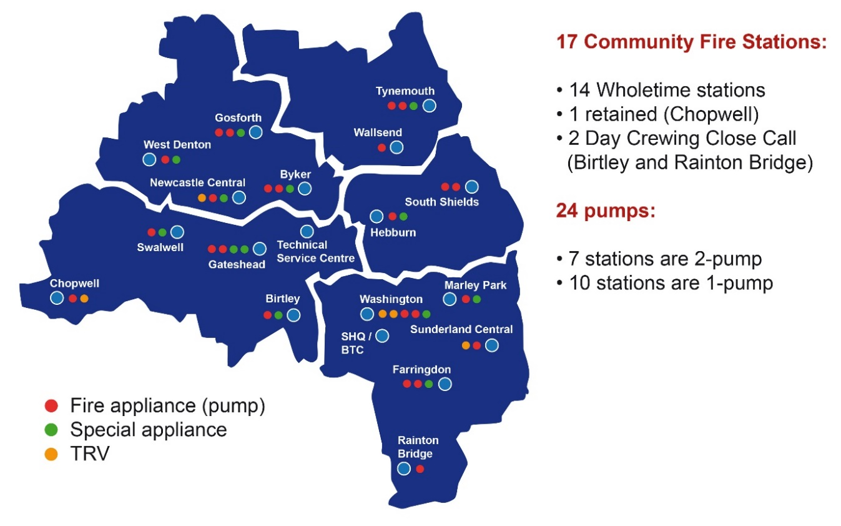

About us

TWFRS are here to make the communities within our area a safer place to live, work and visit. Our Service is accountable to the Combined Fire Authority which is comprised of locally elected councilors who are members of the authority.

TWFRS serves a population of 1.104 million, boosted by 290,000 visitors and a substantial international student population of over 60,000 at our three universities.

All 999 calls are received by our control room at Service Headquarters at Barmston Mere. Fire engines are then mobilised from 17 fire stations across the Service area. All appliances are equipped with state-of-the-art rescue equipment and there is also a fleet of specialist appliances, which are used during road traffic collisions, water rescues and other specialist rescues. Firefighters are trained and ready to respond to a range of emergencies, not just fire. These include road, rail or air crashes, flood, animal rescues, chemical spills and even terrorist attacks.

Could you be an On-call firefighter?

You need to be over 18, live within five minutes of Chopwell Community Fire Station and be able to respond at a moment’s notice. Instead of being based at the fire station, you are called out to respond to incidents when alerted. On-call Firefighters come from every walk of life and no previous experience is required due to the comprehensive training program you will undertake.

All On-call Firefighters attend a drill night every Wednesday to take part in training exercises and carry out equipment maintenance. Many On-call Firefighters also spend time working in their local communities to help reduce the risk of fires and incidents by attending local events and performing safe and wellbeing checks.

Our On-call Firefighters commit to a minimum of 90 hours per week on-call. You won’t spend all this time working - it’s just the time you’re available for us to call you if there’s an incident. You can choose when you want to provide cover daytime, evening, weekends or a combination of the three, provided this fits in with the station staffing requirements.

Although it sounds like a big commitment many people successfully balance their On-call Firefighter duties with another job. Some are self-employed whilst others have permission from their employer to leave work for short periods during the daytime if necessary.

Firefighting is not like any other job. It can be unpredictable, exciting and rewarding, coupled with the satisfaction and respect that comes with providing a crucial service to your local community. You will learn new skills along the way such as first aid, road traffic collision procedures and fire safety.

Job description

Role: Firefighter

Location:

Chopwell Community Fire Station

Duties and responsibilities:

1. Inform and educate the community improving awareness of safety matters:

- To respond to direct requests for safety information, attend special events or leaflet drops both at your normal workplace and out in the community.
- To participate either unsupervised or as a member of team at community events organised by the organisation or community groups as directed.
- To deliver safety education/messages to target groups in the community and those attending your work location.
- To help educate members of the community in the risks and hazards of fire and attending evening or weekend events within the relevant duty system as appropriate.
- To assist in service initiatives, programmes and strategies to reduce fire calls and support the delivery of national and regional community safety campaigns and organisational aims and objectives.
- To assist learning and promote understanding of safety matters through demonstration of fire safety, first-aid fire fighting, calling Emergency Services and fire survival methods.
- To assist the organisation in raising the role and profile of the Fire Service in the community.
- To facilitate events in both formal and informal activities with the local community.
- To assist in the design, delivery and evaluation of community safety campaigns to the community.

Save and preserve endangered life:

- To attend operational incidents.
- To conduct a search to locate life involved in incidents.
- To rescue life involved in incidents.
- To provide treatment to casualties.
- To deal with emergencies as directed and work effectively and efficiently as a member of a disciplined team and supporting people involved in rescue operations.

Resolve operational incidents:

- To control and extinguish fires.
- To resolve incidents other than those involving a fire or hazardous materials.
- To support people involved in an operational incident.
- To drive, manoeuvre and redeploy fire service vehicles, as appropriate.
- To respond immediately and safely to all emergency calls and requests for assistance.
- To check firefighting resources provided for Fire Service use including hydrants and fixed installations as directed.

4. Take responsibility for effective performance:

- To be proactively involved in taking responsibility for your performance ensuring your own health and fitness for work in line with your organisation’s Occupational Health Policy.
- To maintain personal appearance, hygiene and cleanliness of uniform in keeping with a disciplined service.
- To be committed to and involved in developing and maintaining proactive working relationships with colleagues, team members, line managers and external contacts.
- To ensure compliance with fairness, equality and diversity legislation and the Authorities existing Fairness and Equality Policy in all aspects of the working environment.
- To actively promote diversity and equality in the workplace.
- To recognise health and safety issues at work and deal with them to minimise or eliminate the degree of hazard of risk.

- Develop own skills and improve your performance in accordance with the Service IPDS training procedure:

- To be personally involved in and committed to continually improving your performance through self-assessment and proactive action to resolve your development needs.
- To be actively involved in de-briefs and performance reviews and use of your Personal Development Record to maintain competency levels appropriate to role.
- To undertake training as necessary in accordance with the Integrated Personal Development System.
- To take part in a continuous training programme by attending lectures, exercises, practice drill sessions and other forms of training to maintain competence levels.
- To attend development training courses as directed.

Support effectiveness of operational response:

- To collect and disseminate information on risks in your community.
- To collect and disseminate information on resources in your community and have knowledge of local streets, roads and buildings situated within the station area.
- To maintain internal resources.
- To assist with the co-ordination and operation of the relevant station, including administrative and clerical duties as directed.
- To serve at any location under any duty system as directed by the Chief Fire Officer.
- To complete routine administration including the accurate recording of information as directed.
- To use information technology as required and in accordance with the Data Protection Act 1998.
- To maintain all firefighting and emergency equipment in a state of readiness including cleaning, repairing and testing as directed and to approved standards and procedures.

Support the development of colleagues in the workplace:

- To communicate your own skills and knowledge to colleagues possessing the ability to pass on your skills and knowledge at key opportunities, in order to assist colleagues to improve their understanding and performance. This includes opportunities that arise from normal work activities and during debriefs and performance reviews.
- To actively and proactively provide support to colleagues, taking opportunities to assist with the development of skills and competence through demonstration and instruction. This may apply to new colleagues and to existing colleagues who are in a new working situation or demand.

Protect the environment from the effects of hazardous materials:

- To mitigate damage to the environment from hazardous materials.
- To decontaminate people and property affected by hazardous materials.
- To support people involved in hazardous materials incidents.

9 Contribute to fire safety solutions to minimise risks to your community:

- To inspect premises to minimise risks to people, property and the environment;
- To report on issues arising at inspection.
- To prepare and produce written and verbal reports on inspections. Reports will be in the agreed format and produced to specified deadlines.
- To react to the inspection process by providing solutions to an identified risk within a domestic or commercial environment (undertaken after necessary training and development).

10 ROLE SPECIFIC RESPONSIBILITIES

  - To undertake such other duties commensurate with the level of responsibility and expertise as may be required by the Chief Fire Officer from time to time.

  - To assist with the co-ordination and operation of the relevant station, including administrative and clerical duties as directed.

  - To serve at any location under any duty system as directed by the Chief Fire Officer.

  - To complete routine administration including the accurate recording of information as directed.

  - To ensure compliance with the Data Protection Act 1998 and ensure data security is maintained.

  - To maintain all firefighting and emergency equipment in a state of readiness including cleaning, repairing and testing as directed and to approved standards and procedures.

  - To check firefighting resources provided for Fire Service use including hydrants and fixed installations as directed.

  - To recognise health and safety issues at work and deal with them to minimise or eliminate the degree of hazard of risk;

  - To ensure personal safety and that of others at all times.

11 HEALTH AND SAFETY (GENERAL POLICY)

11.1 By reference to current health and safety legislation and the Service’s Health and Safety Policy to ensure that:-

- A safe place of work is maintained by the establishment and continuance of health and safety inspections of premises and equipment;

- All accidents involving personnel and/or equipment are investigated and reported in line with prescribed principles.

- All health and safety defects are reported as appropriate.

12 DIVERSITY AND EQUALITY (GENERAL POLICY)

12.1 To champion a sustainable improvement in equality practice at a corporate and departmental level.

12.2 To ensure a clear understanding, commitment to and responsibility for diversity and equality as detailed in the Authority’s Strategic Plan and Diversity and Equality Policy.

12.3 To ensure the positive promotion of diversity and equality throughout the Fire and Rescue Service particularly in terms of service delivery.

12.4 To be responsible for managing Diversity and Equality Policies through leadership and a positive attitude to secure continuous improvement in organisational culture.

13 SAFEGUARDING CHILDREN AND VULNERABLE PERSONS

13.1 To promote the application of the Authority’s Safeguarding Policies.

14 ENVIRONMENT STRATEGY

14.1 To demonstrate an understanding and commitment to the Service’s Environment Strategy, in relation to the environment and carbon reduction policies.

Rates of pay

As an On-call Firefighter you receive an annual retaining payment, plus hourly rates and disturbance fees (paid when attending incidents).

Firefighter | Full annual retainer (based on 120 hours availability i.e. 100%) | Hourly rate | Disturbance payment per call out
Trainee | £2,291 | £10.46 | £4.02
Development | £2,386 | £10.90 | £4.02
Competent | £3,053 | £13.94 | £4.02

The retaining fee is paid quarterly.

On-call Firefighters are paid an hourly rate of pay for attending the following:
- Drill Night
- Turnout
- Training Course
- Community safety
- Standard tests

Pre-application information

Age
Applicants must be 18 years of age or over at the commencement of training. Your date of birth is verified as part of the process.

Work permit
As an employer, the Fire Authority is subject to the provisions of the Asylum and Immigration Act 1996. It could be guilty of committing a criminal offence if it employed someone who does not have permission to be in or to work in the United Kingdom. The Fire Authority reserves the right therefore to request relevant documentation from all those offered employment to satisfy its obligations in this respect. For more information, you may find the following immigration advice website useful: www.workpermit.com or www.ukba.homeoffice.gov.uk.

Identification
As an employer, we need to ensure all prospective employees have the right to work in the United Kingdom. You will be asked to bring some form of photographic identification e.g. passport, driving license, any other relevant documentation and a work permit if applicable with you at the interview stage of the recruitment process so your identification can be verified. Please visit www.ukba.homeoffice.gov.uk for more information on prevention of illegal working.

Driving
A driving licence is not a requirement for the role. However, If you hold a driving licence you must inform us if your licence is endorsed, giving details to the nature of the offence, offence code (e.g. CD10 driving without due care and attention) and give details of the penalty (e.g. £ fine and number of penalty points). If you have had to attend court you will need to provide details of the outcome.

Diversity monitoring
This helps us ensure we are as accessible as possible to all groups in the community. The data is held in accordance with the Data Protection Act and is not used to assist or make selection decisions. It will be used for statistical analysis only.

Medical standards
Fire and Rescue Authorities are required to assess each applicant on an individual basis with regard to their suitability to perform the role of a fire-fighter, in accordance with Equality Act legislation. This means that Fire and Rescue Authorities will consider what reasonable adjustments could be made to enable you to proceed with your application provided any such adjustments do not contravene Health and Safety legislation. Health & Safety legislation places the obligation on Fire and Rescue Authorities to ensure that individuals are safe at work for their own protection and that of others. (In the context of the Fire and Rescue Service "others" includes colleagues and members of the public).

To ensure that support is readily available, you are required to bring your specific needs to the attention of the human resources team in advance. Please email
recruitment@twfire.gov.uk

If you have any concerns regarding your eyesight we suggest that you book an appointment with your optician and take the information below:

The visual entry standards for fire-fighters are as detailed below:
- Corrected visual acuity should be 6/9 binocularly, and a minimum of 6/12 in the worse eye.
- The minimum uncorrected vision for retained firefighters should be 6/18 in the better eye and 6/24.
- Be able to read N12 at 30cm unaided with both eyes open (applicants aged 25 and over).
- Be able to read N6 at 30cm unaided with both eyes open (applicants under 25 years of age).
- Have an appropriate level of colour perception. Individuals with either normal colour vision or slightly abnormal green colour vision are suitable for appointment. If you believe you are colour blind you may wish to be formally assessed prior to submitting an application form. The minimum standard accepted is the Farnsworth D-15 standard test.

If you wear corrective visual aids please bring them with you when you attend for medical assessment. For contact lens wearers please bring spares/holders as an unaided eyesight test will be undertaken.

If you have any queries about the above please contact TWFRS Occupational Health Unit.

If you are unsure whether you meet these requirements you are advised to seek advice from a qualified optometrist.

Candidates who have undergone laser eye surgery will not be considered for an appointment to a position for a minimum of 12 months after the date of the procedure. This does not preclude anyone from joining the recruitment process.

Declaration of offences
You are required to declare any offence for which the conviction is not yet spent. Within the meaning of the Rehabilitation of Offenders Act 1974 – incorporating the Rehabilitations of Offenders Act (exemptions) 1975 and the Rehabilitation of Offenders Act 1974 (exemptions) (Amendment) Order 1996 – you are advised to declare any charge that is pending as a subsequent conviction could lead to your dismissal from the Service.

Broadly the Act provides for anyone who has ever been convicted of a criminal offence and not sentenced to more than 2.5 years in prison to become a ‘rehabilitated person’ at the end of the rehabilitation period, provided there have been no further convictions. At the end of this period, the conviction is considered spent and thus to be treated as it had never happened. There are fixed rehabilitation periods for specific offences. If you are unsure whether you must declare a previous conviction you should contact your local Probation Office, Citizens Advice Bureau or your Solicitor. Alternatively, you can consult the Home Office publication ‘A Guide to the Rehabilitation of Offenders Act 1974’.

Do you really want to be an on-call firefighter?

The following questions have been designed to help you decide whether being an On-call firefighter is really for you. Simply tick Yes or No to each of the following questions.
 | Yes | No
Are you genuinely interested in people?
Can you get on with people from different backgrounds and cultures?
Do you want to work as part of a close-knit team?
Can you work under pressure?
Can you think on your feet and solve problems when you know a lot depends on the suggestion you come up with?
Do you have the sensitivity to deal with members of the public when they are distressed, confused or being obstructive?
Can you take responsibility for representing the Service when you are at work and when you are not?
Are you committed to always maintaining and developing your skills?
Are you committed to maintaining your health and physical fitness?
Are you prepared to work in situations where you may see blood, seriously injured or dead people?
Are you prepared to talk to people in the local community about fire safety?
Are you a practical person who likes to work with your hands/equipment?
Do you enjoy making things or finding out how things work?
Are you someone who can always be relied on to be somewhere on time?
Are you prepared to work at height?
Are you prepared to work outside in all types of weather, when it is wet and cold?
Are you prepared to work unsociable hours?
Are you prepared to work in enclosed spaces?
Are you prepared to carry heavy equipment?
Do you live within 5 minutes of Chopwell Community Fire Station?

If you answered ‘Yes’ to ALL of the above, and you think that you have what it takes to serve and protect the community you live and work in, read the information provided and join our recruitment campaign.

On-call firefighter recruitment process
The following notes are designed to give you an indication of the recruitment process what to expect and what will be required of you. There are 6 stages:
  - Application Form
  - Written/Online assessment
  - Fitness test/Role related tests
  - Interview
  - Medical
  - References
Feedback will be available following completion of the process.
Applications must be submitted by 9am on 28 May 2019

Online assessment 3-18 June 2019
Behavioural questionnaire
Situational judgement
Ability tests
Fitness Test/Role related tests 26-27 June 2019
Ladder climb
Equipment carry
Equipment assembly
Casualty evac
Confined space
Ladder lift
Interview
3-4 July 2019
Interview
Presentation
Medical 8 July 2019
Lung function
Drug & alcohol
Grip strength
Blood pressure
Eyesight
Hearing
Pre-employment checks

Stage 1 – Application Form

An application form will be available to download from our website with effect from Tuesday 21 May 2019. Applications must be completed and submitted via email to recruitment@twfire.gov.uk by no later than 9am on Tuesday 28 May 2019.

Stage 2 – Online assessment

The second stage of the recruitment process is undertaken online. Candidates successful at shortlist will be emailed and informed of the process for completing the online tests. There are a number of online tests, each will take place on dates between 3-8 June 2019 (see below).

Dyslexia
If you are dyslexic and require reasonable adjustments you must contact the human resources team on 0191 444 1111 or email recruitment@twfire.gov.uk who will advise you of how to continue with your application. Evidence of your dyslexia will be required.

The online assessment is divided into 5 elements, each must be completed before progressing to the next stage.

Behavioural styles questionnaire (3-4 June 2019)
Explores your preferred behaviours and values in a working environment. The purpose of the questionnaire is to assess whether you have the right behaviours and attitudes to be effective in the role. No revision or additional study is required for this element and the test is untimed.

Situational judgement test (10-11 June 2019)
Measures your judgement and decision-making skills in situations that are typical in the Fire and Rescue Service. No knowledge or experience as a firefighter is required to complete this test and no prior revision is needed. The test is untimed.

Ability tests (17-18 June 2019)
There are 3 ability tests:
- Numerical reasoning – Candidates will be required to calculate basic numerical equations that are equivalent to GCSE level maths.
- Verbal reasoning – Candidates will be required to answer questions on short passages of information. No prior knowledge is required.
- Mechanical reasoning – Candidates will be required to apply cognitive reasoning to mechanical, physical and practical concepts in order to solve problems.
The ability tests are timed, with a specific amount of time allocated per question.

All online tests will open at 0900 and close at 2359 on their respective dates.

If you are successful, you will receive an email inviting you to the next stage of the process.

Stage 3 - Role related tests and Fitness test

If you are successful at the online stage you will be invited to undertake the role related or practical tests which will be held at our training centre at Barmston Mere. The role of a firefighter is physically demanding so it is important for us to assess your ability to handle the situations and challenges you will face. The tests are designed to assess your level of physical fitness in line with the requirements of the role. Candidates must perform all the tests whilst wearing firefighter personal protective equipment (PPE), provided on the day. For each test, full instructions will be provided.

Ladder climb – designed to assess confidence at heights. Wearing a safety harness, you are required ascend two thirds of the way up a 13.5 metre ladder and take a leg-lock. You will be asked to lean backwards and outstretch your arms to the sides, then confirm a symbol being shown by the assessor at ground level.
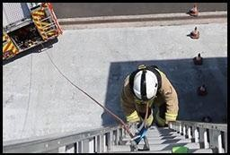

Casualty evacuation – designed to assess upper and lower body strength and coordination Candidates drag a 55kg dummy backwards around a 30M course, by a carrying handle fixed to the dummy.
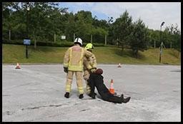

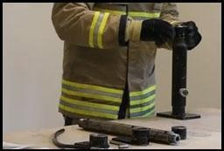
Ladder lift – designed to assess upper and lower body strength and coordination Candidates raise the bar of a ladder lift simulator to the required height with 15kg of weight placed on the simulator cradle, which gives a total lift load of 24kg.

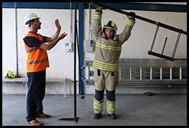

Enclosed space – designed to assess confidence, agility and stamina. Candidates put on a facemask and with un-obscured vision make their way through a crawl and walkway. Once inside the crawl/walkway they have their vision obscured and return to the start.

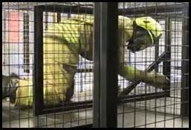

Equipment assembly – designed to assess manual dexterity. Candidates are given a demonstration of the test before having to assemble and disassemble a number of components to make an item of equipment.
Equipment carry –designed to assess upper and lower body strength and coordination Candidates carry items of equipment up and down a course between two cones placed 25m apart. They are given a brief, a demonstration of correct lifting techniques and are permitted to practice picking up the correct items.
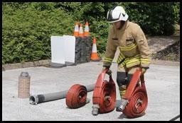

Fitness Test

Firefighting can be a physically demanding and hazardous activity with potential for exposure to high physiological and environmental loads. To ensure effective and safe operational performance an appropriate level of physical fitness is essential.

As part of the role related tests you will be invited to attend a fitness assessment (VO 2 max) which will be carried out via a Chester Step Test to determine aerobic fitness. The minimum requirement for candidates at recruitment is 42.3 mls/O2/kg/min (equivalent to level 8 shuttle or bleep test).

Stage 4 – Interview

Upon successfully passing the practical tests you will be invited to attend an interview and presentation which will last for about an hour. This will be our chance to get to know more about you and ask you more about the information you provided with your online application.

Stage 5 – Medical

Should you be successful at all elements of the recruitment process, you will be invited to attend a full medical assessment prior to joining us. This will be conducted by our Occupational Health Unit.

As part of the assessment you will be asked to complete a health questionnaire and you will also have to undertake the following tests:
- Hearing test
- Lung function
- Eyesight test
- Grip strength
- Blood pressure
- Specific general tests – which will be carried by the Service Medical Advisor
- Drug test

It is important that you do not complete any exercise or consume alcohol or caffeine immediately prior to the medical assessment.

Stage 6 – References

If you are successful at all stages of the recruitment process we will need to check your references. Should an unsatisfactory reference be received, any offer of employment will be withdrawn.

Offers of employment will be made as vacancies arise and your details may be placed on a holding list.

We would like to take the opportunity to wish you every success throughout the recruitment process.

If you have any queries, you are invited to email: recruitment@twfire.gov

