Durham County Council

Apprenticeship Information Pack

August 2018

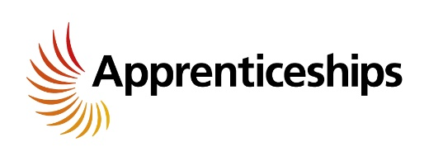
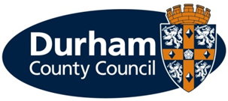

What is an apprenticeship?

Apprenticeships are an excellent option for all ages. An apprenticeship is a genuine job where you will receive formal training to gain a recognised qualification alongside gaining technical knowledge, practical experience and wider skills you need for employment and a future career.

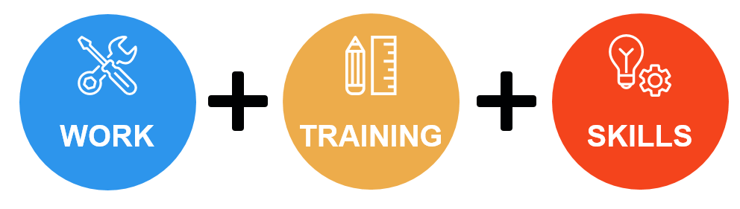

We are pleased to offer the following apprenticeship for a September 2018 start:

Service | Apprenticeship | Length of Apprenticeship | Location | Training | Training Provider
CYPS – Education – Progression & Learning | 1 x Apprentice (Business Administration) | Projected end date 30th June 2020. | Crook Civic Centre | Business Administration Standard Level 2/3 | ALSS
What are the different levels of apprenticeship?

There are a range of apprenticeships at different levels including:

- Intermediate level apprenticeship (Level 2) – equivalent to five GCSE passes
- Advanced level apprenticeship (Level 3) – equivalent to two A level passes
- Higher apprenticeship (Level 4 and 5) – can lead to a higher national certificate (HNC) or a foundation degree
- Degree apprenticeship (Level 6 and 7) – can lead to the achievement of a full bachelor’s or master’s degree

How much will I earn?
This will depend on the type of apprenticeship you are doing.

If you are working towards a Level 2, 3 or 4 qualification during the term of your apprenticeship (excluding craft apprenticeships) you will be paid:
- £3.70 per hour for the first year of your apprenticeship

If you are aged 19 years or over and have completed the first year of your apprenticeship you will then be paid:
  - 19 to 20 year old £5.90 per hour
  - 21 to 24 year old £7.38 per hour
  - 25+ years £7.83 per hour
(Rates effective from 1 April 2018)

You will be paid on the last working day of each month, with the money paid directly into your bank account.

Your apprenticeship training will be fully funded by the council.

What should I expect from an apprenticeship at Durham County Council?

- A workplace induction to help you understand your role and the Council
- A structured work programme working alongside experienced employees
- Ability to study towards a recognised qualification
- Regular review meetings with your manager
- A workplace mentor
- Opportunities to undertake work based and off the job training
- Access to a range of training opportunities
- Support to help you apply for jobs
      - To be part of an Apprenticeship Network where you will receive updates of what is happening across the Council including any training or job opportunities available, build a network of support, be able to discuss support/information required and put forward ideas for improvements.

What are the additional benefits of working for the Council?

- Holiday entitlement
- Pension
- A range of flexible working options, some depending on job role
- Maternity, paternity, dependency and adoption leave
- Sickness pay

How do I apply?

If you are not already registered, you will need to register with North East Recruitment Portal and apply online at https://www.northeastjobs.org.uk/default.aspx?page=orghome&orgid=73. Click on the apprenticeship job category to see the opportunities available.

Key dates
If you are shortlisted you will receive notification of the date and time of your interview via an e-mail from North East Recruitment Portal.
Applications | Online applications close on 21st August 2018
Shortlisting | Takes place following 22nd August 2018
Interviews | Take place w/c 4th September

Overview of the service area:
Children & Young People’s Services – Education – Progression & Learning
- CYPS Education covers a broad range of services in relation to the achievement and attainment of children and young people in County Durham.
- The service works with schools & education providers to achieve positive outcomes for children & young people. This includes maximising potential, closing the attainment gaps between identified vulnerable groups & their peers, and increasing overall wellbeing.
- A major priority within the Education Service area is to reduce youth unemployment in County Durham. DurhamWorks has attracted funding from the European Commission, through ESF and the Youth Employment Initiative. The programme supports unemployed 16-24 year old residents in County Durham. It helps them to improve their personal and work skills, and progress into employment, education or training. Each DurhamWorks participant has an individualised programme that meets their specific needs - they receive advice and guidance from Progression staff and from the nine Delivery Partners who provide work and life skills training and support. DurhamWorks is funded until the end of July 2021.

What other types of apprenticeships are available?

Durham County Council provides the majority of local council services in the county. The Council offers a huge range of job opportunities and a wide range of apprenticeships are also available including catering, accounting, construction and business administration to name a few. We have the career to meet your aspirations.

All of our available apprenticeships are advertised on our North East Recruitment Portal.

Further information on the Council’s services can be found on our website at www.durham.gov.uk.

