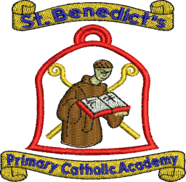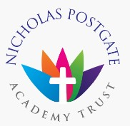
St. Benedict’s Primary Catholic Voluntary Academy
Mersey Road
Redcar
Cleveland
TS10 1LS
Telephone: 01642 495770
‘Together in God we love, learn and grow’

Dear Applicant,
May I take this opportunity to thank you for expressing an interest in applying for a position at St Benedict’s Primary Catholic Voluntary Academy.
In September 2015, we formed a Catholic Multi Academy Trust - The Nicholas Postgate Academy Trust – along with St Bede’s, Marske, St Paulinus, Guisborough and St Joseph’s, Loftus and Sacred Heart, Redcar. We aim to continue to develop as a school within the trust, providing our pupils with a high quality education.
Staff at Saint Benedict’s are committed to driving standards through delivering a thoughtful and knowledgeable curriculum were each child is valued and at the heart of everything we do.

We are looking for an outstanding teacher who is willing to share ideas and will contribute to our Catholic ethos and be part of our school and parish community.
As a school, our vision is to ensure we provide the highest standards of education and well-being for all our children.

St Benedict’s is committed to safeguarding and promoting the welfare of children and young people. Safer recruitment practices will be undertaken before any appointment is confirmed, please refer to the enclosed information on Safer Recruitment.
Visits to the school are welcome.

Application forms are available from school or from www.cesew.org.uk. Please note applicants who do not use the CES forms will not be considered. Please submit forms by post or electronically.
The post provides a great opportunity for a recently qualified teacher. I look forward to your application.
Regards,

Mrs K Sill
Headteacher

