Regeneration & Local Services

Customer Services Apprenticeship Information Pack

Contents

Page
- Apprenticeships – what’s on offer 3

- Development Framework and activities 4

- Customer Services – Overview 6

- Job Description & Person Specification 7

- Council Vision & Management Structure 11

- Key dates: Shortlisting & Interview 13

- Apprenticeships – what’s on offer

Apprenticeships are a great way to improve your skills and knowledge, gaining recognised qualifications through ‘on the job training’.

The Regeneration & Local Services service group offers the opportunity for successful applicants to join a team that supports continuous improvement and whom strive toward excellence in delivering public services.

With around 5000 employees, we have a wide range of delivery areas including:

- Customer Services
- Regeneration
- Economic Development
- Planning (housing and large scale developments)
- Sport & Leisure
- Asset Management of all Council owned land and buildings
- International Relations
- Communications
- Strategy & Policy
- Transport & Highways
- Direct Services (inc Refuse and Grounds maintenance)

The service group are crucial to both the long term strategic planning of the Council and to immediate and front line service delivery.

Our Apprentices are supported by our own ‘development framework’, that means you will have a mentor and easy access to your NVQ assessor which is delivered in-house. The framework includes career planning, social media and interview skills; in addition to this you will also have access to our employee skills programme with 100 courses on offer.

Our apprenticeship ‘offer’ is exciting and innovative.

What we expect from you is a commitment to learn and develop, to work effectively and to respect your colleagues, to positively represent the Council, to complete your training course, and to put forward ideas and suggestions to make improvements.

Case Study

Aaron, 20 years old, joined the DCC Apprenticeship Scheme in March 2015. Aaron had been working late nights and weekends in the retail sector so was looking for a more suitable career path to improve his work/life balance.
Based in the Planning Development team in Planning & Assets, Aaron provides an essential support role to the team helping process planning applications in an extremely busy office.
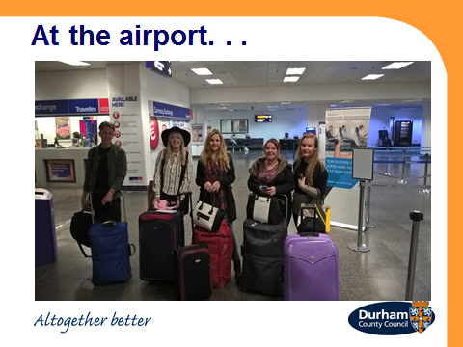
Always keen to develop himself Aaron has attended a variety of training courses to improve his knowledge and skills and is making good progress towards his NVQ Level 3 in Business Administration.
Following a successful European funding bid we were able to offer our apprentices the opportunity to take part in a 2 week work placement in Gothenburg, Sweden and Aaron was one of the first to volunteer for the placement and was successful in obtaining a place on the trip.
The placement enabled the apprentices to meet senior officers from a variety of government departments and Aaron showed maturity beyond his years engaging with the senior officers showing interest throughout and represented the Council to a very high standard.
The placement was a huge success and enabled Aaron to achieve some vital personal development that will help him moving forward in both his personal and working life.
This was demonstrated further by the group being asked to provide an overview of their experiences from the placement and some best practice to a variety of interested parties including the Director and Management Team and being invited along to a local Swedish community group based in Newcastle to chat to the Swedish Consul and the Director of the North East Local Enterprise Partnership, Hans Moller.
Earlier in 2016, Aaron was successfully recruited as a Planning Support Assistant.

- Development Framework and activities

Integral to our ethos, is the continuous professional development of apprentices, affording them with the skills, ability and personal motivation to self-develop, and to secure long term goals such as secure employment or further education.

Working with partners from the public and private sector, we ensure that our apprentices have the opportunity to produce a personal training plan, work toward a selection of training courses sponsored by the Council, prepare CV’s, e-networking tools, and to improve their Interview Skills.

Over the two year apprentice training period, we encourage all apprentices to undertake a range of formal training and development sessions to improve their skills and overall employability. While it is not essential for apprentices to undertake all courses listed below, time off will be granted by managers to attend in all cases where practical:

- Corporate Induction
- Equality & Diversity / Culture and Religion
- Customer First
- Data Protection
- Information Security
- Health & Safety
- Telephone Skills
- MS Office
- Social Media for Work
- CV creation and enhancement
- Linked-in Profile
- Self-Development Plan
- Interview Skills

Activities

Over the last 4 years our apprentices have been active in a number of local, regional and international activities, with great success. The activities are optional and vary from year to year and include:

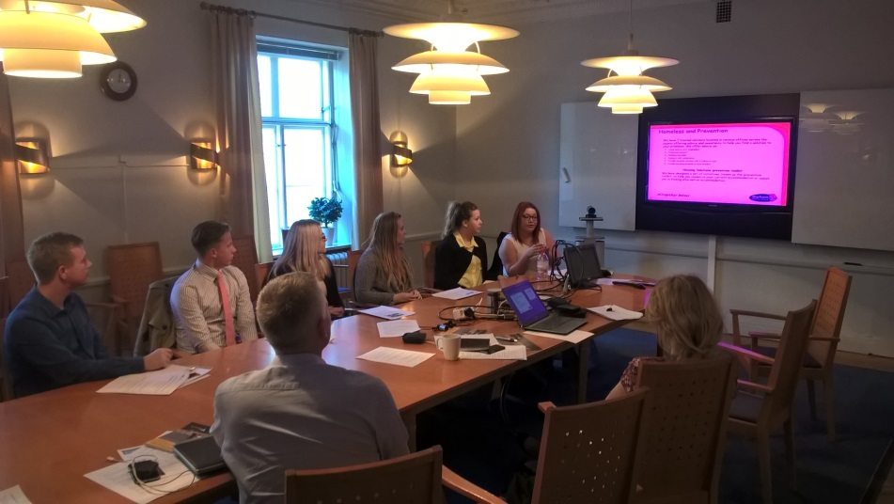

- Customer Services – Overview

The Customer Services team work to put the customer at the heart of everything the Council does. It’s the first point on contact for many of our customers.

We have a team of approximately 120, and run all 8 of the Council Customer Access points around the County.

We're committed to providing high standards of customer service. We start with listening and finding out what is important to you. The information you give us helps shape our services to meet your needs and expectations.

To enable this, we have produced a Customer First Strategy, and a Customer Service Charter.

These key documents are available on our website and helped to form our ‘Our promise to you’ which outlines how the public can expect to be greeted when they get in touch with the Council.

We would recommend that all candidates visit the Customer Service web pages on the DCC website.

- Job Description & Person Specification

 | POST TITLE: | Customer Services Apprentice
- 2. | POST NUMBER:
- 3. | GRADE: | National Apprentice Wage
 | LOCATION: | You will normally be based at County Hall in Durham; however, you may be required to work at any council workplace within County Durham.

5. RELEVANT TO THIS POST:

Flexible Working: Subject to service needs the council’s flexible working policy is applicable to this post.

Apprenticeship duration: 12 months with a possibility to be considered for available posts past this point.

6. ORGANISATIONAL RELATIONSHIPS:

You will be responsible to a Customer Services Team Coach for the duration of your programme; however, you will spend time working within the wider Teams within Customer Relations, Policy and Performance to gain a wide range of knowledge and experience.

- DESCRIPTION OF ROLE:

You will learn about the provision of services provided by DCC via the Customer Services Teams (Contact Centre and Face to face), Customer Feedback Team, Communications and Marketing Team and the Service Improvement Team. You will gain experience of providing the first point of contact service for all our customers. You will deal with customer enquiries on all aspects of the Council and also build knowledge of systems, communications and improvement work.

8. DUTIES AND RESPONSIBILITIES SPECIFIC TO THIS POST:

Listed below are the primary responsibilities of the role:

- To assist the Customer Services Assistants, Customer Service Officers and Team Coaches in the day-to-day provision of the front line service to customers wanting to access Council Services. The main ways customers contact us are through our through our Customer Access Point buildings, by telephone, and through the website e mail and social media.

- Learn to deal effectively with customers’ service requests, answering queries, giving advice covering the full range of Council and partner services and managing the progress of each enquiry through all stages to its conclusion.

- Learn to support the capture and progression of complaints, comments, compliments and suggestions from customers using the Council’s Customer Relationship Management system and understand the importance of using feedback to improve services.

  - To understand the importance of data protection and accuracy of information when collecting and validating information given by all customers to assist in a quick and accurate service provision.

- To learn about and support the Service Improvement Team in providing a customer first approach

- Familiarising yourself with Business Process Reviews (BPRs) and how they can improve the customer journey.

- To attain and maintain up-to-date knowledge of the Councils Policies and Procedures required to provide the effective processing of service requests, enquiries and complaints.

- Understand where to locate Council information stored in computerised and manual formats including the processing of payments and be able to signpost customer to this information as required.

- Participate in required learning activities including the attainment of an NVQ Level 3 qualification in Customer Service which will be supported by the learning and experience you will gain through being part of the service teams

- The duties and place of work may change as you will be required to rotate through the different service provisions within our service area.

- We are looking for enthusiasm for learning and a passion for helping people

Flexible Working – Although we offer flexible working, you will need to work during the hours that we offer services to our customers in line with our main opening hours of:

Monday to Thursday 8.30 to 5.00
Friday 8.30 to 4.30

The above is not exhaustive and the post holder will be expected to undertake any duties which may reasonably fall within the level of responsibility and the competence of the post as directed by the Head of Service.

The generic responsibilities which will be undertaken in support of the above work include the following (if applicable):

- COMMON DUTIES AND RESPONSIBILITIES:

9.1 Quality Assurance
To work towards the standards set so that the service’s requirements are met and that the highest standards are maintained.
To help maintain and work to ensure we adhere to data security and confidentially procedures.
To maintain confidentiality and not divulge to anyone personal and/or confidential information to which they may have access during the course of their work.
9.2 Communication
Participate in team and council wide communication updates, being familiar with corporate communications and newsletters.
9.3 Professional Practice
To ensure that professional practice in the team is carried out to the highest standards and developed in line with the Service’s stated objectives of continual improvement in quality of its service to internal and external customers.
9.4 Health and Safety
To ensure that the Health and Safety policy, organisation arrangements and procedures as they relate to areas, activities and personnel under your control are understood, implemented and monitored.
9.5 Appraisal
All members of staff will receive appraisals and it is the responsibility of each member of staff to follow guidance on the appraisal process.
9.6 Equality and Diversity
As an organisation we are committed to promoting a just society that gives everyone an equal chance to learn, work and live free from discrimination and prejudice. To ensure our commitment is put into practice we have an equality policy which includes responsibility for all staff to eliminate unfair and unlawful discrimination, advance equality of opportunity for all and foster good relations.

These policies apply to all employees of Durham County Council.
9.7 Confidentiality
All members of staff are required to undertake that they will not divulge to anyone personal and/or confidential information to which they may have access during the course of their work.
All members of staff must be aware that they have explicit responsibility for the confidentiality and security of information received and imported in the course of work and using Council information assets. The Council has a Personal Information Security Policy in place.
9.8 Induction
The Council has in place an induction programme designed to help new employees to become effective in their roles and to find their way in the organisation.

Person Specification – Customer Services Apprentice
 | Essential | Desirable | Method of Assessment
Qualification | - 4 GCSE’s at Grades A-C including English and Mathematics or hold an equivalent relevant qualification | - BTEC or NVQ Level 2 in a relevant subject  - Level 3 Qualification | - Application form  - Selection Process  - Pre-employment checks
Experience | - Working with a PC to input and recall stored data | - Some experience of working with the public in either paid or voluntary work | - Application form  - Selection Process  - Pre-employment checks
Skills/ knowledge | - Ability to work on own initiative  - Ability to process numerical data  - Be able to demonstrate a good understanding of customer service principles  - The ability to converse at ease with customers and provide advice in accurate spoken English is essential for the post | - Customer Services Skills attained through either voluntary or paid interaction with the public | - Application form  - Selection Process  - Pre-employment checks
Personal Qualities | - Positive attitude to learning  - A flexible approach to work  - Confident and polite telephone manner  - ‘Can Do’ attitude | - Passionate about helping people | - Application form  - Selection Process  - Pre-employment checks

- Council Vision and Management Structure

Our vision and priorities

Since becoming a unitary authority, Durham County Council has refocused its vision and priorities, together with partners and in consultation with local people and Area Action Partnerships (AAPs).
We have developed a new vision to reflect the views and aspirations of the community and opportunities for improvement. This is focused around being an Altogether Better Durham. This vision comprises of two aims of being an Altogether Better Place which is Altogether Better for people.
This vision helps provide a framework which guides all of our detailed plans and programmes, which will help turn our vision into a reality. This will also be achieved through organising our improvement actions into a structure comprised of five priority themes:

Altogether wealthier
Focusing on creating a vibrant economy and putting regeneration and economic development at the heart of all our plans.

Altogether better for children and young people
Helping children and young people to develop and achieve their aspirations and to maximise their potential in line with the Government's Every Child Matters initiative.

Altogether healthier
Improving health and wellbeing.

Altogether safer
Creating a safer and more cohesive county.

Altogether greener
Ensuring an attractive and 'livable' local environment, and contributing to tackling global environment challenges.

Ian Thompson
Corporate Director of
Regeneration and Local Services
Andy Palmer
Head of
Strategy Programmes & Performance
Steve Howell
Head of
Culture & Sport
Sarah Robson
Head of
Economic Development & Housing
Alan Patrickson
Head of
Projects, Business Services & Customer Services
Adrian White
Head of
Transport & Contract Services
John Reed
Head of
Technical Services
Stuart Timmiss
Head of
Planning & Assets
Oliver Sherratt
Head of
Direct Services

- Key dates: Shortlisting and Interview

Interview
Interviews are scheduled exact date to be arranged..

