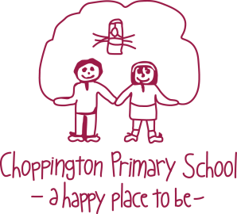
JOB SUMMARY
Contract Type: Fixed term (1 year initially)
Working Pattern: Full time x1 employed by Choppington Primary School;
Part time x1 employed by Mowbray Primary School
Advert Start Date: 08/06/2020
Advert End Date: Closed for applications on 26/06/20, 12 noon
Salary: Band 5 £21,589 - £23,836 (pro rata)
Hours per week: 37 hours Full time; 20 hours Part time
Job Category: Education
Employment Location: Bedlington/Blyth Primary Schools
FURTHER INFORMATION
The Bedlington Partnership of schools are seeking to offer a position as Specialist Speech, Language and Communication Needs Teaching Assistant to a suitably qualified and experienced person. The successful candidate will be required deliver intensive teaching programmes over a time- limited period for pupils with speech, language and communication needs (SLCN) and/or social communication needs. They will also facilitate the inclusion in mainstream schools of pupils with SLCN. The role will also involve training SEN support assistants and relevant staff in school and contribute to courses delivered by teachers.
The post is based at the Choppington Primary School and involves travel across the south west of Northumberland.
You will have:-
- a relevant qualification i.e. NVQ3 Child Care and Education or NNEB or equivalent. A specialist qualification in Speech Language and Communication and Autism e.g. OCNNER Level 3 or BTEC Level 3. Numeracy and literacy skills equivalent to NVQ 2 in English and Maths.
• experience in working with/supporting pupils with speech and language difficulties in the mainstream classroom in Early Years and Key Stages 1 & 2.
• experience in delivering Speech and Language Therapy Programmes
• your own transport arrangements to enable you to travel distances between schools
Interviews will be held week commencing 6th July 2020.
The Service is committed to safeguarding and promoting the welfare of all children and young people and expects all staff to share this commitment.

