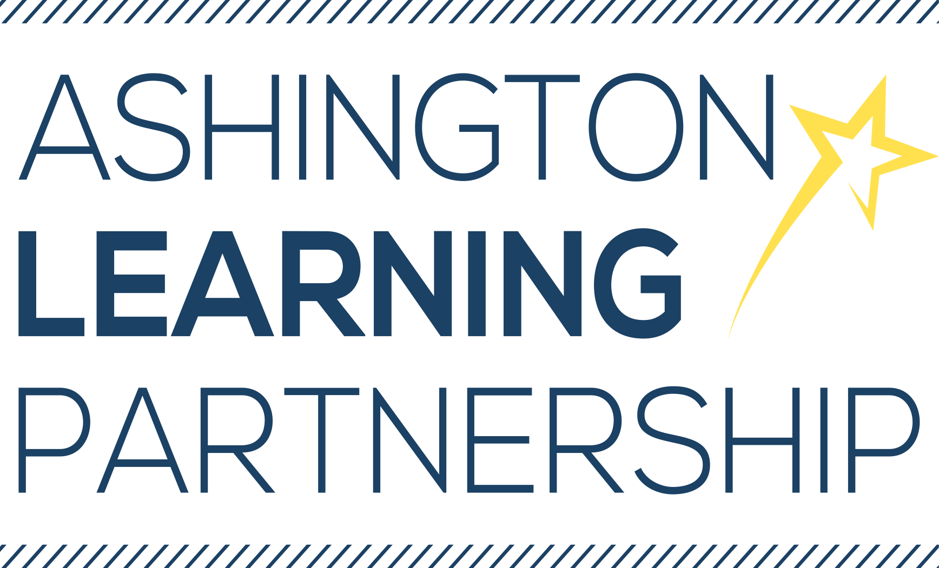

LETTER TO APPLICANTS

Dear Prospective Candidate,

Thank you for your interest in the posts of Midday Supervisors in the Ashington Learning Partnership. The Ashington Learning Partnership consists of two large primary schools (Bothal Primary School and Central Primary School), which collectively cater for over 1,500 pupils. The two schools are led by an Executive Principal and experienced Senior Leadership Team. Each school operates a lower and upper site provision and all four sites are based within the semi-rural town of Ashington, Northumberland.

We are very proud of our schools and work hard to ensure that they are vibrant and exciting places for young learners to be. We are fortunate to benefit from specialist facilities as well as modern buildings and grounds which allow us to provide a safe and stimulating learning environment for our whole community.

Both schools are at the heart of a very close community and work in collaboration with local businesses, parent groups and external agencies to extend learning beyond the classroom and into the lives and homes of the community that we serve.

The position of Midday Supervisor means you will be working in a small, close-knit team looking after the pupils at lunchtime. The advertised jobs are based at Bothal Primary Upper Site, High Market, Ashington. Main duties include supervising pupils in the dining hall and playground areas. This is a role for an enthusiastic, caring, cheerful person who would like to be a good role model for our pupils.

The ALP has not yet undergone Single Status but may begin a job evaluation process in due course. Pay, terms and conditions are therefore subject to change.

Application Process
An Application Form and Criminal Record Declaration Form is included in the pack along with completion guidance and these should be returned to us. A Job Description and a Person Specification is also included for your information. A Child Protection Policy and Equality Policy are also included. If you would like any further policies or information, please contact our HR Assistant on jayne.hawkins@alptrust.co.uk. Application forms and letters should be returned by post or email to Bothal Primary School, High Market, Ashington, Northumberland, NE63 8NT or jayne.hawkins@alptrust.co.uk or hand-delivered to either school office by 9am on Monday 21st May 2018. Further details of the interview process will be sent to shortlisted candidates by email.

Visits are warmly welcomed and these can be arranged by contacting Ann Sharp, Senior Midday Supervisor, on 01670 812360.

