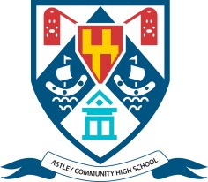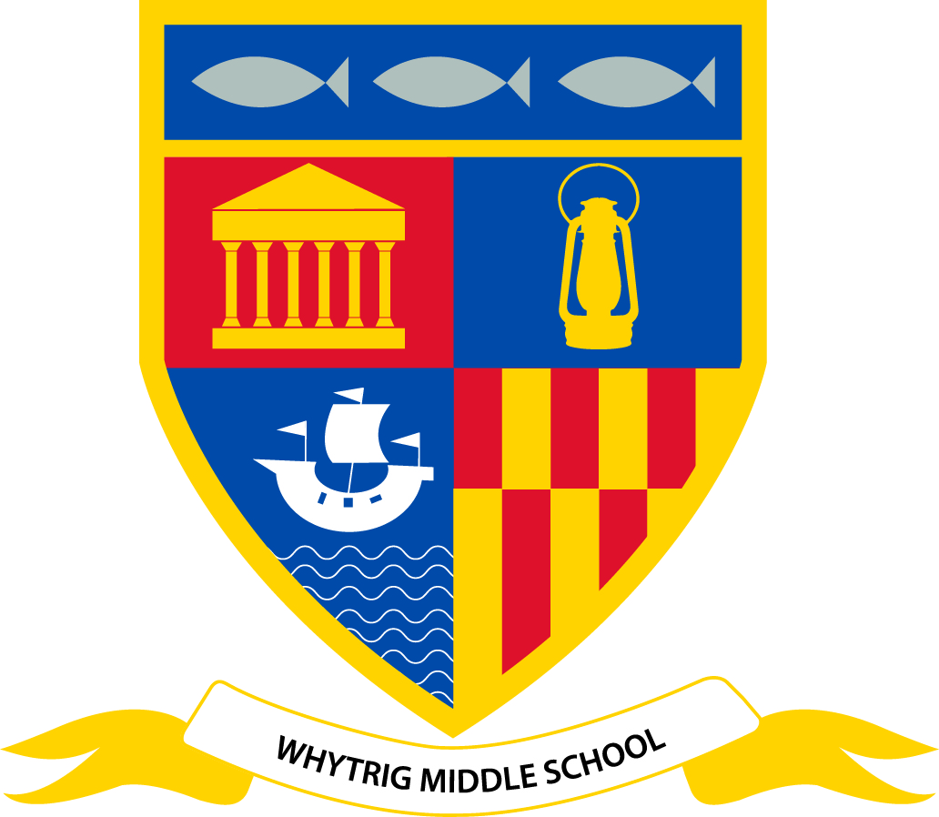

Astley Community High School and Whytrig Middle School
Elsdon Avenue
Seaton Delaval
Tyne and Wear
NE25 0BP
0191 237 1505

Teaching and Learning Assistant – 2 posts
28.35 hours per week, term-time plus one training day
Band 2: £9,824 - £10,438 per annum, pro rata of £15,238 - £16,191 per annum

Effective support for students with special educational needs and/or disabilities is a key priority across the Seaton Valley Federation of Schools in order to help all students to achieve their full potential. This role is within a team of Teaching and Learning Assistants who work across both Astley Community High School and Whytrig Middle School, which share a single site in Seaton Delaval. Working under the direction of the Assistant Headteacher – Inclusion, you will be engaged jointly by both schools however it is expected that you would initially be deployed to work mainly at Astley Community High School with students aged 13-18.

With a track record of supporting students to achieve their targets and knowledge of strategies, you will ideally also have 5 A*-C grades at GCSE level (or equivalent) including English and Maths and hold a Teaching Assistant or Special Needs Support qualification. You will also need to be able to form effective relationships with students, staff, parents and fellow professionals.

This role will be for five days per week, term-time plus one training day at the start of the school year. It is expected that your initial working hours will be Monday 8.40am to 3.15pm, Wednesday 8.40am to 3.20pm plus Tuesday, Thursday and Friday 8.50am to 3.15pm, with a 15 minute morning break and 35 minute lunch break each day, although this working pattern may change from time to time to meet the operational needs of the schools.

We are committed to safeguarding and promoting the welfare of children and young people and expect all staff to share this commitment. An enhanced criminal records check is required for this post.

Interested in applying? A completed application form and criminal records declaration form must be submitted by 9am on Monday 6 February 2017 by e-mail to svfjobs@svlp.org.uk Please indicate clearly the title of the role you are applying for in the subject field.

It is expected that interviews will be held on Thursday 9 February. Further infomation about all of our current vacancies is available at: http://www.astleyhigh.org/aboutus/vacancies

