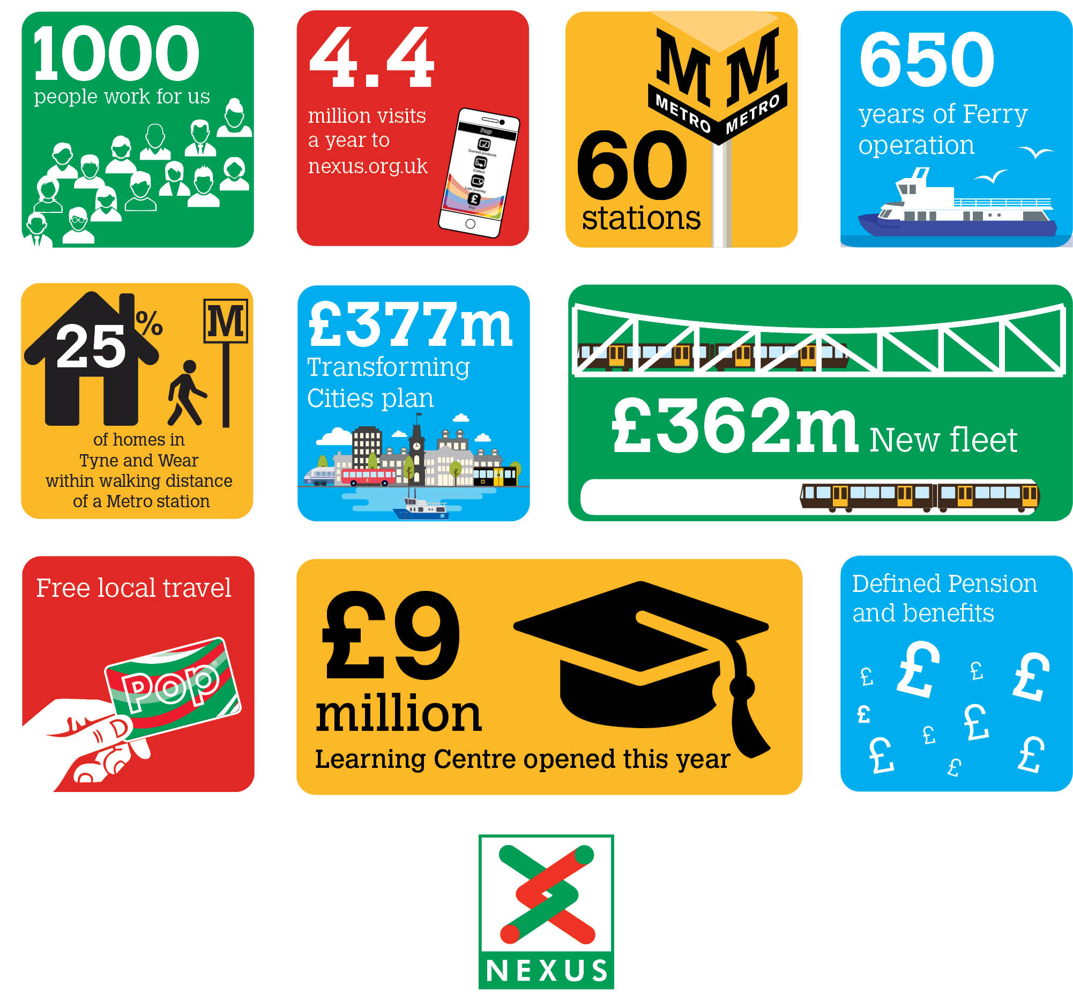
Be part of our story
Marine Fitter
Nexus is looking to recruit an experienced Marine Fitter to work on the Tyne and Wear Ferry located at South Shields. The successful candidate will be responsible for the safe and efficient maintenance of the Ferry assets including vessels, landings, waiting rooms and staff accommodation.
As a Marine Fitter it is essential that you have experience of planned and reactive maintenance on a variety of machinery including diesel engines. You will be required to carry out servicing on engines, generators and auxiliaries ranging from lubrication to full servicing, part replacement and major overhaul.
You will have an adaptable attitude to work, willing to partake in an emergency call out procedure and work flexibly to ensure the punctuality and reliability of the Shields ferry. You will have the ability to work unsupervised as well as be part of a team and have good communication and organisational skills.
Salary £24,365 pa
plus shift and weekend allowance
Plus defined benefit pension scheme, free local travel and access to other benefits.
Closing date 25 July 2021
Find out more at nexus.org.uk

