Recruitment Pack

Teaching Assistant
Autumn 2019

Welcome from Skelton Primary School

Dear Applicant,
Thank you for expressing an interest in applying for the position of teaching assistant at Skelton.
Skelton is on an incredibly exciting journey and we are all committed to nurturing, sharing and encouraging very best practice. We are determined to be a centre of educational excellence, pedagogical innovation, research and development. This is to support our children in their life chances, opportunities and employability.
All of our staff, regardless of their role, work together to ensure that our children are provided with the best education possible. We are committed to giving our leaders and teachers time to fulfil their professional duties and responsibilities.
The Lower School phase at Skelton is made up of three year groups: Foundation Stage 1 and 2 and also Year 1 and Year 2 where we teach a fully connected curriculum. We currently have 300 children in Lower School. It is overseen by Nichola Chapman, Assistant Headteacher, each year group has a team leader who oversees both pastoral and academic journey of the children and team. The Upper School phase has twelve classes and is overseen by the Deputy Head, Lonia Krywiczanin.
This role would suit a newly qualified or more experienced teaching assistant. We can offer you the opportunity to work in a vibrant, supportive and friendly atmosphere where you will be enabled to develop both personally and professionally. We are members of NESTA, our programme of professional development is really important to us and continues to develop all the time. You will therefore have the opportunity to work alongside outstanding practitioners and leaders of education.
Enclosed with this recruitment pack you will find the advert, person specification and job description.
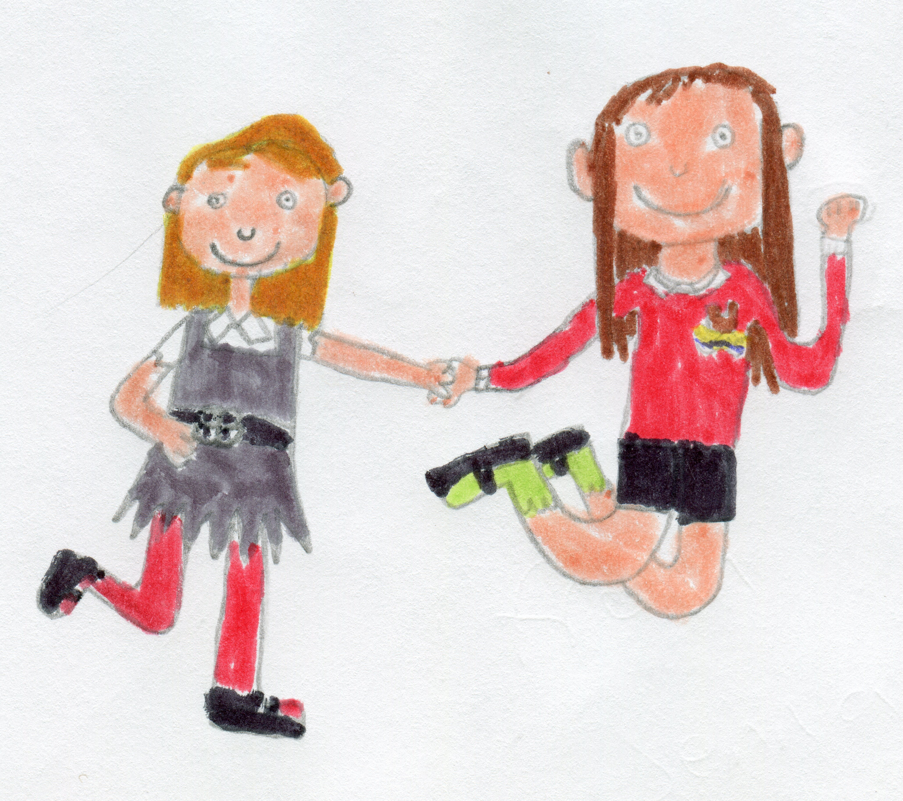
GOOD LUCK!

Yours faithfully
Sarah Walker

Safeguarding Children
Skelton Primary School are committed to Safeguarding and Promoting the Welfare of all children. We recognise that some children may be especially vulnerable to abuse e.g. those with Special Educational Needs, those living in adverse circumstances.
Skelton Primary School’s Child Safeguarding Policy applies to all adults, including volunteers, working in or on behalf of the school.
Whilst local authorities play a lead role, safeguarding children and protecting them from harm is everyone’s responsibility. Everyone who comes into contact with children and families has a role to play.
Skelton Primary School pays full regard to DfE guidance ‘Working Together to Safeguard Children DfE ’ and ‘Keeping Children Safe in Education’. Anyone who works for school, who is likely to be perceived by children as a safe and trustworthy adult (including volunteers and staff employed by contractors), is subject to appropriate checks in line with current legislation and best practice.
Safer recruitment practice includes but are not limited to: scrutinising applicants, verifying identity and academic or vocational qualifications, obtaining professional and character references, checking previous employment history and ensuring that a candidate has the health and physical capacity for the job. It also includes undertaking interviews and, where appropriate, undertaking checking details with the Disclosure & Barring service.

Explanatory Notes
Applications will only be accepted from candidates completing the Skelton Primary School application form. Please complete ALL sections of the application form which are relevant to you as clearly and fully as possible. CVs will not be accepted.
Safeguarding Children & Young People
We are committed to safeguarding and promoting the welfare of children and young people. We expect all staff to share this commitment and to undergo appropriate checks, including DBS checks with Barred List check.
Candidates should be aware that all posts in school involve some degree of responsibility for safeguarding children and young people, although the extent of that responsibility will vary depending on the nature of the post.
If you are currently working with children, on either a paid or voluntary basis, your current employer will be asked about any current disciplinary sanctions and whether you have been the subject of any child protection allegations or concerns and if so the outcome of any investigation or disciplinary proceedings and sanctions issued whether expired or not. If you are not currently working with children, but have done in the past, that previous employer will be asked about these issues.
Where neither your current or previous employment has involved working with children, your current employer will be asked about your suitability to work with children, although it may be answered ‘not applicable’ if your duties have not brought you into contact with children or young people.

Interview process
Interview Process
After the closing date, short listing will be conducted by a panel, who will match your skills/experience against the criteria in the Person Specification. You will be selected for interview entirely on the contents of your application form, so please read the Job Description and Person Specification carefully before you complete your form.
As part of the DBS application and as a form of identification, all successful candidates must bring a copy of their certificates and the following documents:
Route 1 – 3 documents (at least 1 must be from Group A, the other 2 can be from any group) OR Route 2 – 3 documents (1 from Group B and 2 from B or C, plus External ID check) OR Route 3 – 5 documents (birth certificate and 4 other documents - 1 from B and C) One document must confirm the applicant’s current address and date of birth.

GROUP A PRIMARY IDENTITY DOCUMENTS
Current valid passport (UK or overseas) | Biometric Residence Permit (UK)
Current driving license- photo card & counterpart (where applicable) UK, Isle of Man, Channel Islands, EU- full or provisional | Birth certificate – issued at time of birth (UK, Channel Islands – including those issued by UK authorities overseas)
Adoption Certificate (UK & Channel Islands)
GROUP B TRUSTED GOVERNMENT DOCUMENTS
Current driving licence - photocard (UK & overseas) | Current driving licence – paper (UK & EU)
Fire Arms Licence (UK & Channel Islands) | HM Forces ID Card (UK)
Birth certificate – issued any time after birth (UK & Channel Islands)
GROUP C FINANCIAL & SOCIAL HISTORY DOCUMENTS
Mortgage statement (UK or EEA) | Bank/Building Society Statement (UK)
Credit Card Statement (UK or EAA) | Financial Statement, eg Pension, investments (UK)
Benefit statement, eg child allowance, pension (UK) | EU National ID card
Letter from Head Teacher or Principal | P45/60 Statement
Council Tax statement | Work Permit/Visa (UK)
Utility Bill | Sponsorship letter from employer (outside UK)
Cards carrying PASS accreditation logo
A document from Central/Local Government/Government Agency/Local Authority giving entitlement (UK & Channel Islands), eg from the Department for Work and Pensions, the Employment Service, HMRC, Job Centre, Social Security, etc.
ID validation must be attempted in order. If you are unable to validate via Route 1, move to Route 2, if unable to validate Route 2, move to Route 3.
Failure to meet any of the above routes may mean that you will be sent for fingerprinting by the Police which you should be aware is likely to cause delay to the DBS application process and subsequently the recruitment process.
Please note that originals of the above are necessary. Photocopies or certified copies are not sufficient.

Selection Procedures
We will seek references for candidates that are shortlisted for interview and may also approach previous employers for information to verify particular experience or qualifications before interview. Any relevant issues arising from references will be taken up at interview.
In addition to candidates’ ability to perform the duties of the post, the interview will also explore issues relating to safeguarding and promoting the welfare of children, including:
* Motivation to work with children and young people
* Ability to form and maintain appropriate relationships and personal
boundaries with children and young people * Emotional resilience in working with challenging behaviours * Attitudes to use of authority and maintaining discipline

Conditional Offer: Pre-Employment Checks Any offer to a successful candidate will be conditional upon reeipt of satisfactory clearances including but not limited to:
* Verification of right to work in the UK * Receipt of at least two satisfactory references (if these have not already been received) Verification of identity checks and qualifications * Satisfactory DBS check * Verification of professional status such e.g. QTS Status, NPQH (where required) * Satisfactory completion of a Health Assessment * Satisfactory completion of the probationary period (where relevant)
Where the successful candidate has worked or been resident overseas in the previous five years, such checks and confirmations as may be required in accordance with statutory guidance
.
How to Apply
To apply please complete the Skelton Primary School application form. Your supporting statement should address and evidence the selection criteria detailed in the Person Specification.
Applying: Application packs are available in paper form direct from school, or they can be printed directly from the school website. Electronic printed copies should be emailed, posted or hand delivered to school for the attention of Mrs McCluskey.
Visits to the school are encouraged and can be arranged by contacting the school directly.
If you have any queries about the application process or the position please feel free to contact Mrs Cath McCluskey on 01287 650689 or by email at headteacher@skeltonprimaryschool.

