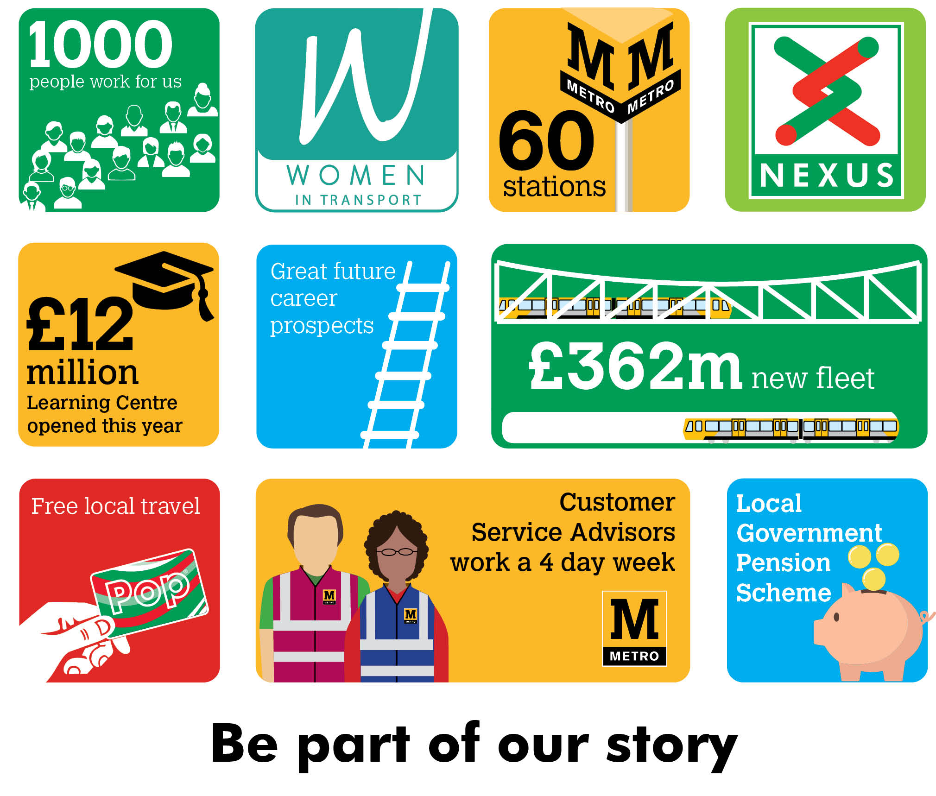
Customer Service Advisors
Circa £20,000 per annum
Plus defined benefit pension scheme, free local travel and access to other benefits

Are you passionate about delivering exceptional customer service? Do you enjoy the challenge of solving problems in a fast-paced environment? If so, then a Customer Service Advisor role could be for you.
We have opportunities to work at our city and town centre stations, or with our mobile customer support teams. Either way, you’ll be at the heart of everyday life and become the face of one of the North East’s most iconic brands.
As a Customer Service Advisor, you’ll make sure our customers enjoy their journey – offering a warm welcome, advice and information, checking tickets and help with travel for those who need it. You will participate in delivering the best possible experience for those travelling with us during fantastic events such as Great North Run, international sporting events and stadium pop concerts.
No two days are the same in this job, and you’ll meet and help people from all walks of life. If customer service with a smile is your speciality, come and be part of our story…..

Closing date: 9th June 2021
To find out more information visit nexus.org.uk

