Secondment opportunity - Frontline Consultant Social Worker (CSW)

What is Frontline?
Frontline is a two-year social work qualifying programme which offers people the opportunity to join one of Britain’s most challenging, but most rewarding professions. Participants work as frontline children’s social workers in Greater London and the South East, North West, North East, and the Midlands, undertaking child protection work. They work in units of four, managed by a Consultant Social Worker.

What is a Consultant Social Worker?
Consultant Social Workers (CSWs) are vital to the Frontline model; you will be an experienced practitioner, a practice educator and a manager of four participants working together in a unit. This unit model approach is a systemic practice model working for and with families, with cases managed through the weekly unit meetings. These meetings provide a dynamic learning environment and a reflective space to thinking about the cases in your unit systemically. For more information about what a day in the life of a CSW would be like, take a look at our website: (add link to day in the life)

What will I get from being a CSW?
- An exciting opportunity for experienced practitioners to remain in practice whilst also taking on a management and teaching role
- Access to a high quality training programme and the opportunity to work towards a Foundation level in Systemic Practice
- Access to 1:1 coaching and mentoring from a Practice Tutor
- Be part of a national network of CSWs contributing to innovations in practice and broader social work reforms
- CSW continuing in the role for two or more years will also become part of the Frontline Fellowship

The Frontline Model
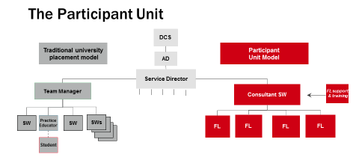
What is the application process?
There are two parts to the application process, a standard local authority application form (you do not need to complete the additional information section) and a video interview.
successful, you will be invited to an assessment centre where you will undertake a series of exercises. For more information please refer to the CSW Job Description.

