Durham County Council
Our Lady & St. Thomas R.C. Primary School
Tel: 01388 746336 Fax: 01388 748229 E-mail: OurLadyStThomas@durhamlearning.net
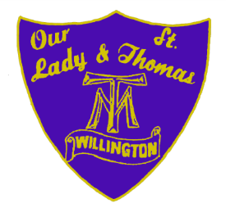
Website: olst.org.uk

Head Teacher Cumberland Terrace
Mrs. F.M. Gowland Willington
Crook
Co Durham
DL15 0PB

24 October 2014

Dear Candidate,
EYFS / KS1 Class Teacher - MPS 1-6 / UPS 1 - 3
Thank you for your interest in the above position.

You can find all the relevant forms to complete the application in this pack; a Catholic Education Service Application Form, Notes to Applicants, Recruitment and Monitoring Form and a Rehabilitation of Offenders Form, together with the Job Description and Person Specification.

We are a small, friendly team, who work closely together for the benefit of all within our school community.

Visits to the school are warmly encouraged by prior appointment, on either :-

- Friday 7th November, 2014 at 1.20pm
- Wednesday 12th November at 4.00pm

The closing date for the position is noon on Monday 17th November, 2014. If you decide that this is the school for you, good luck with your application!

Yours sincerely,

F M Gowland

Head teacher

