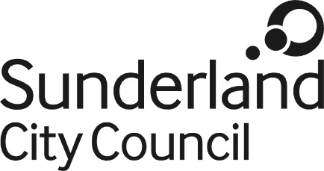

Job Description

Job Title: Senior Consumer Protection Officer (Age-restricted products)
Salary Grade: Grade 5
Job Family: Regulatory and Technical
Job Profile: RT4S
Directorate: Neighbourhoods
Work Environment: Various locations throughout the City
Reports to: Senior Trading Standards Officers
Number of Reports: 1

Purpose:

To enforce and advise on the full range of criminal Trading Standards legislation, excluding weights and measures, and provide assistance and advice to the public and businesses in order to promote a fair and safe trading environment.

To particularly focus on the use of legal and other tools to reduce the harms to health associated with age-restricted products (including tobacco and alcohol.)

Key Responsibilities:

- To undertake enforcement of Trading Standards legislation.

- Deliver projects relating to age-restricted products with the aim of reducing the harms associated with those products across the City.

- Use computer systems to accurately record work undertaken and to evaluate data for service and project planning.

- Provide data in order to answer requests for information.

- Conduct investigations into breaches of Trading Standards legislation, obtain statements, interview suspects and witnesses and produce prosecution reports.

- Attend court as required.

- Serve notices and fixed penalties when proportionate to the legislative breach.

- Work with businesses to ensure a responsible attitude to the sale of age-restricted products.

- Develop intelligence to inform policy making and delivery of operational work.

- Undertake a programme of surveillance and enforcement activities across the City in relation to test purchasing of age-restricted products and other illegal sales of alcohol and tobacco products.

- Coordinate responses on behalf of the service with regard to Government proposals concerning tobacco and alcohol legislation and assist in ensuring that any changes to service policies and guidance necessitated by national developments are implemented.

- Deliver non-statutory activities which are intended to reduce the harms to health associated with age-restricted products including the development and implementation of Best Bar None and Responsible Retailer schemes.

- Work with partner agencies with regard to all aspects of Trading Standards legislation.
- Participate in a programme of training of persons employed within the night time economy including the safeguarding of vulnerable patrons and the avoidance of sales of alcohol to inebriated people.

Work with Public Health colleagues on issues relating to alcohol, tobacco and other age-restricted products including participation in relevant publicity campaigns and distribution of material to relevant agencies and traders.

Supervise colleagues in undertaking service delivery.

Safeguard the welfare of any young people who volunteer to assist the Council in relation to age-restricted products.

Work flexibly as part of a team and assist in the training of colleagues in order to improve the capabilities of the service.

Undertake training as required.

Undertake any other duties assigned that are commensurate with the grade of the post.

Comply with the principles and requirements of the Data Protection legislation in relation to the management of Council records and information.

Comply with the principles and requirements of the Freedom of Information Act 2000.

Comply with the Council’s information security standards, and requirements for the management and handling of information; Use Council information only for authorised purposes.

Carry out duties with full regard to the Council’s Equality policies, Code of Conduct and all other Council policies.

Comply with the Council’s Health and Safety policy, rules and regulations and with Health and Safety legislation.

Date: January 2019

