Durham Trinity School & Sports College
Additional information for the Key Stage 3 Skills Class Teacher
We are moving to a new school building
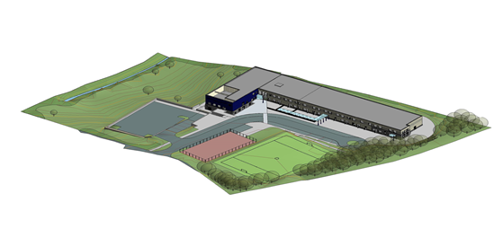
Would you like to teach in this purpose built environment? If so, read on.
The new school building is scheduled to open after half term in November 2014.
The new school building is located at Flambard Premises, Aykley Heads, Durham.
Our new school building will accommodate:
- Nursery, KS1 & KS2 classes, all ages of specialist ASD provision, all ages of sensory provision on the ground floor. Each class has direct access to their outdoor learning space.
- Secondary pupils and Post 16 pupils on the first floor. Specialist teaching rooms are located on this floor.
There are 2 dining areas on the ground floor. One will be used by primary pupils and the other by secondary pupils. The multi purpose hall will be timetabled for PE lessons throughout school.
The design of the building has embraced the gradient of the site and there is a small lower ground floor area. The small swimming pool is located on this level along with a variety of rooms for professionals, visiting and school based staff.
Externally there will be a MUGA and sports field. The sports field will be operational from April 2016 after the current school building has been demolished and the seed sown. There is also a grassed area for pupil use below the building and car park.
We are a popular school. Currently there are 198 pupils on roll with a further 4 places allocated for pupils to join us in the coming months. The new school building will have capacity for 220 pupils.
The Offer on the school website www.durhamtrinity.durham.sch.uk gives additional information about school life.

Key Stage 3 Skills Class Teacher vacancy in Warkworth class
Within Key Stage 3 there are 5 classes plus pupils of this age range accessing specialist sensory and specialist ASD provision.
The classes are organised as follows:
Bamburgh class caters for Y7 pupils.
Hylton class caters for Y8 pupils.
Alnwick class caters for Y9 pupils.
Raby class is a mixed age class catering for Y7, 8 & 9 pupils.
The above classes follow a secondary curriculum model i.e. subjects are delivered by subject specialists and the pupils move classrooms.
Warkworth class is a mixed age class currently catering for Y7 & Y9 pupils. The class has a base (as in a primary model). The class is taught all subjects by the class teacher except music and PE. These subjects are delivered by subject specialists.
Pupils in Warkworth class generally have severe learning difficulties and/or ASD. Academically pupils in this class would be accessing a curriculum that was pre National Curriculum or the very beginnings of National Curriculum.
School uses BSquared as the main assessment system.
Currently there are 8 pupils in the class with a full time Teaching Assistant.
The successful candidate will join the staff in January 2015.

