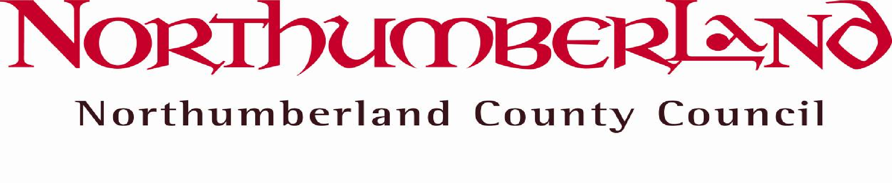
The Dales School

Headship application pack – Contents
- School Information

- Guide for applicants

- Job Description and Person Specification

- Working and Living in Northumberland

- Equality in Employment Policy

- Criminal Records Policy

- Immigration, Asylum and Nationality Act 2006

- Application Form

- Criminal Records Declaration Form

- Childcare Disqualification Form

