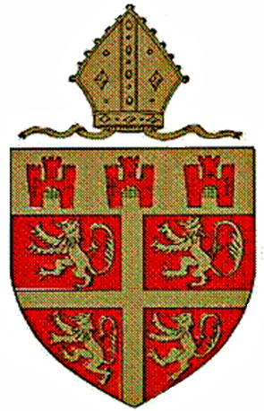
The Diocesan Boards of Education
of Durham and Newcastle

SCHOOLS

The Durham and Newcastle Diocesan Boards of Education provide education for over 24,500 children in 9 secondary or middle schools and 93 primary or first schools.
Church of England schools are distinctive from their neighbouring schools in terms of their leadership and management, their ethos, and their religious education and collective worship, which are distinctively Christian.
The Boards of Education carries out statutory functions and provides support to all their schools and academies. These include:

- support for Church schools’ leadership and management, including the recruitment, selection, induction and on-going training of Head Teachers and senior leaders;
- support for schools causing concern;
- appointment, support, training and guidance for governors;
- inspection under Section 48 of the Education Act 2006 (“SIAMS”);
- advice and guidance regarding the RE curriculum and collective worship;
- support for clergy in their relationships with schools;
- regular cluster group meetings;
- review of, and advice regarding, school admissions;
- a range of services regarding schools’ buildings and finances.

Consultation with the Board of Education

School governing bodies must ask the Board before:

- publishing proposals for any prescribed alteration to the school;
- publishing proposals for the discontinuance of a school;
- consulting about proposed admission arrangements for any school year;
- publishing proposals for changing the character of a school.
School governing bodies must have consent of the Board in writing which must then go to the Secretary of State before alteration or repair which requires a grant.
The trustees of any church endowment held in connection with a church school must gain advice from the Board before agreeing to any alterations being made.

