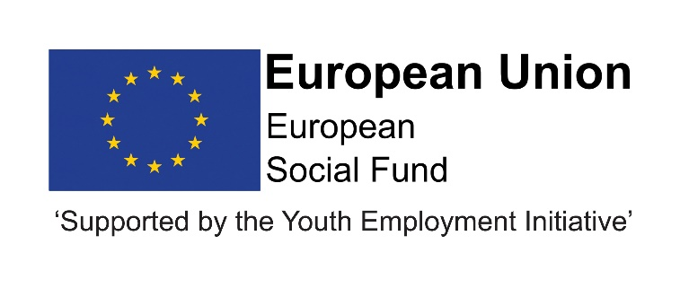

Job Description
Post title | Administration and Data Assistant
JE Reference No | N7142
Grade | Grade 3
Service | Children and Young People’s Service
Service Area | Education and Skills; Progression and Skills
Reporting to | The postholder will be responsible to the Progression Team Leader.
Location | Your normal place of work will be one of the following - Seaham Contact Centre, Stanley Education Centre or Civic Centre Crook. However, you may be required to work at any Council workplace within County Durham.
DBS | This post is not subject to a disclosure.
Flexitime | This post is eligible for flexitime.
Politically restricted | This post is not designated as a politically restricted post in accordance with the requirements of Section 1(5) of the Local Government and Housing Act 1989 and by regulations made from time to time by the Secretary of State.
Relevant to this post | This post is funded until July 2021 through the ESF/YEI DurhamWorks project.  This post is funded through ESF and the Youth Employment Initiative (YEI) as part of the 2014-2020 European Structural and Investment Funds Growth Programme in England. The YEI/ESF funding will end in July 2021.

Description of role

To play an active part as a team member in providing administration and data support to the DurhamWorks project.
Duties and responsibilities

Listed below are the responsibilities this role will be primarily responsible for:

- Input learner information onto the project’s MIS system and other databases as appropriate and ensure Individual Records are kept up to date in order to ensure that returns can be completed successfully,

- Operate a range of computer software such as Word, spreadsheets and databases to produce documents and information for the project,

- Respond to requests for advice and information from staff, service users and stakeholders with respect to DurhamWorks,

- Provide a quality message taking service during normal office hours. Answer the telephone, transferring and taking calls and messages as necessary and respond to web site requests in a timely manner,

- Maintain and retrieve information from paper and electronic filing systems,

- Ensure that all paperwork relating to learning activity is collected, stored and retrieved efficiently from both paper based and computer systems,

- Monitor resources and requisition supplies when necessary,

- Provide administrative support at project events when required,

- Work throughout the County providing flexible cover as appropriate,

- Work with colleagues to ensure offices are covered during normal office hours,

- Provide mentoring support to the Level 2 apprentices.

The above is not exhaustive and the post holder will be expected to undertake any duties which may reasonably fall within the level of responsibility and the competence of the post as directed by the Head of Service.

Organisational responsibilities

- Values and behaviours
To demonstrate and be a role model for the council’s values and behaviours to promote and encourage positive behaviours, enhancing the quality and integrity of the services we provide.

- Smarter working, transformation and design principles
To seek new and innovative ideas to work smarter, irrespective of job role, and to be creative, innovative and empowered. Understand the operational impact of transformational change and service design principles to support new ways of working and to meet customer needs.

- Communication
To communicate effectively with our customers, managers, peers and partners and to work collaboratively to provide the best possible public service. Communication between teams, services and partner organisations is imperative in providing the best possible service to our public.

- Health, Safety and Wellbeing
To take responsibility for health, safety and wellbeing in accordance with the council’s Health and Safety policy and procedures.

- Equality and diversity
To promote a society that gives everyone an equal chance to learn, work and live, free from discrimination and prejudice and ensure our commitment is put into practice. All employees are responsible for eliminating unfair and unlawful discrimination in everything that they do.

- Confidentiality
To work in a way that does not divulge personal and/or confidential information and follow the council’s policies and procedures in relation to data protection and security of information.

- Climate Change
To contribute to our corporate responsibility in relation to climate change by considering and limiting the carbon impact of activities during the course of your work, wherever possible.

- Performance management
To promote a culture whereby performance management is ingrained and the highest of standards and performance are achieved by all. Contribute to the council’s Performance and Development Review processes to ensure continuous learning and improvement and to increase organisational performance.

- Quality assurance (for applicable posts)
To set, monitor and evaluate standards at individual, team and service level so that the highest standards of service are delivered and maintained. Use data, where appropriate, to enhance the quality of service provision and support decision making processes.

- Management and leadership (for applicable posts)
To provide vision and leadership to inspire and empower all employees so they can reach their full potential and contribute to the council’s values and behaviours. Managers and leaders must engage in personal development to ensure they are equipped to lead transformational change; always searching for better ways to do things differently to meet organisational changes and service priorities.

- Financial management (for applicable posts)
To manage a designated budget, ensuring that the service achieves value for money in all circumstances through the monitoring of expenditure and the early identification of any financial irregularity.

The above is not exhaustive and the post holder will be expected to undertake any duties which may reasonably fall within the level of responsibility and the competence of the post as directed by your manager.

Person specification
 | Essential | Desirable
Qualifications | - 4 GCSEs (A-C grades including English Language or Literature),  OR  - GNVQ (Intermediate in Business),  OR  - NVQ 2 Business (or equivalent). | - NVQ Business Administration Level 3, BTEC National, BTEC Higher or ICSA.
Experience | - General administrative experience. | - Able to type to 35 wpm,  - Use of IT systems.
Skills & Knowledge | - Can apply numeracy and literacy skills in the workplace,  - Can use full range of communication skills,  - Manage time effectively. | - Able to make decisions and be assertive when appropriate.
Personal Qualities | - Commitment,  - Enthusiasm,  - Flexible approach to work,  - Initiative,  - Discretion and confidentiality,  - Problem-solving,  - Put the users of your services first,  - Teamwork,  - Attention to detail.

