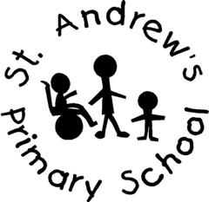
St Andrew’s Primary School

Person Specification for Teaching Assistant – Grade 5

Category | Essential | Desirable | Where Identified
Education, Qualification and Training | • A teaching assistant qualification at NVQ3, or CACHE level 3, or BTEC National Diploma level 3, or NNEB, or equivalent  • CGSE Maths and English Language at Grades A – C, or equivalent; and have | Valid First Aid Certificate | Letter of application  Application Form
Experience | Are familiar with a school or Early Years environment.  Can use ICT effectively to support learning.  Knowledge of curriculum and learning experiences for children in Early Years Foundation stage and of the Development Matters Document.  Experience in recording observations and accurate assessments of children | A working knowledge of the curriculum for children in the Early Years. Experience of supporting intervention strategies for pupils. Experience with working with a foundation stage team. | Letter of application  Referneces  Interview
Skills, knowledge and aptitude. | Ability to relate well with children and adults.  Ability to work constructively as a member of a team.  A willingness to work co-operatively with a wide range of professionals.  Good communications skills both written and verbal.  Ability to be flexible and adapt to suit pupils needs.  An understanding of safeguarding procedures.  Ability to work within the LA and School’s policies and guidelines | Any further Early Years training or specialisms within Early Years. | Letter of application  Refernces  Interviews
Personal requirements | Constantly improve own practice/knowledge.  Calm and positive approach.  Sensitive to the needs of children and their parents/carers. | Appreciate and support other profressionals. | Letter of application  Referneces  Interveiw

