SUBJECT LEADER OF MODERN FOREIGN LANGUAGES
Candidate Information Pack

INTRODUCTION

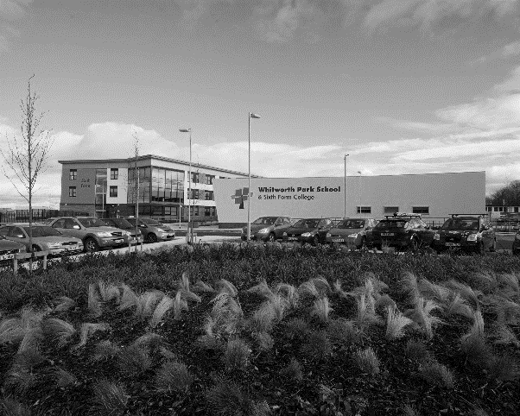
Whitworth Park School and Sixth Form College is a successful, welcoming and caring school.
Whitworth Park was opened in September 2012 following the amalgamation of Spennymoor School and Sixth Form Centre and Tudhoe Grange School. Both schools were highly successful serving the community of Spennymoor and the surrounding villages. The school is situated in a semi-rural location within easy reach of the cities of Durham and Newcastle-Upon-Tyne. Spennymoor is also ideally located for access to the A1M which is situated close by. Housing prices in the local vicinity are moderate when compared to the National average.
The school offers a broad and balanced curriculum and is committed to offering the highest quality learning experience to all of its students. It was judged to be ‘Good’ by Ofsted in 2013 and we are now committed to working towards outstanding. We were recently awarded North East School of the Year 2015.

THE MODERN FOREIGN LANGUAGES DEPARTMENT

The Modern Languages Department is a forward-looking, committed department firmly focused on teaching and learning.
Presently, the department consists of six teachers who teach across the ability and age range. The Subject Leader is supported by an Assistant Leader within the department. French and German are currently offered as Modern Foreign Language subjects across the school. Levels of achievement and attainment are high and continue to improve.
The department is accommodated on the first floor of the main school building. Staff have their own dedicated teaching space which benefits from interactive whiteboards that link directly to each teacher’s laptop. There is a dedicated subject office for use by the MFL staff.

THE CURRICULUM:
The MFL department aims to inspire, nurture and foster a passion to succeed; the MFL Leader will take this a step further and ensure outstanding attainment and achievement for the young people it educates.
Within MFL there is an extensive curriculum offer delivered across key stages three, four and five. The key stage three curriculum currently delivers French or German in a rolling programme with the most able students being taught both French and German. The key stage four curriculum offer is currently for French and German, both of which are becoming increasingly popular.
Students continue their studies into key stage five at our Sixth Form College and there is a commitment to ensure these numbers grow further. German is a relatively new addition to the Sixth Form programme but French has a long established reputation of high achievement in post-16 studies.
JOB DESCRIPTION

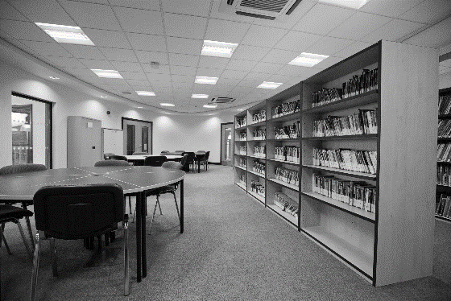
JOB TITLE:
SUBJECT LEADER FOR MODERN FOREIGN LANGUAGES
ACCOUNTABLE TO:
ASSISTANT HEADTEACHER (ACHIEVEMENT AND ATTAINMENT)
GRADE:
MPS/UPS + TLR 1a

Whitworth Park School and Sixth Form College is an Equal Opportunities employer. We want to develop more diverse workforce and positively welcome applications from all sections of the community. Applicants with disabilities will be invited for interview if the essential job criteria are met. The school is committed to safeguarding and promoting the welfare of children and young people and expect staff and volunteers to share this commitment. Any offer of employment will be subject to receipt of an enhanced DBS Certificate and Pre-Employment Health Check.

THE ROLE:
This an exciting opportunity to lead a thriving MFL department and contribute to the overall success of the whole school.
We are seeking to appoint an outstanding, enthusiastic and ambitious teacher to lead and manage our MFL subject area.
The ideal candidate will be able to:
- offer two languages
- be the prime deliverer of German
- offer inspirational leadership and a modern approach to language teaching
- have a proven track record of achieving excellent outcomes for students
- have the vision, drive and determination to create a Modern Foreign Language department that will inspire young people through their own passion for the subject
- to deliver a rigorous academic curriculum that instils the highest standards for staff and students
- stretch the most able students as well as motivate and inspire those who do not arrive at Whitworth Park with a natural love for Languages
- inspire both staff and students
- have the ability, creativity, ambition and drive to take the department forward to the next phase of its development
If you have a clear vision to develop languages and further improve examination results, we should like to hear from you.
KEY RESPONSIBILITIES

Staff are expected to support and contribute to the school ethos.

Success through Partnership- an inclusive education for all learners in the community of Spennymoor providing
“Excellence for Everyone.”

The school creates an environment which is inspirational and aspirational, in which every learner has the opportunity to develop the skills to lead a positive and fulfilling life. We work in collaboration with parents, carers, the community, and all other educational and service providers to nurture all of our young people. Our educational programme provides a climate which inspires learning, creates trust, respect and tolerance and promotes sustainability and collaboration - “Excellence for Everyone”.

General Expectations
Staff will:

- contribute effectively to the work of the school and to the achievement of the ‘School Improvement Priorities’;
- play a full part in the life of the school community, to support our distinctive aims and ethos, to encourage staff and students to follow this example;
- follow school policy regarding care, support and supervision of students;
- attend training and development activities and courses, ensuring continuing, personal and professional development;
- contribute to a welcoming school culture by promoting mutual respect for all;
- comply with any reasonable request from a leader to undertake work of a similar level that is not specified in this job description;
- work as a team member;
- act as a role model to students in speech, dress, behaviour and attitude;
- have common duties in the areas of: Quality Assurance, Communication, Professional Practice, Health & Safety, General Management (where applicable), Financial Management (where applicable), Appraisal, Equality & Diversity, Confidentiality and Induction.

This job description will be reviewed annually and may be subject to amendment or modification at any time after consultation with the post-holder. It is not a comprehensive statement of procedure and tasks but sets the main expectations of the school in relation to the post holder’s professional responsibilities and duties.

Whitworth Park School and Sixth Form College is committed to safeguarding and promoting the welfare of children and expects all staff and volunteers to share this commitment. This post is subject to signing our ICT Staff User Policy and having a satisfactory Enhanced DBS Certificate.

Duties and Responsibilities for all Teaching Staff

All teaching staff will:

- work within the National Conditions for Employment of School Teachers (STPCD);
- uphold and observe the Professional Code for Teachers (GTC) and meet the National Standards for Qualified Teachers;
- promote the school’s stated ethos and support the school’s policies in student leadership and Management;
- support and encourage colleagues at all levels within the school;
- contribute to and implement the annual School Improvement Plan and agreed policies;
- teach as directed throughout the school, subject to appropriate training;
- expect, monitor and improve progress in student learning;
- contribute to the personal and social development of all students;
- participate in the pastoral management and delivery of the schools Personal Social Health Citizenship Education programme (PSHCE) as requested;
- take part in quality assurance and performance management procedures outlined in an agreed school policy;
- take responsibility for personal development.

Responsibilities for all Subject Teachers

All subject staff will:

- take full responsibility for ensuring a scheme of work is delivered to students in their allocated classes;
- plan lessons using a range of strategies to meet student’s individual learning needs understood from attainment and supporting data;
- have a thorough knowledge and understanding of their subject, its teaching and place in the
National Curriculum and that of the school;
- use the models set out in School Policies for delivery of lessons;
- set homework according to school and department policies;
- mark, assess record and report on student’s achievements, setting appropriate targets;
- keep to deadlines for reporting, marking, submission of coursework and assignments;
- prepare students for examinations when required, taking part in standardising and moderating activities required by departments and examination boards;
- contribute to the development of schemes of work, school and department policies as appropriate;
- attend and contribute to appropriate meetings and professional development activities;
- take an active part in the school’s self-evaluation process, including the completion of appropriate documentation, and contribute to this process within the subject area;
- undertake whatever other duties might reasonably be requested by the Head Teacher or Subject Leader.

Responsibilities of all Form Leaders

All Form Leaders:

- are responsible for day-to-day administration in the form group;
- review and discuss student’s work and welfare, setting targets as necessary;
- meet with parents including school calendared meetings;
- promote good behaviour and positive attitudes at all times;
- support form, year and school activities as appropriate;
- deliver an appropriate programme of form group activities, including the agreed PSHCE programme.

Responsibilities of Post Threshold Teachers

Teachers who have passed the Threshold should ensure that they continue to meet Threshold Standards and should demonstrate that they make an active contribution to the policies and aspirations of the school.

Specifically;

- they provide a role model for teaching & learning;
- make a distinctive contribution to the raising of student standards;
- contribute effectively to the work of the wider team;
- take advantage of appropriate opportunities for professional development, using outcomes effectively to improve students’ learning.

There is a clear expectation that Post-Threshold Teachers will take a lead role in the development of other teaching staff and will welcome Student and Newly Qualified Teachers and visitors, by prior arrangement, into their learning environment.

Specific Responsibilities for this Post
- to develop a positive climate for learning which promotes success for all;
- to actively monitor and support student learning and progress in the subject;
- to produce regular reports on the progress of the subject tracked against prior attainment and
targets;
- to identify underachieving students in the subject in liaison with colleagues and ensure an
appropriate subject support programme is put in place;
- to co-ordinate and deliver Intervention Strategies to support student attainment and
achievement;
- to ensure high quality teaching and learning in the subject;
- to work to the National Standards for Subject Leaders;
- to monitor, review and evaluate all aspects of the subject recording outcomes on the subject self-
evaluation form, recording key areas for development on the subject action plan and ensuring
progress towards targets;
- to lead curriculum development, teaching and learning in the department and evaluate
and review their progress;
- to actively monitor and respond to curriculum development initiatives across the school, and at
national, regional and local levels;
- to ensure that there are up to date schemes of work and department manuals with the assistance
of the subject team;
- to oversee assessment arrangements and preparations for examinations in the subject area
liaising, where necessary, with the Examinations Leader and ensuring the Officer has accurate
information;
- to lead and direct the subject team, deploying all staff and resources appropriately, monitoring
and reviewing the work of the staff in the subject team and furthering the professional
development of all staff;
- to promote teamwork and motivate staff to ensure effective working relations;
- to lead subject meetings and record action points;
- to support staff within the subject team to set annual targets in accordance with school policy
and to complete the performance management process;
- to ensure staff within the subject team have appropriate professional development, to organise
CPD opportunities where appropriate and to liaise fully with consultants and advisers;
- to liaise with the Leadership Team on timetable and accommodation issues;
- to take responsibility for student behaviour within the subject area;
- to support subject area staff in curriculum and pastoral matters;
- to oversee the fabric and displays in teaching areas and ensure good resource provision;
- to promote activities which stimulate an interest in the subject area;
- to liase with feeder primary schools and outside agencies, including examination boards, as
necessary;
- to promote the subject area through school publications and events;
- to ensure appropriate cover arrangements for absent colleagues.

PERSON SPECIFICATION
 |  | Essential | Desirable
Application | A well-structured letter of application indicating interests and strengths in the subject | *
 | Fully supported in references | *
Qualifications and Professional Development | Qualified Teacher Status (QTS) | *
 | Ability to teach GCSE and A-Level | *
 | A degree in a relevant subject | *
 | Commitment to further study including any in-service training during the last three years | *
 | Ability to use ICT as a learning tool | *
 | Post Graduate qualification |  | *
Experience | A proven track record of raising standards, good examination results and delivery against targets | *
 | Ability to demonstrate high standards of classroom practice | *
 | Catering for the needs of all students including Gifted and Talented, SEND and Pupil Premium | *
 | Use of data to inform planning, teaching, measuring progress and to aid target setting and improving performance | *
 | Recent experience of leading and managing a team of people | *
 | Experience of introducing a new initiative or of managing change | *
 | Contribution to whole-school Improvement Planning |  | *
 | Experience of working with external providers to enhance curriculum delivery |  | *
 | Experience in more than one secondary school |  | *
 | Experience of teaching at KS5 |  | *
 | Effective leadership of teams and management of people |  | *
 | Experience of successful management and curriculum development |  | *
 | Experience of staff development | *
 | Experience of leading in staff development |  | *
Qualities and Values | A clear educational philosophy that underpins pedagogy to support high quality teaching and learning | *
 | A passion for the subject | *
 | A drive to make learning fun, engaging and exciting | *
 | The ability to inspire others, share good practice and reflect on local/national education pressures | *
 | Good communication skills with the ability to relate effectively to all ages and abilities | *
 | An ability to educate the whole child and contribute effectively to pastoral systems | *
 | A desire to extend learning beyond the classroom | *
 | A commitment to raising the aspirations of the whole school community | *
Personal Attributes | Ability to work under pressure and retain a sense of humour | *
 | Ability to work as team member to achieve common goals | *
 | Initiative, energy and perseverance | *
 | Enthusiasm and self-confidence | *
 | Personal presence and impact | *
 | Ambition to go on to senior leadership |  | *

Assessment against the criteria outlined above will be through the Application Form, Letter of Application, Work Related Assessments, Interview Process and References.

In addition to candidates’ ability to perform the duties of the post, the interview will also explore issues relating to safeguarding and promoting the welfare of children including:

- motivation to work with children and young people;
- ability to form and maintain appropriate relationships and personal boundaries with children and young people;
- emotional resilience in working with challenging behaviours;
- attitudes to use of authority and maintaining discipline;

Any relevant issues from references will be taken up at interview.
APPLICATION

Please return a completed application form including the names, addresses and relevant contact details of two referees together with your letter of application.
The letter of application should be no more than two sides of A4 and should set out the particular strengths that you would bring to the post, how you feel you meet the criteria outlined in the job description and person specification as well as a response to the following questions:
- What does an outstanding Modern Foreign Languages department look like and how would you contribute to this?
- How do you measure student success?
- What you would contribute to extra-curricular activities within the department
Please ensure you also complete and return the required DCCR form. Completed applications must be received by the school by noon on Friday 17th April 2015 addressed to:
Mr P Gillis
Headteacher
Whitworth park School and Sixth Form College
Whitworth lane
Spennymoor
County Durham
DL16 7LN

or by e-mail to the Headteacher’s PA, Mrs J Woodward at:
j.woodward@whitworthpark.org.uk

Interviews are scheduled to be held week commencing Monday 27th April 2015. If you have not heard from us within 4 weeks please assume that you have been unsuccessful on this occasion.

Whitworth park School and Sixth Form College:
- is committed to the protection and safety of its students. Appointment will be subject to an enhanced DBS check, satisfactory medical report and satisfactory references
- is an Equal opportunity employer
- operates a strict no-smoking policy

Unfortunately we are unable to acknowledge receipt of your application.

