Introducing Moorside Primary School

Moorside Primary School is a Foundation Trust School which means that whilst the Local Authority funds and supports the school on the same basis as all other Local Authority maintained schools, it is the school governing body, rather than the local authority, that is the employer. However, we still must teach the national curriculum, follow the School Admission Code, employ teaching staff under the terms of the School Teachers’ Pay and Conditions Document and, of course, we are inspected by Ofsted.

With approximately 470 children, Moorside Primary School is a larger than average primary school. It is situated in the west end of the city not far from the city centre. The management team was appointed in 2017 following the school’s separation from a school it had previously been partnered with in a federation. There is an active Governing Body; members often visit the school and are closely involved in school life.

Our school serves a very diverse community. There are over thirty languages represented in our school. More than 80% of our children do not have English as their first language. Around 55% of our children are classified as Pupil Premium. 16.5% have special educational needs. Mobility is high, currently at 24.5%.

These few statistics give an indication of some of the challenges we have to meet and overcome in order to ensure that our children receive an enjoyable and engaging educational experience that supports them to achieve their best and equips them for their next steps.

Our school exists to serve our children. We work from the principle that all children deserve to experience success and that all of them may need some tailored support to make that happen. Our teaching method is an expression of this principle. We have introduced “group” teaching throughout the school to promote differentiation and to identify situations where children need targeted additional support. We have recently developed a skills based curriculum so that our children’s many diverse talents can be recognised and celebrated.

Ensuring high quality first wave teaching is a priority for us. We value our staff and have high expectations of them and we invest in their development.

Since November 2018 Moorside has been a member of the West End Schools Trust, a group of eight schools that work together to share experience and expertise and to develop practice. Through the Trust our staff have the opportunity to work regularly with colleagues from our partner schools and we also work with a number of other partners, including Newcastle City Council, Gateshead Council and a variety of community and private specialist organisations to equip staff with specific knowledge and skills and to support our children.

Developing children’s language skills is key. All of our teachers have to be equipped to teach phonics. The teaching of reading with fluency and understanding is a priority. Significant investment has recently been made to ensure that children have access to a wide range of high quality books in a range of languages. The children have assisted us in progressing this development by identifying books that they wanted to see in their classrooms and in their school library.

We have extended the range of aids available to children to develop their maths skills and expect to see these used daily in our classrooms. Children have responded well to being able to access these resources.

We are also investing heavily in improving the physical environment both in and out of doors. The school had been converted to an “open plan” internal layout when it was part of a Federation. In the course of the last year we have re-instated the internal walls. A complete rewire and upgrading of some IT facilities was recently completed.

Our children live in a built up area principally in homes without gardens. We want outdoor learning to be an integral part of our curriculum and children’s learning. Our extensive grounds have recently been re-fenced to ensure security. We have redeveloped and re-equipped the outside area for Early Years and aspects of the Year 1 and 2 outside space and we have installed a MUGA and a running track. We have recently upgraded our outside areas and included new play equipment and outside exercise equipment. Collectively, these developments will support children’s learning, well-being and environmental awareness.

The pandemic and the demands it has placed on us have provided an opportunity to engage differently with children and their parents/carers. Our staff have developed new approaches and skills, parents/carers have become more directly engaged in their children’s learning and have given us useful information about the merits and demerits of different approaches. We’ll be looking at the lessons learned very closely to identify where the experiences of the last year can usefully inform our future practice.

Here are a few comments from our children:

I have got friends to play with
and it makes me happy. When I get to school everyone
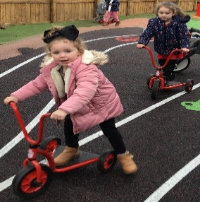
says good morning. I like that.

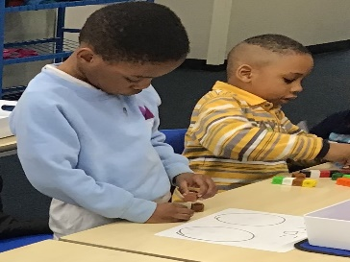
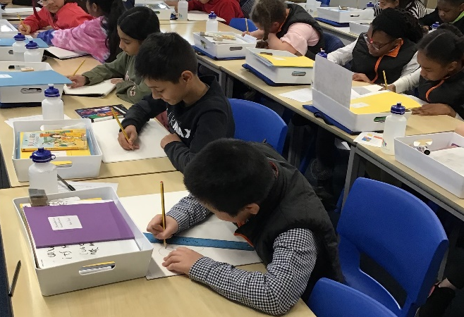

When things happen in the world, it is
explained so we understand and it makes
sense the changes that might have to happen.

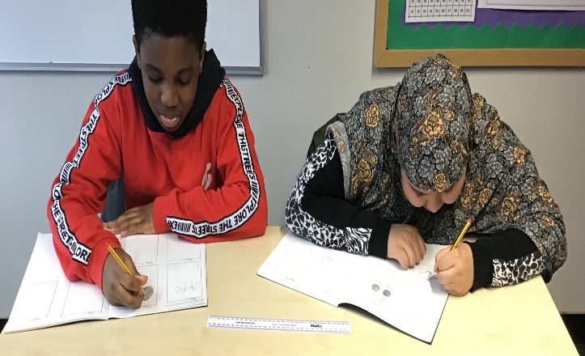

I feel proud of myself.
It’s hard for me to come
into school sometimes but
I want to. My teachers help me.

Just when I think I know everything,
my teacher makes me think more!
I like a challenge, I am very curious.

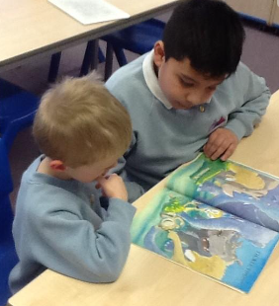

It is fair in school.
Everyone gets help.
Everyone is important.

