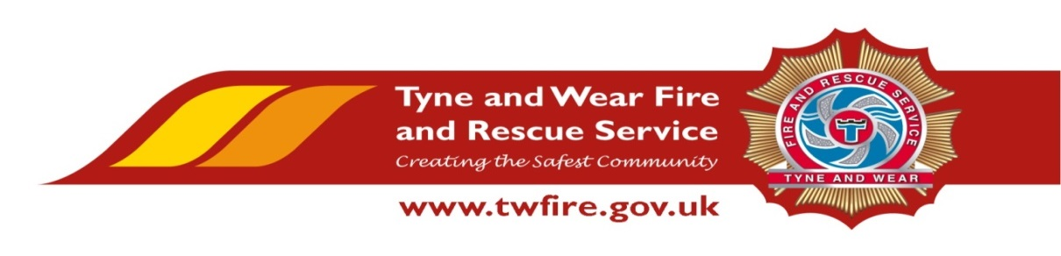

Fire Safety Assistant – Fixed Term until 20 December 2019
Starting salary of £18,795 + Benefits

We have an exciting opportunity for a talented and experienced member of staff to work as a Fire Safety Assistant in our Fire Safety department.

This role will include inputting, maintaining and reporting on data and information held within fire safety management information systems, providing an efficient and effective range of administrative support to the function and delivering exceptional services to our community and key stakeholders
The Service values and respects the diversity of its employees, and aims to recruit aworkforce that represents the communities we serve. We welcome applications irrespective of people’s race, disability, gender, sexual orientation, religion or belief, age, gender identity, marriage and civil partnership, pregnancy and maternity.

Required Skills/Experience:

- An experience of handling, inputting, extracting and manipulating data held in a database accurately.

- Experience of working in an administrative environment dealing with a variety of clerical tasks.

- Excellent IT skills including experience using databases, spreadsheets and Microsoft Office suite.

- Ability to work efficiently and effectively when working to conflicting deadlines.

What we can offer you

Tyne and Wear Fire and Rescue Service Headquarters Fire Safety Department is based at our West Denton Fire Station, with free parking and easy access from the A1. The role benefits from an attractive package, including a flexible working scheme, up to 22 days holiday and public holidays, Local Government Pension Scheme and access to a range of social and volunteering opportunities.

Closing Date: Wednesday 10 April 2019 at 12 noon.

Interviews: Week commencing 15 April 2019
