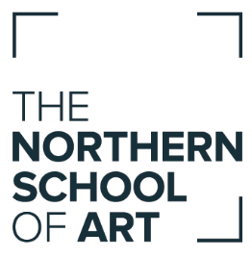
Job Advert

Digital Marketing Assistant
Hartlepool
Full-time: 37 Hours per week
Permanent
Annual Salary - £18,194 - £20,225 (based on increments, starting salary £18,194)

The Northern School of Art is dedicated to providing the best education in creative subjects to new and existing students both locally and nationally. We are looking for an organised, self-motivated and enthusiastic individual to support the work of a busy, performance-driven marketing team.

The Digital Marketing Assistant will deliver digital and online marketing activities, including Search Engine Optimisation (SEO), social media and online paid-for advertising, in line with the marketing strategy and including activities relating to the maintenance and development of the School website.

The ideal candidate will have a degree qualification or equivalent in digital marketing or web design/related discipline or online marketing and can demonstrate experience or interest in creating and updating website content, social media, writing for online platforms, Search Engine Optimisation (SEO) and digital advertising.

Further information about the role and the experience and skills we’re looking for can be found in the Job Description and Person Specification.

In return, as a member of The Northern School of Art team of staff, you will be provided with:

- The opportunity to develop your career and demonstrate you can reach achievable goals;
- The opportunity to be supported to regularly update your skills and knowledge;
- The opportunity to make a difference to the lives of young people in the Tees Valley; and
- Membership of the local government pension scheme with employer’s contributions.

Closing date for receipt of completed applications: 12th September 2019

Applications must be on our application form available at https://northernart.ac.uk/careers/

If you have any questions please call (01642) 856119 or email HR@NorthernArt.ac.uk

