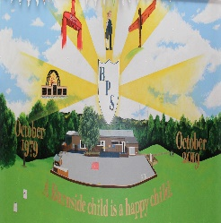
Burnside Primary School
Mendip Terrace
Stanley
County Durham
DH9 6QP
Tel: 01207 234020
Email: burnside@durhamlearning.net

Friday 22nd October 2021
Dear Prospective Candidate,
Thank you for your interest in our vacant post.
Our school is at the heart of the community. We have 178 children on roll aged from 2 to 11. We have a nurturing and forward thinking ethos and are committed to ensuring that each and every child is provided with the knowledge and experiences to be the best they can be.
Unfortunately, due to the pandemic and limiting visitors in school, we are unable to show prospective candidates around our school at this time. If you require more information regarding our school, please visit our school website at www.burnsideprimary.org.uk where you will find lots of information as well as our prospectus video. The shortlisted candidates will be offered a tour.
I look forward to reading your application and supporting letter.
Yours sincerely,

Mrs K Charlton
Head Teacher

