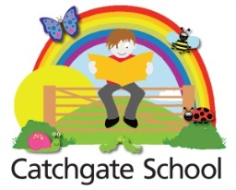
Catchgate Primary School – 0 – 5 Childcare and Early Years Provision

Person Specification

Essential

- NVQ Level 3 Early Years Care & Education Diploma or Equivalent

- Experience of working in a pre-school environment

- Knowledge of Health and Safety / Child Protection Procedures

- Knowledge of OFSTED

- Adaptability, strong motivation, good team member

- Willingness to develop training skills

- Attendance at staff meeting and in service training sessions

Desirable

- Play work diploma/ certificate

- Current first aid certificate

- Basic food hygiene certificate

- Full day care experience

- Experience in record keeping

- Key person duties

- Principles of EYFS

- Good communication skills

- Creative flair

- Participation in association meetings and social events

