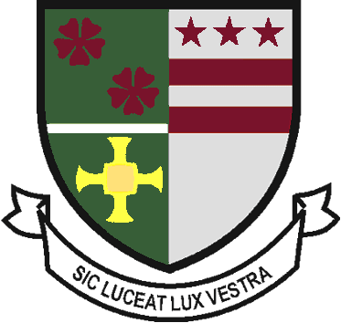
ST ROBERT OF NEWMINSTER CATHOLIC SCHOOL AND SIXTH FORM COLLEGE

JOB Description

POST TITLE: Head Chef/Catering Manager

POST TITLE: Head Chef/Catering Manager

RESPONSIBLE TO: School Business Manager and Head Teacher

RESPONSIBLE FOR: Deputy Catering Manager, Kitchen Assistants and Trainees

Overall Objectives of the Post:

To provide a safe, healthy catering service to the school which is within budget and to customer satisfaction. Additionally, provide a supportive environment to enable trainees, placed in the team, to gain a wide range of practical kitchen experience in the catering trade.

Key Tasks of the Post:

1. You will provide a high quality food service to customers. You will:
- Be responsible for preparation, cooking and service of food in school
- Plan creative, innovative and nutritious menus for pupils, staff and visitors, considering dietary needs, preference, cultural and religious backgrounds
- Manage the provision of high quality events catering as required
- Ensure that portion control is observed consistently
- Ensure organisation and supervision of food service, including procurement of food and non food stock within budgetary constraints
- Promote healthy eating within school
- Test and develop new products and menus

2. You will observe health, safety and hygiene regulations and be responsible for the overall performance of the school’s catering service, including the following duties:

- Control of hygiene and health and safety, and COSHH compliance
- Ensure that equipment is maintained and faults reported
- Be responsible for the health and safety of all catering employees and ensure that safe working practices are maintained
- Ensure that the kitchen cleaning schedule is adhered to effectively
- Be responsible for maintaining food safety, preparation and production
- Administration duties attached to the post
- Assist with the development of school policies and procedures relating to catering services

3. You will train, develop and supervise a team of kitchen staff. You will:
- Provide Leadership, supervision and support to employees and trainees, including allocation of duties, work rotas and training
- Coach trainees to improve their skills
- Undertake promotional events e.g. parents visits, healthy eating initiatives, National School Meals Week or any promotion as directed by the Area Manager, in order to maximise meal uptake and raise the profile of the service
- Ensure that the highest standards of customer care are upheld, including handling positive and negative feedback swiftly, effectively and professionally
- Support cross-curricular initiatives e.g. pupil diploma courses, 6th form cookery tutorials, healthy eating and lifestyle messages delivered in PE classes

All employees have a responsibility to undertake training and development as required. They also have a responsibility to assist, where appropriate and necessary, with the training and development of fellow employees.

All employees have a responsibility of care for their own and others’ health and safety.

The above list is not exhaustive and other duties may be attached to the post from time to time. Variation may also occur to the duties and responsibilities without changing the general character of the post.

