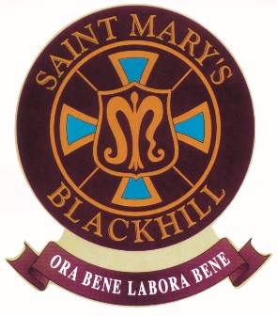
ST. MARY’S R.C. PRIMARY SCHOOL
Pemberton Road, Blackhill, Consett, Co Durham, DH8 8JD
Tel: (01207) 502657

Fax: (01207) 503237
E-mail: blackhillstmary@durhamlearning.net
Website: www.blackhill-st-marys-rc.durham.sch.uk

Headteacher: Mr D Miller
11th September 2018
Dear Applicant

Caretaker - Permanent, Full Time Post - 37 hours per week (split shift)
Grade 3 (points 12 -16) £16123 - £17419

Thank you for your interest in the above post currently available at St Mary’s RC Primary School. We would like the successful candidate to start on as soon as possible following completion of pre-employment checks and any notice period required by their current employer.

Governors are seeking to appoint a flexible, enthusiastic and reliable Caretaker for St Mary’s RC Primary School. Good communication, interpersonal and DIY skills are essential. Previous experience of caretaking in a school would be an advantage.

We are looking for someone who:
- Is hardworking, dedicated and reliable.
- Has excellent organisational skills and can prioritise work effectively.
- Acts as a role model and sets personal high standards in the completion of cleaning and other duties.
- Has the ability to successfully manage and motivate cleaning staff, and review their performance.
- Can communicate effectively with outside agencies.
- Maintains effective records related to health and safety and maintenance check procedures.
- Is committed to becoming part of our team.
- Has the ability to promote the school’s ethos and reputation within the community.

In return we can offer:
- A welcoming and committed team of staff, parents and governors.
- An inspiring group of pupils who are polite and enjoy learning.
- The chance to join a forward thinking team who are dedicated to continuous improvement.
- Opportunities for continual professional development.

The school is committed to the safeguarding and welfare of all pupils and expects all staff and volunteers to share this commitment. The post is subject to an Enhanced DBS Disclosure check along with relevant employment checks.

If you would like to visit the school prior to submitting your application please call the school office on 01207 502657 or email blackhillstmary@durhamlearning.net to arrange a convenient date and time. Please also visit our website to see more about our school:
www.blackhill-st-marys-rc.durham.sch.uk

Please return your completed application form (marked Confidential) by post to:

Mr David Miller
Headteacher
Pemberton Road
Blackhill
Consett
County Durham
DH8 8JD

The closing date for applications is 12 noon, Thursday 27th September 2018. Shortlisting will take place on 27th September 2018. Interviews will be held on Thursday 4th October 2018.

Thank you for your interest in this post. We look forward to receiving your application.

Yours sincerely

Mr David Miller
Headteacher

