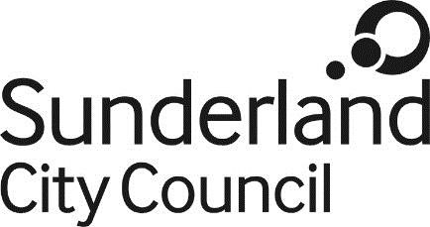
Job Description

Job Title: | Technical Support Officer Level 1
Salary Grade: | Grade 4
SCP: | 22 - 25
Job Family: | Organisational Support
Job Profile: | OS2
Directorate: | Corporate Services
Work Environment: | Agile
Reports to: | Technical Team Lead
Number of Reports: | None

Purpose:
To contribute towards the delivery of effective organisational support by providing specialist advice and conclusions of internal or external customers.
Key Responsibilities:
To investigate and implement solutions to customer’s technical issues and Service Requests, ensuring these are implemented within agreed timescales.
To have a strong emphasis on customer care providing excellent customer experiences, as well as a strong technical computing background
To be responsible for providing in-depth technical support to the unit’s internal and external customers, in relation to all computing related issues.
To be responsible for managing aspects of Active Directory, networking, configuration of Microsoft Windows operating systems, application support and troubleshooting of related hardware and software, as well as asset management.
The position will be based within Moorside, but will require travel within the City of
The post holder must carry out their duties with full regard to the Council’s Equal Opportunities Policy, Code of Conduct and all other Council Policies.
The post holder must comply with the Council’s Health and safety rules and regulations and with Health and safety legislation.
The post holder must act in compliance with data protection principles in respecting the privacy of personal information held by the Council.
The post holder must comply with the principles of the Freedom of Information Act 2000 in relation to the management of Council records and information.
To comply with the principles and requirements of the Data Protection Act 2018 and GDPR in relation to the management of Council records and information, and respect the privacy of personal information held by the Council

