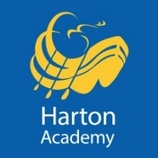
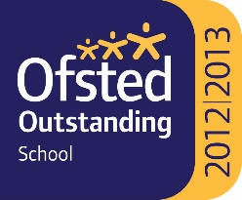

FIRST AID AND MEDICAL SUPPORT ASSISTANT
3 days a week – up to 5 days a week; term time only
£11, 794 - £19,835 (actual salary)

Your proven experience in being a first aid responder and providing medical care in a similar setting will enable you to deal effectively and efficiently with all requests for first aid assistance. You will be fully qualified in First Aid at Work and it is desirable that you are also able to train colleagues to this standard. Your experience will also help you assist those pupils in school who have an agreed care plan, along with your strong administrative skills will ensure that records are maintained and updated as required.

Your strong interpersonal skills will help you deal compassionately with our pupils, and build effective relations with parents, carers and outside agencies who contribute to looking after those who come to Harton Academy.

In return, you can be confident that you are joining a committed, supportive and very successful team. You will be coming to an extremely popular and over-subscribed 11-18 school, with over 1600 students, which …

- was judged “outstanding” in all categories in our Ofsted inspection in January, 2013
- in February 2009 featured in a national publication by Ofsted entitled ‘12 Outstanding Secondary Schools – Excelling Against the Odds’
- achieves excellent examination results in KS4 and KS5
- was designated as a ‘Teaching School’ in September, 2011
- opened a 6th Form Centre in September 2010, offering an extensive range of level 3 courses, a varied enrichment programme and a challenging academic environment
- prepares all students for the destination of their choice, whether continuing in further and higher education or into the world of work

We are committed to safeguarding and promoting the welfare of children, young people and vulnerable adults. We expect all our staff and volunteers to share our commitment. Successful applicants are required to obtain an Enhanced Certificate of Disclosure from the Disclosure and Barring Service.

Application packs are available from Harton Academy’s website – https://harton-tc.co.uk/year-7-11/information/vacancies/first-aid-and-medical-support-assistant/

All applications are to be returned to Harton Academy by 12 Noon on Monday 8th November, 2021.

Harton Academy is the Employer.

