Silver Tree Primary School & Nursery
Durham Road
Ushaw Moor
Durham
DH7 7LF
Tel: 0191 3730622

Email: silvertree@durhamlearning.net
Website: www.silvertreeprimary.co.uk
Facebook: silvertreeprimaryschool

Head Teacher: Mrs. N. Maughan

March 2023
Dear Applicant

Post of Headteacher

Thank you for your interest in the post of Headteacher at Silver Tree Primary School and Nursery.

Governors anticipate that a shortlist of candidates will be drawn up on Monday 17th April, in order to enable interviews for the post to take place on Friday 28th April.

It is anticipated that the successful candidate will take up duty on 1st September 2023.

Visits to the school are actively encouraged where you will be shown around by two of our governors. Visits dates:

Tuesday 21st March 4pm
Thursday 23rd March 9am
Friday 24th March 1:30pm
Tuesday 28th March 9:30am

Please contact myself to make an appointment. pam.monaghan@durham.gov.uk

Further information about the school is available on our website.

Completed application forms should be returned to EDGS.Administration@durham.gov.uk by no later than Monday 3rd April at 8am.

I wish you well should you decide to proceed with your application.

Yours faithfully
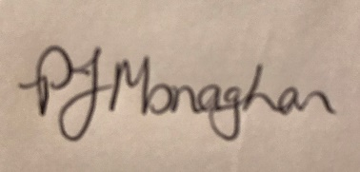
Mrs Pamela Monaghan
Chair of Governors

