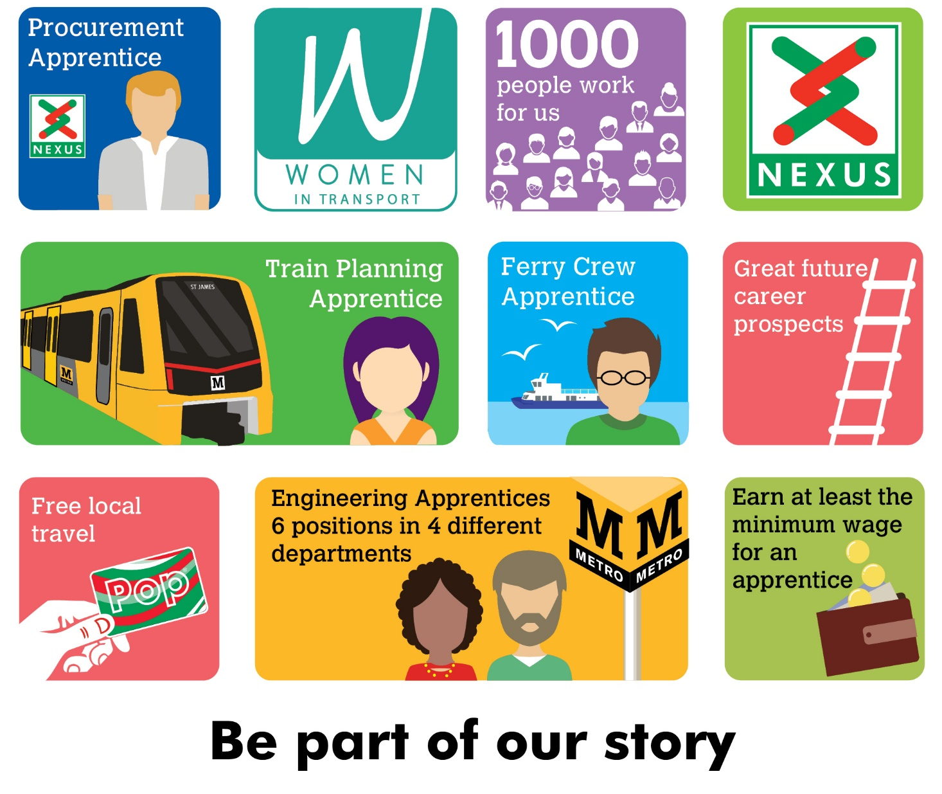
Signalling Apprentice
Nexus is searching for an Apprentice to join the Signalling section of the Maintenance Delivery Department.
The successful candidate will learn both at work and at college how to safely work on a modern Rail Signalling System. If successful, you will be part of a team that will maintain and rectify faults on the Signalling Systems on the Tyne and Wear Metro’s network.
We are looking for a colleague who has a positive attitude towards learning, rules and procedures, a logical approach towards problem solving and who can remain calm under pressure.
Interviews will be held on 27th June 2022 and alternative dates will not be available.

Salary - Age dependant (not less than Apprentice minimum wage),
plus shift allowance if applicable.
Plus, defined benefit pension scheme, free local travel and access to other benefits.
Closing date 5th June 2022

Find out more at nexus.org.uk

