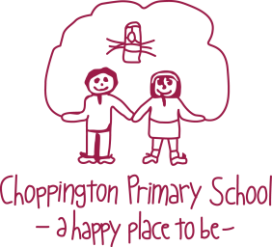
Choppington Primary School

Job Description Class teacher - 0.6 – 1fte variable contract.
Initially 0.8fte

All teachers at Choppington Primary School are required to:

1. Promote a learning environment where children are safe, happy and show consideration for others at all times so that they learn and achieve.

2. Promote good behaviour at all times, implementing the school’s behaviour policy consistently and fairly.

3. Plan, prepare and deliver a broad and balanced activity based curriculum. Assess children’s learning to celebrate achievements and inform future planning using relevant national and local guidelines from appropriate sources:- The EYFS, Read Write Inc, National Curriculum, Agreed Syllabus for R.E, National Primary Strategies.

4. Maintain appropriate records of attendance, progress, development and attainment in line with the school’s policy.

5. Act professionally at all times, setting a good example to children through high standards of presentation and personal conduct whilst contributing positively to effective working relationships within the school.

6. Set appropriate targets for children in line with the school’s assessment policy.

7. Use all learning resources effectively (including ICT and additional adults).

8. Promote the highest possible standards of teaching and learning which meets internal and external quality standards so that as many children as possible can become successful independent learners.

9. Undertake playground and supervisory duties.

10. Direct and support the work of teaching assistants.

11. Create an atmosphere of trust and co-operation between home and school by working and communicating with parents/carers.

12. Comply with health and safety policy and undertake risk assessments as appropriate.

As part of our school team you will be expected to:

13. Devise teaching strategies, which implement agreed school policies and schemes with particular reference to the following: Health & Safety, Child Protection, Equal Opportunities, Learning & Teaching, Assessment, Behaviour, SEN & Inclusion.

14. Work collaboratively with others to identify and maximize the learning potential of all children including those with SEN and those who are gifted and talented.

15. Keep up to date with latest developments in the Early Years/Primary Curriculum and pedagogy. Evaluate teaching methods with a view to continual improvement.

16. Provide an annual report to parents and attend parent meetings as required.

17. Contribute to the development of the school curriculum, teaching methods and their review.

18. Support and contribute to the school’s responsibility for safeguarding children.

19. Contribute to the formulation and implementation of the school improvement plan and associated action plans.

20. Play a full part in the life of the school community and support its ethos.

21. Comply with the duties and regulations of a school teacher as set out in the latest School Teachers’ Pay and Conditions Document.

22. Carry out any other reasonable tasks as directed by the Headteacher.

To progress and further your career you will:

23. Participate in the school’s appraisal system.

24. Actively pursue your own personal and professional development.

